CAST & CONVERT Functions in T-SQL
For more information on MS SQL Server Functions go to:
http://msdn.microsoft.com/library/default.asp?url=/library/en-us/tsqlref/ts_fa-fz_9dyr.asp

CAST & CONVERT explicitly convert an expression of one data type to another. They provide similar functionality.

Syntax

Using CAST:
CAST (expression AS data_type )

Using CONVERT:
CONVERT ( data_type [ ( length ) ] , expression [ , style ] )

Arguments
expression
is any valid Microsoft® SQL Server™ expression.

data_type
is the target data type. User-defined data types cannot be used.

length
is an optional parameter of nchar, nvarchar, char, varchar, binary, or varbinary data types. If it isn’t specified, the default values are used.

style
is the style desired to convert the expression to character data (nchar, nvarchar, char, varchar, binary, or varbinary data types). See the following tables and information for the specific styles available.

This table shows the style values for float or real conversion to character data.
Value | Output
0 (default) | Six digits maximum. Use in scientific notation, when appropriate.
1 | Always eight digits. Always use in scientific notation.
2 | Always 16 digits. Always use in scientific notation.

This table shows the style values for money or smallmoney conversion to character data.
Value | Output
0 (default) | No commas every three digits to the left of the decimal point, and two digits to the right of the decimal point; for example, 4235.98.
1 | Commas every three digits to the left of the decimal point, and two digits to the right of the decimal point; for example, 3,510.92.
2 | No commas every three digits to the left of the decimal point, and four digits to the right of the decimal point; for example, 4235.9819.
In this table, the two columns on the left represent the style values for datetime or smalldatetime conversion to character data. Add 100 to a style value to get a four-place year that includes the century (yyyy).
Without century (yy) | With century (yyyy) | Standard | Input/Output**
- | 0 or 100 (*) | Default | mon dd yyyy hh:miAM (or PM)
1 | 101 | USA | mm/dd/yy
2 | 102 | ANSI | yy.mm.dd
3 | 103 | British/French | dd/mm/yy
4 | 104 | German | dd.mm.yy
5 | 105 | Italian | dd-mm-yy
6 | 106 | - | dd mon yy
7 | 107 | - | Mon dd, yy
8 | 108 | - | hh:mm:ss
- | 9 or 109 (*) | Default + milliseconds | mon dd yyyy hh:mi:ss:mmmAM (or PM)
10 | 110 | USA | mm-dd-yy
11 | 111 | JAPAN | yy/mm/dd
12 | 112 | ISO | yymmdd
- | 13 or 113 (*) | Europe default + milliseconds | dd mon yyyy hh:mm:ss:mmm(24h)
14 | 114 | - | hh:mi:ss:mmm(24h)
- | 20 or 120 (*) | ODBC canonical | yyyy-mm-dd hh:mi:ss(24h)
- | 21 or 121 (*) | ODBC canonical (with msec) | yyyy-mm-dd hh:mi:ss.mmm(24h)
- | 126(***) | ISO8601 | yyyy-mm-dd Thh:mm:ss.mmm(no spaces)
- | 130* | Hijri**** | dd mon yyyy hh:mi:ss:mmmAM
- | 131* | Hijri**** | dd/mm/yy hh:mi:ss:mmmAM

* The default values (style 0 or 100, 9 or 109, 13 or 113, 20 or 120, and 21 or 121) always return the century (yyyy)
** Input when converting to datetime; output when converting to character data.
*** Designed for XML use. For conversion from datetime or smalldatetime to character data, the output format is as described in the table. For conversion from float, money, or smallmoney to character data, the output is equivalent to style 2. For conversion from real to character data, the output is equivalent to style 1.
****Hijri is a calendar system with several variations, of which Microsoft® SQL Server™ 2000 uses the Kuwaiti algorithm.

Note: When you convert to character data from smalldatetime, the styles that include seconds or milliseconds show zeros in these positions. You can truncate unwanted date parts when converting from datetime or smalldatetime values by using an appropriate char or varchar data type length.

Return Types
Returns the same value as data type 0.

Remarks
Implicit conversions are those conversions that occur without specifying either the CAST or CONVERT function. Explicit conversions are those conversions that require the CAST (CONVERT) function to be specified.

This chart shows all explicit and implicit data type conversions allowed for SQL Server system-supplied data types.
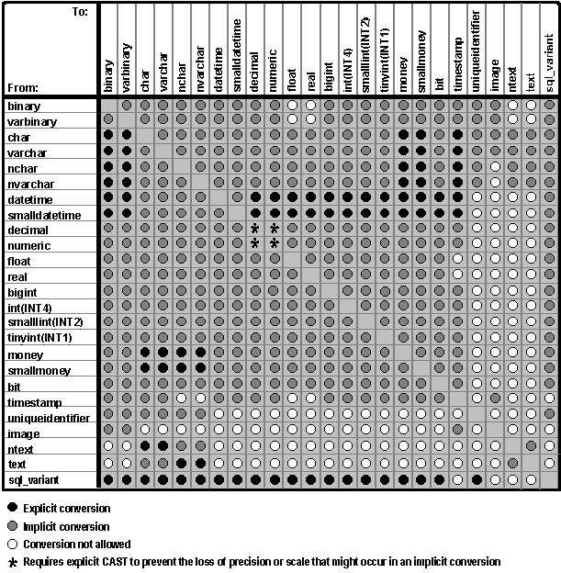

Notes

Because Unicode data always uses an even number of bytes, use caution when converting binary or varbinary to or from Unicode supported data types. For example, this conversion does not return a hexadecimal value of 41, but of 4100: SELECT CAST(CAST(0x41 AS nvarchar) AS varbinary)
- Automatic data type conversion is not supported for the text and image data types. You can explicitly convert text data to character data, and image data to binary or varbinary, but the maximum length is 8000. If you attempt an incorrect conversion (for example, if you convert a character expression that includes letters to an int), SQL Server generates an error message.
- When the output of CAST or CONVERT is a character string, and the input is a character string, the output has the same collation and collation label as the input. If the input is not a character string, the output has the default collation of the database, and a collation label of coercible-default. To assign a different collation to the output, apply the COLLATE clause to the result expression of the CAST or CONVERT function. For example:
- SELECT CAST (‘abc’ AS varchar(5)) COLLATE French_CS_AS
- When data types are converted with a different number of decimal places, the value is truncated to the most precise digit. For example, the result of SELECT CAST(10.6496 AS int) is 10.
- When data types in which the target data type has fewer decimal points than the source data type are converted, the value is rounded. For example, the result of CAST(10.3496847 AS money) is $10.3497.
- SQL Server returns an error message when non-numeric char, nchar, varchar, or nvarchar data is converted to int, float, numeric, or decimal. SQL Server also returns an error when an empty string (" ") is converted to numeric or decimal.

