Thevenin’s and Norton’s Theorems Say…

- That if we are only interested in current, voltage and power delivered by a linear portion of a circuit, we can replace that portion (potentially a large complex network,) by an equivalent circuit containing only an independent source and a single resistor. The response will be unchanged in the rest of the original circuit.
- Thevenin’s Theorem says that the independent source is a voltage source and we should place it in series with the resistor. The theorem also tells us how to calculate the value of the voltage source, V_{s}, and the value of the resistance, R_{t}, called the Thevenin Resistance.
- Norton’s Theorem says that the independent source is a current source and we should place it in parallel with the resistance. The theorem also tell us how to calculate the value of the current source, I_{s}, and the value of the resistance, R_{t}, called the Thevenin Resistance.
- Of course, by source transformations, we can always switch from the “Thevenin” equivalent circuit to the “Norton” equivalent circuit.

R_{t}

V_{s} I_{s} R_{t}

Thevenin Equivalent Network Norton Equivalent Network

To find the Thevenin Equivalent Network
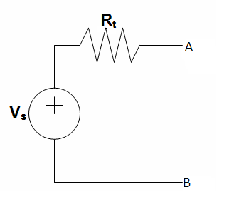
- First you must identify the network to find the equivalent of.
You can rearrange any circuit in the form of two networks connected by two resistance-less conductors, labeled terminals A and B. (Note: If either network contains a dependant source, its control variable must be in the same network.)
If one of the networks is linear it can be replaced by this Thevenin equivalent network:
The only thing left to do is find the values of R_{t} and V_{s}.
- To find V_{s}:
Define a voltage, v_{oc}, as the open circuit voltage which would appear across the terminals A and B (of the original network) if there was an open circuit between A and B. This voltage is V_{s}.
- To find R_{t}:
There are three different cases that will require different methods to find R_{t}:
  - If there are only independent sources in the network, then “kill” them.
R_{t} = R_{eq}
  - If there are dependant sources and independent sources in the network, find both v_{oc} and i_{sc}.
R_{t} = v_{oc} / i_{sc} .
  - If there are only dependent sources apply a 1A current source at the terminals A and B. Calculate the resulting voltage, v, across this current source.
R_{t} = v / 1A
(Alternatively you can apply a 1V voltage source and measure resulting current, i, through it. R_{t} = 1V / i)

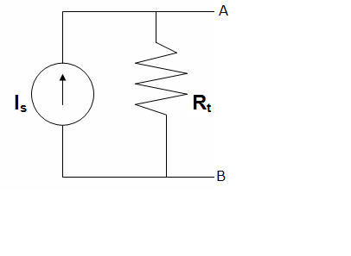
To find the Norton Equivalent Network

- First you must identify the network to find the equivalent of.
You can rearrange any circuit in the form of two networks connected by two resistance-less conductors, labeled terminals A and B. (Note: If either network contains a dependant source, its control variable must be in the same network.)
If one of the networks is linear it can be replaced by this Norton equivalent network:
The only thing left to do is find the values of R_{t} and I_{s}.
- To find I_{s}:
Define a current, i_{sc}, as the short circuit current which would be the current that would flow from terminal A to B (of the original network) if A and B were short circuited. This current is I_{s}.
- To find R_{t}:
There are three different cases that will require different methods to find R_{t}:
  - If there are only independent sources in the network then “kill” them.
R_{t} = R_{eq}
  - If there are dependant sources and independent sources in the network, find both v_{oc} and i_{sc}.
R_{t} = v_{oc} / i_{sc} .
  - If there are only dependent sources apply a 1A current source at the terminals A and B. Calculate the resulting voltage, v, across this current source.
R_{t} = v / 1A
(Alternatively you can apply a 1V voltage source and measure resulting current, i, through it. R_{t} = 1V / i)

