Operational Amplifier

An operational amplifier is an example of an integrated electronic device. (An integrated circuit is a combination of inter-connected circuit elements inseparably associated on or within a continuous semi-conducting material called a “chip”.)

An operational amplifier is an active element with high-gain ratio designed to be used with other circuit elements to perform a specified signal-processing operation.

Combined with resistors, capacitors and inductors op-amps can be used for various purposes, including the performance of mathematical operations such as addition, subtraction, multiplication, division, integration, and differentiation.

Advantages of an op-amp include isolation between the input and the output terminals and a power gain between input and the output terminals.
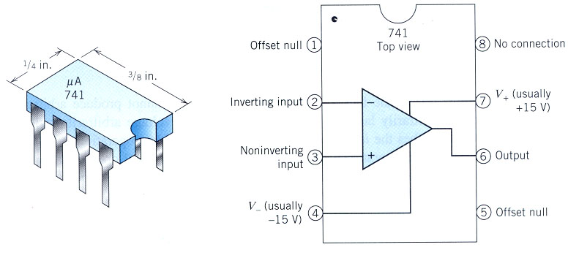

One example of the many op-amps widely available is the μA741. It has 8 connecting pins.
The second diagram shows the correspondence between the circled pin numbers of the integrated circuit and the nodes of the operational amplifier.

The power supply is used to bias the op-amp. i.e. to create certain conditions so that it may function. Once this happens, the power supply doesn’t do much and so is frequently omitted from drawings showing the function of an op-amp. (However, it is not omitted from the schematic drawings.)

NOTE: BE CAREFUL when using drawings that don’t show the power supplies! The power supply currents are there, even if they are not shown, and should be included in KCL applied to the ground node and KCL applied to the op-amp itself.
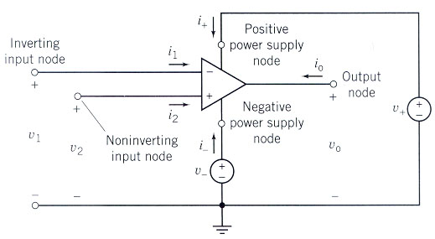

This shows the op amp,
including power supplies
v⁺ and v⁻.

For an op-amp to be linear these must hold:

|v_{o}| ≤ v_{sat} the saturation voltage

|i_{o}| ≤ i_{sat} the saturation current

|d v_{o}(t)| ≤ SR the Slew Rate Limit
dt

These equations reflect the fact that op-amps cannot produce arbitrarily large voltages or currents of change output voltage arbitrarily quickly.

For an op-amp to be ideal, these must hold:

i₁ = 0 i₁ = 0 v₂ - v₁ = 0

i₁
inverting
input node + i₀
non-inverting output node
input node +
+ i₂
v₁ v₂ v_{o}

- -

