City College of San Francisco

ENGN 20

Introduction to Circuit Analysis

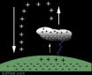

Homework Problems

Chapter 1
Voltage/Current/Power

- A walker’s cassette tape player uses four AA batteries in series to provide 6 V to the player circuit. The four alkaline battery cells store a total of 200 watt-seconds of energy. If the cassette player is drawing a constant 10mA from the battery pack, how long will the cassette operate at normal power?
(Answer: 3333 seconds)
- The energy w absorbed by a two-terminal device is shown in the figure as a function of time. If the voltage across the device is v(t) = 12 cosπt V, where t is in ms, find the current entering the positive terminal at t = 1ms, 3ms and 6ms. The element voltage and current adhere to the passive convention.
(Answer: i(1ms) = -0.3333A, i(3ms) = 0A, i(6ms) = 0.5 A)

- The circuit shown in Figure 3a has a current source i as shown in Figure 3b.
The resulting voltage across the circuit is shown in Figure 3c.
Determine the power p(t) and the energy w(t) absorbed by the element and sketch both.
+
i v
_
Figure 3a
Circuit

Figure 3b

Figure 3c

Answer: p(t) = 6t for 0 < t <= 1/2
= 6 – 6t for ½ <= t <= 1
= 0 for 1 <= t <= 2
w(t) = 3t² for 0< t <= 1/2
=-3t² + 6t -1.5 for ½ <= t <= 1
= 1.5 for 1<= t <= 2


- The current through and voltage across an element vary with time as shown in the figures. Sketch the power delivered to the element for t > 0. What is the total energy delivered to the element between t = 0 and t = 25 s? The element voltage and current adhere to the passive convention.
Answer: p(t)=60t for 0 <t <= 10
=-10t²+160t for10<= t<=15
= -15t+375 for 15<= t<= 25
w_{from 0 to 25 sec} = 5833 J)
- Neglecting losses, determine the power that can be developed from Niagara Falls, which has an average height of 168 ft and over which the water flows at 500,000 tons per minute.
Answer: 3.8 GW
Chapter 2
Circuit elements
- An element is represented by the relation between current and voltage as v = √i . Determine if the element is linear.
(Answer: The element is NOT linear.)
- An electrical element has a current i entering the positive terminal with a voltage v across the element. For t > 0 it is known that:
v(t) = 10 sin 100t V
i(t) = 2 cos 100t mA
  - Find the power p(t) and plot it.
  - Determine intervals of time when the element is supplying or absorbing power.
Answer:
p(t) = 10sin(200t) mW
Power is absorbed on the intervals 10πn < t < (2n+1)5π where n = 0,1,2,3…..
Power is delivered on the intervals (2n+1)5π < t < (n+1)10π where n = 0,1,2,3…..
- The current entering the positive terminal of an element is: i = 2 sin t A for t ≥ 0
and i = 0 for t < 0
The voltage across the element is: v = 2 di
dt
Determine whether the element is active or passive by calculating the energy absorbed by the element.
(Answer: The element is passive.)
- A voltage source and two resistors are connected in parallel in the circuit shown. Elements connected in parallel have the same voltage, so v₁ = v_{s} and v₂ = v_{s} in this circuit. Suppose that v_{s} = 150V, R₁ = 50Ω, and R₂ = 25Ω. Calculate the current in each resistor and the power absorbed by each resistor.
Hint: Notice the reference directions of the resistor currents.
(Answer: i₁ = 3A and i₂ = -6A. R₁ absorbs 450W and R₂ absorbs 900 W.)
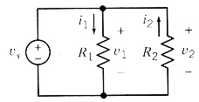
- A current source and a voltage source are connected in series with a resistor as shown in the figure. All of the elements connected in series have the same current, i_{s}, in this circuit. Suppose that v_{s} = 10V, i_{s} = 2A, and R = 5Ω.
  - Calculate the voltage v across the resistor and the power absorbed by the resistor.
  - Change the voltage source voltage to v_{s} = 5V and recalculate the voltage, v, across the resistor and the power absorbed by the resistor.
(Answer: v = 10V and the resistor absorbs 20 W for both situations.)
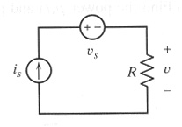
- The current source and the voltage source in the circuit shown are connected in parallel so that they both have the same voltage, v_{s}. The current source and voltage source are also connected in series so that they both have the same current, i_{s}. Suppose that v_{s} = 12V and i_{s} = 3A. Calculate the power supplied by each source.
(Answer: The voltage source supplies -36 W,
and the current source supplies +36W)
i_{s} v_{s}
- The ammeter in the circuit shown indicates that i_{a} = 2A, and the voltmeter indicates that v_{b} = 8V. Determine the value of g, the gain of the VCCS.
(Answer: g = 0.25 A/V)
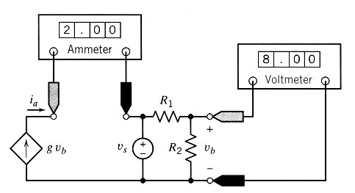
- The current source in the potentiometer circuit provides 1.1 mA. The potentiometer resistance is 100kΩ. Calculate the required angle, θ, so that the measured voltage is 23 V.
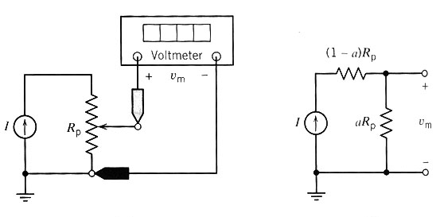
(Answer: θ = 75.27º)
- Determine the voltage, v, at t = 1s and at t = 4s for the circuit shown.
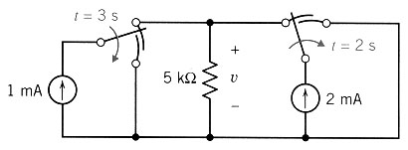
(Answer: v(1s) = 15V, v(4s) = 0V)

Chapter 3
Resistive Circuits
- Determine the power supplied by each current source.
(Answer: The 2 mA current source supplies -6mW
and the 1mA current source supplies +7mW.)
5V 2mA
15V 1mA
8V
- The ideal voltmeter in the circuit shown measures the voltage v.
- Suppose R₂ = 100 Ω. Determine the value of R₁. (Answer: R₁ = 50Ω)
- Suppose, instead, R₁ = 100 Ω. Determine the value of R₂. (Answer: R₂ = 200Ω)
- Suppose, instead, that the voltage source supplies 1.2 W of power. Determine the values of both R₁ and R₂. (Answer: R₁ = 40Ω and R2 =80Ω)
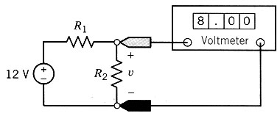
- a) Determine the values of R₁ and R₂ in Figure b that make the circuit equivalent to the circuit in Figure a. (Answer: R₁ = 6Ω and R₂ = 4Ω)
b) Analyze the circuit in Figure b to determine the values of the currents i_{a} and i_{b}.
(Answer: i_{a} = 3A and i_{b} = 2.25A)
c) Because the circuits are equivalent, the currents i_{a} and i_{b} shown in Figure b are equal to the currents i_{a} and i_{b} shown in Figure a. Use this fact to determine values of the voltage v₁ and current i₂ shown in Figure a.
(Answer: v₁ = - 10V and i₂ =1.125A )
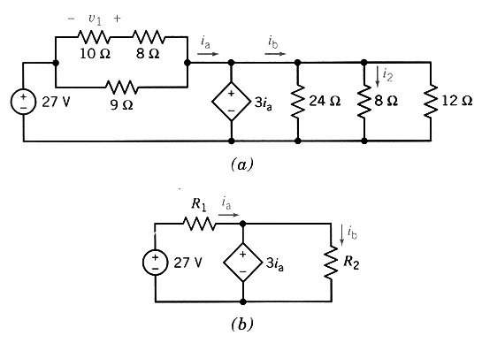
- Most of us are familiar with the effects of a mild electric shock. The effects of a severe shock can be devastating and often fatal. Shock results when current is passed through the body, and especially the heart.
A person can be modeled as a network of resistances. Consider the model circuit shown. The heart is represented by R_{h}. The floor has resistance to current flow equal to R_{f} and the person is standing barefoot on the floor. The upper-body resistance R_{u} and lower-body resistance R_{L} vary from person to person.
Determine the voltage developed across the heart and the current flowing through the heart of the person when he or she firmly grasps one end of a voltage source whose other end is connected to the floor. This type of accident might occur at a swimming pool or boat dock. 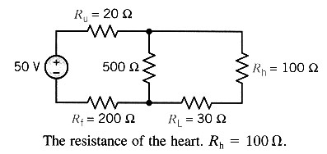(Answer: i_{h} = 0.123A and v_{h}= 12.3V)
- Find i and R_{eq a-b} if v_{ab} = 40V.
(Answer: R_{eq a-b} = 8Ω, i = 5/6 A)
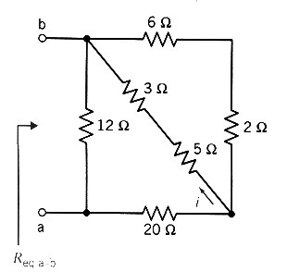
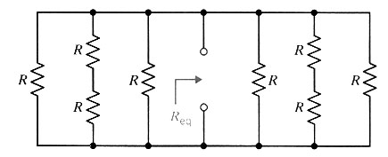
- Determine the Resistance R when R_{eq} = 20 Ω. (R_{eq} would be the resistance measured if the probes of a multimeter were place at the two terminals a and b.)
(Answer: R = 100Ω)

a

b
Chapter 4
Node Voltage Analysis
Mesh Current Analysis
- Find the voltage v for the circuit.
(Answer: v = 21.7 mV)
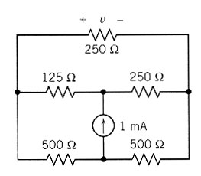
- Determine the node voltage v_{a}.
(Answer: v_{a} = 4V )
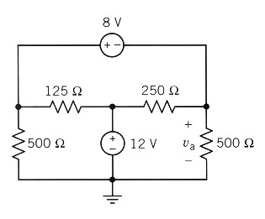
- Determine the node voltage v_{b}.
(Answer: v_{b} = 1.5V )
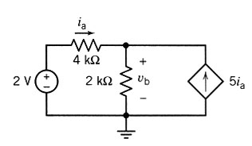
- Determine the mesh currents, i₁, i₂ and i₃.
(Answer: i₁ = 3A, i₂ = 2A and i₃ = 4A)
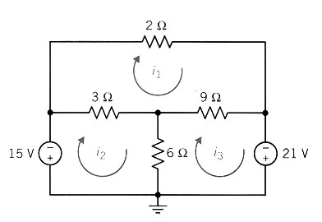
- Determine the mesh current i_{a}.
(Answer: i_{a} = -48 mA)
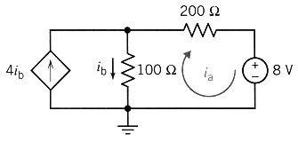
- An amplifier provides a gain in voltage between the input voltage v_{in} and the output voltage v_{o}. A model of a transistor amplifier is shown where d = 10. Find the ratio v_{o}/v_{in}.
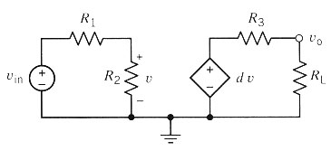
(Answer: v_{o} = dR₂R_{L} )
v_{in} (R₁ + R₂) (R_{L} + R₃)
- Determine the node voltage v_{c} and the current i_{x} of the circuit using mesh current analysis and then node voltage analysis.
(Answer: v_{c} = 5V and i_{x} = -1A)
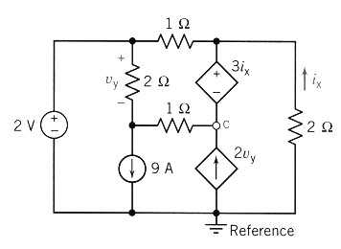
Chapter 5
Thevenin and Norton Equivalent Circuits
- Use source transformations to find the voltage v across the 1 mA current source for the circuit shown.
(Answer: v = 3V)
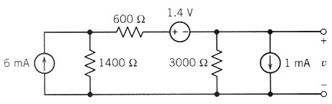
- For the circuit shown, specify the resistance R_{L} that will cause current i to be 2A.
Hint: Use source transformations to simplify the circuit connected to R_{L}.
(Answer: R_{L} = 2Ω)
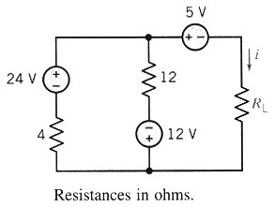
- Use superposition to find i for the circuit.
(Answer: i = -2 mA)
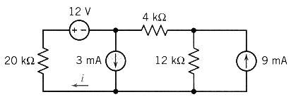
- Find the Thevenin equivalent circuit for the circuit shown.
(Answer: R_{t} = 10Ω, v_{oc} = -24V)
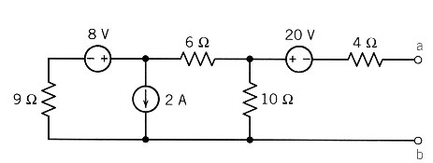
- Find R_{t} for the circuit.
(Answer: R_{t} = 3Ω)
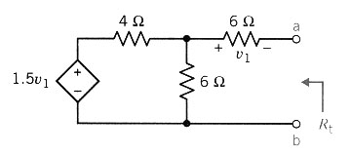
- Find the Norton equivalent circuit for the circuit shown.
(Answer: R_{th} = 2Ω, i_{sc} = -7.5A)
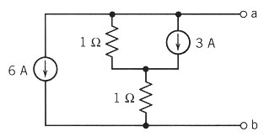
- Find the Norton equivalent circuit for the circuit shown.
(Answer: R_{th} = -18Ω, i_{sc} = 0.5A)
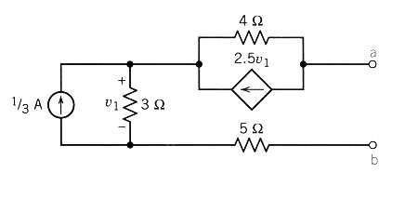
- Find the maximum power to the load R_{L} if the maximum power transfer condition is met for the circuit.
(Answer: max p_{L} = 0.75 W)
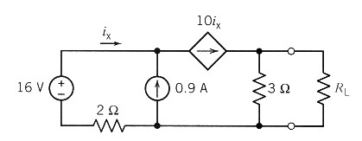
Chapter 6
The Operation Amplifier
- Find v_{o} and i_{o} for the circuit assuming an ideal op amp.
(Answer: v_{o} = -30 V, i_{o} = 3.5 mA )
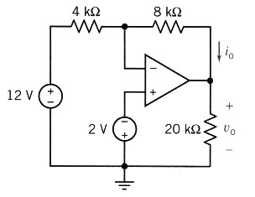
- An operational amplifier can be used to convert a current to a voltage, v_{o}, as shown in the figure. Find the ratio v_{o} / i_{s}, using an ideal operational amplifier.
(Answer: v_{o} / i_{o} = -R)
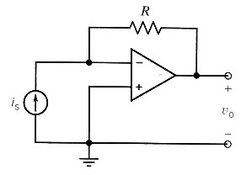
- Find v_{o} and i_{o} for the circuit. Assume an ideal operational amplifier.
(Answer: v_{o} = 5 V, i_{o} = 0.1667 mA )
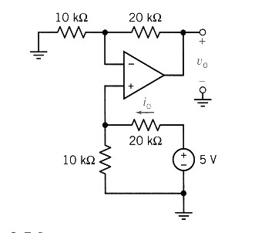
- The circuit shown includes a simple strain gauge. The resistor R changes its value by ΔR when it is twisted or bent. Derive a relation for the voltage gain v_{o} / v_{s} and show that it is proportional to the fractional change in R, namely ΔR / R_{o}.
($\text{Answer}:v_{o}=−v_{s}\frac{R_{o}}{R_{o}+R_{1}}\frac{ΔR}{R_{o}}$)
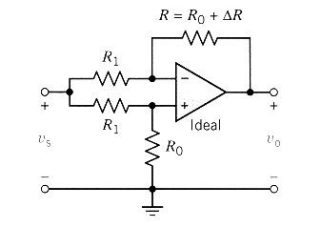
- The circuit shown is called the inverted R-2R ladder digital-to-analog converter (DAC). The input to this circuit is a binary code represented by b₁ b₂ …. b_{n}, where b_{i} is either 1 or 0. Each switch shown in the figure is controlled by only one of the digits of the binary code. If b_{i} = 0, the switch will be in the right position, whereas if b_{i} = 1, the switch will be in the left position. Depending on the position of the switch, each current I_{i} is diverted to either to true ground bus (adding to I⁺) or the virtual ground bus (adding to I⁻).
  - Show that I = V_{R}/R regardless of the digital input code.
  - Show that the output voltage can be expressed as
$V_{o}=−\frac{R_{f}}{R}V_{R}(b_{1}2^{−1}+b_{2}2^{−2}+b_{3}2^{−3}+⋯+b_{n−1}2^{−n+1}+b_{n}2^{−n})$
  - Show that I⁺ + I⁻ = (1 – 2^{-n}) V_{R} / R regardless of the binary code.
  - Given R_{f} = R = 10 kΩ, V_{R} = -16V and assuming a four-digit binary input code, find the output voltage V_{o} for each combination of the input code, ranging from 0000 to 1111. Explain the relationship between the output and the input code.
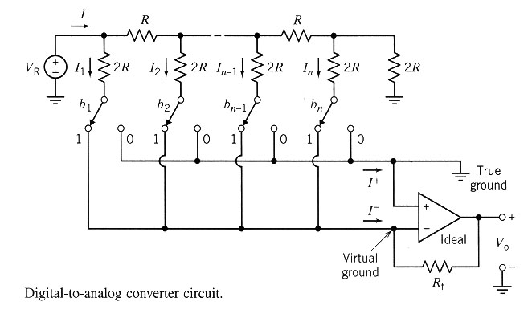
Chapter 7
Energy Storage Elements
- The voltage, v(t), across a capacitor and current, i(t) through that capacitor adhere to the passive convention. Determine the capacitance when the voltage is
v(t) = 12 cos(500t – 45º) V and the current is i(t) = 3 cos(500t + 45º) mA.
(Answer: C = 0.5 μF)
- The voltage across a 40-μF capacitor is 25 V at t₀ = 0. If the current through the capacitor as a function of time is given by i(t) = 6e^{-6t} mA for t > 0, find v(t) for t > 0.
(Answer: v(t) = 50 – 25e^{-6t} V )
- The energy stored by a 1-mF capacitor used in a laser power supply is given as w = 4e^{-10t} J for t ≥ 0. Find the capacitor voltage and current at t = 0.1 s.
(Answer: v(0.1s)=54.25V i(0.1s)=0.27A )
- The circuit contains five identical capacitors. Find the value of the capacitance C.
(Answer: C = 10 μF)
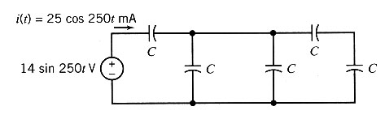
- The model of an electric motor consists of a series combination of a resistor and inductor. A current i(t) = 4te^{-t} A flows through the series combination of a 10Ω resistor and 0.1-henry inductor. Find the voltage across the combination.
(Answer: v(t) = 0.4 e^{-t} + 39.6te^{-t} V )
- Rind R of the circuit shown in the figure if v₁ =1e^{-200t} V for t ≥ 0.
(Answer: R = 80Ω )
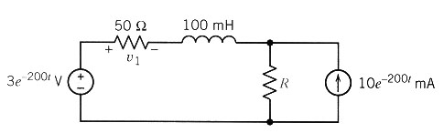
- The voltage, v(t), across a 25-mH inductor used in a fusion power experiment, is 0 for t ≤ 0 and v(t) = 6 cos 100t for t > 0. (The units of time are s and the units of voltage are V.) The current in this inductor is zero before the voltage changes at t = 0. Determine the power, p(t), absorbed by the inductor and the energy, w(t), stored in the inductor.
(Hint: sin2A = 2 sinA cosA and 2sin²A = 1 – cos 2A )
(Answer: p(t) = 7.2 sin 200t W and w(t) = 36(1 – cos 200t)mJ )
- Find the voltage v(t) for the circuit shown.
(Answer: v(t) = -6e^{-250t} mV )
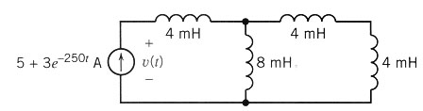
- The switch in the figure has been open for a long time before closing at time t = 0. Find v_{c}(0⁺) and i_{L} (0⁺), the values of the capacitor voltage and inductor current immediately after the switch closes. Let v_{c} (∞) and i_{L} (∞) denote the values of the capacitor voltage and inductor current after the switch has been closed for a long time. Find v_{c}(∞) and i_{L}(∞).
(Answer: v_{c}(0⁺) = 12V, i_{L}(0⁺) = 0, v_{c}(∞) = 4V, i_{L}(∞) = 1mA )
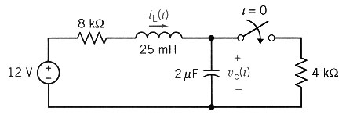
- For the circuit shown find dv_{c}(0⁺)/dt, di_{L}(0⁺)/dt, and i(0⁺) if v_{c}(0⁻) = 16V. Assume that the switch was closed for a long time prior to t = 0.
(Answer: dv_{c}(0⁺)/dt = -3.5MV/s , di_{L}(0⁺)/dt = 0, and i(0⁺)= 3A)
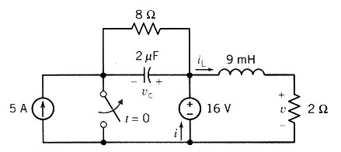
Chapter 8
First Order Circuits

- Find i_{L}(t) for t>0 for the circuit shown. The circuit is in steady state at t = 0⁻.
(Answer: i_{L}(t) = 2e^{-6t} A for 0<t<51 ms and i_{L}(t) = 1.47e^{-14(t - 0.051)} A for t>51ms )
6Ω 12Ω 2Ω
i
t=51ms i_{L}
52V t=0 1H
6Ω
- The figure shows a circuit model for a large tool called the apogee capture device (ACD). This was used by astronaut Dale Gardner to stabilize a satellite and capture it for recovery. Find the inductor current i_{L} for t > 0.
(Answer: i_{L}(t) = 6e^{-20t} A )
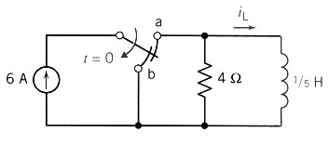
- An electronic flash of a camera uses a small battery to charge a capacitor. When the flash is activated, the capacitor is switched across the flashbulb of the camera. Assume:
  - The battery is a 6-V battery that should not be operated with a current above 100 μA.
  - The value of the bulb resistance is 10 kΩ.
  - It is desired to charge the capacitor within 5s and to discharge it within ½ s.
  - The capacitor is charged or discharged in five time constants.
Draw a circuit model that will represent the charging and discharging action and select the appropriate values for the elements in the circuit.
(Answer: One possible choice is a capacitor with C=10μF and R= 100kΩ
There are other possibilities.)

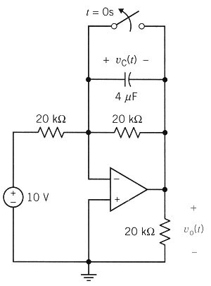
- The circuit shown is at steady state before the switch opens at t = 0s. Determine the voltage, v₀(t), for t > 0s.
(Answer: v₀(t) = -10 + 10e^{-12.5t} V for t > 0 )
- Sequential switching is used repetitively to generate communication signals. For the circuit shown in the figure, switch a has been in position 1 and switch b has been open for a long time. At t = 0, switch a moves to position 2. Then, 100 ms after switch a moves, switch b closes. Find the capacitor voltage v for t ≥ 0.
(Answer: v(t) = 10V for t<0, v(t) = 10e^{-20t} for 0<t<0.1s, v(t) = 1.35 e ^{-25(t - 0.1} for t>100ms)
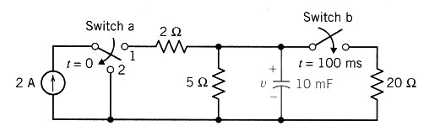
- The circuit in the figure contains a current-controlled voltage source (CCVS). What restriction must be placed on the gain, R, of this dependent source in order to guarantee stability?
(Answer: R>= 400Ω)
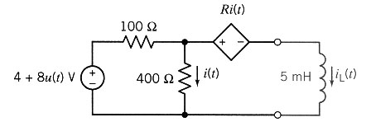
- The input to the circuit shown in the figure changes at time t = 0. Before time t = 0, the circuit is excited by a constant input. After time t = 0, the circuit is excited by a different constant input. The response of this circuit is the capacitor voltage v_{c}(t). This circuit has two steady-state responses, one before t = 0 and the other after t = 0. Find both of these steady-state responses.
(Answer: v_{c} (t) = 8 V before t = 0 and v_{c} (t) = 4 V after t = 0)
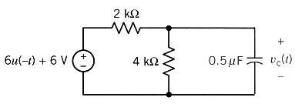
- For the circuit shown v_{c}(0⁻) = 3V. Find v_{c}(t) for t ≥ 0.
(Answer: v_{c}(t) = 4 - e^{-250t} V, t ≥ 0 )
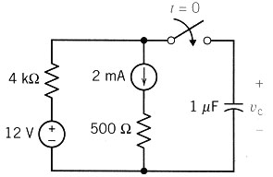
Chapter 9
Second Order Circuits

- Find the differential equation for the circuit shown using the operator method.
(Answer: $\frac{d^{2}}{{\text{dt}}^{2}}i_{L}(t)+\text{11000}\frac{d}{\text{dt}}i_{L}(t)+1\text{.}1x{\text{10}}^{8}i_{L}(t)={\text{10}}^{8}i_{s}$ )
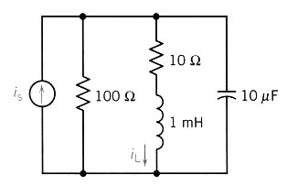
- Find the characteristic equation and its roots for the circuit.
(Answer: s² + 400s + 3x10⁴ = 0 roots: s = -300, -100 )
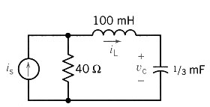
- Determine v(t) for the circuit when L = 1H and v_{s} = 0 for t ≥ 0.
The initial conditions are v(0) = 6V and dv/dt(0) = -3000 V/s.
(Answer: v(t) = -2e^{-100t} + 8e^{-400t} V )
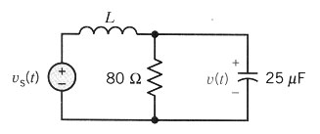
- Find v_{c}(t) for t>0 for the circuit shown.
(Answer: v_{c}(t) = (3 + 6000t) e ^{-2000t} V )
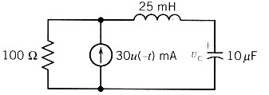
- The switch of the circuit shown is opened at t = 0.
Determine and plot v(t) when C = ¼F. Assume steady state at t = 0⁻.
(Answer: v(t) = -4e^{-2t} sin2t V )
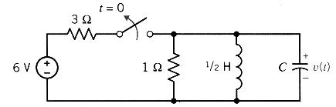
- Determine the forced response for the capacitor voltage, v_{f}, for the circuit when
a) v_{s} = 2V
b) v_{s} = 0.2t V
c) v_{s} = 1e^{-30t} V
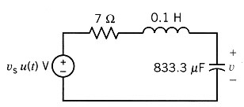
(Answer:
a) v_{f}(t) = 2V
b) v_{f}(t) = (0.2t - 0.001167) V
c) v_{f}(t) = (1.11e^{-30t})V )

- Find v_{c}(t) for t>0 in the circuit shown when
a) C = 1/18 F b) C = 1/10 F c) C = 1/20 F
(Answer: a) v_{c}(t) = 8e^{-3t} + 24te^{-3t} – 8 V
b) v_{c}(t) = 10e^{-t} - 2e^{-5t} – 8 V
c) v_{c}(t) = e^{-3t} (8 cost + 24 sint) – 8 V )
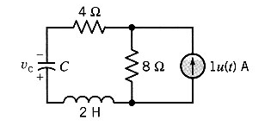
- Find v(t) for t > 0 using the state variable method. C = 1/5F.
Sketch the response for v(t) for 0 < t < 10s.
(Answer: v(t) = -25e^{-t} + e^{-5t} +24 V )
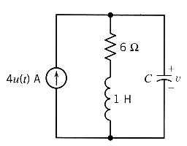

Chapter 10
Steady State Sinusoidal Responses
- Represent each of the signals shown by a function of the form A cos (ωt + θ).
(Answer:
a) v_{s}(t) = 10 cos (1900t + 30º) V
b) v(t) = 10 cos (1260t + 30º) V
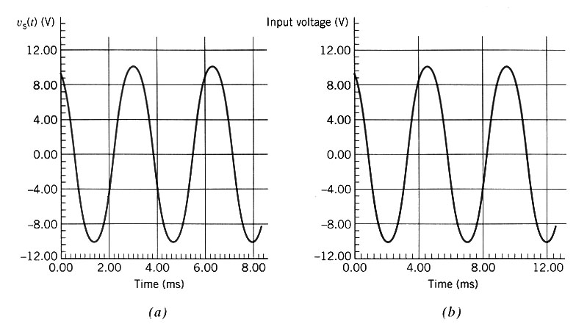
- Find the forced response i(t) for the circuit.
(Answer: i(t) = 2 cos (4t + 45º) mA )
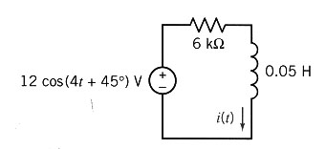
- For the circuit shown, find v(t) when v_{s} = 2 sin 500t V.
(Answer: v(t) = 1.25 cos (500t – 141º) V )
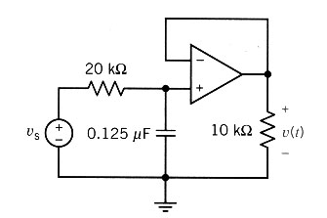
- Two voltages appear in series so v = v₁ + v₂.
Find v when v₁ = 150 cos (377t - π/6)V and V₂ = 200 ∠+60º V .
(Answer: v(t) = 250 cos (377t + 23.1º) V )
- For the circuit shown find the value of C required so that Z = 590.7Ω when f = 1MHz.
(Answer: C = 0.27 nF)
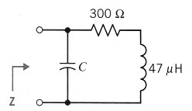
- Determine i(t) of the RLC circuit shown in the figure when v_{s} = 2 cos (4t + 30º)V.
(Answer: i(t) = 0.185 cos (4t – 26.3º) A
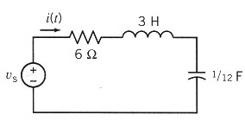
- For the circuit of the figure it is known that:
v₂(t) = 0.7571 cos(2t + 66.7 º)
v₃(t) = 0.6064 cos(2t - 69.8 º)
Determine i₁(t).
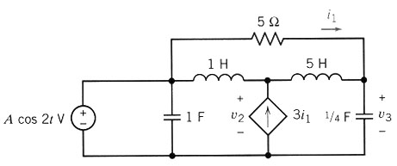
- A pocket-sized mini-disk CS player system has an amplifier circuit shown in the figure with a signal v_{s} = 10 cos (ωt + 53.1º) at ω = 10,000 rad/sec. Determine the Thevenin equivalent at the output terminals a-b.
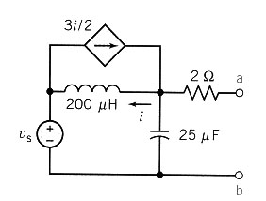
- Consider the signal
i(t) = 72e3 cos8t + 36e3 sin(8t + 140º) + 144 cos(8t + 210º) + 25 cos(8t + φ)
Using the phasor plane, for what value of φ does the |I| attain its maximum?

