ENGN 38
Introduction to Computing for Engineers
Chapter 4: Parameters & Function Overloading

Variables in memory
The names of program variables actually refer to memory locations.
- When a variable is declared, memory is allocated for it.
- Each memory location has a unique address.
(Addresses are stored in the computer as hexadecimal numbers.)
- The compiler assigns one memory location to each variable.
- The names of the variables act as aliases for the addresses.

int doubler (int someNumber);
100
100
200
int main()
{ int y, x = 100;
y = doubler (x);
return 0; someNumber
}

int doubler (int someNumber)
{ return (2 * someNumber);
} x
y
main doubler

What happens when a function is invoked?
In short, when a function is invoked the arguments pass (give) “something” to the parameters in the function definition.

Exactly what they pass depends on what type of parameter it is.

There are three different types of parameters for functions:
- call-by-value parameters
This is what we have been using so far.
The argument given to the function for a CBV parameter will pass its value.
- call-by-reference parameters
We’ll learn these now.
The argument given to the function for a CBR parameter will pass its address in memory.
- array parameters
To be covered later.
The argument given to the function for an array parameter will pass its address in memory.
What happens when a function is invoked? (More detail!)

Here are the detailed steps that occur when a function is called:

- The program control goes to the function definition.
- The parameters of the function are declared as variables local to the function.
  - If the parameter is a CBV parameter then this happens:
    - new memory is allocated for the local variable
    - this local variable is initialized to the same value as the argument that was passed to the function in the function invocation.
  - If the parameter is a CBR parameter then this happens:
    - the memory location that is allocated for the local variable is the same memory location as the argument that was passed to the function in the function invocation.
    - the local variable does not need to be initialized
- The function body is executed.
- When the return statement is encountered in the function body, control goes back to the place where the function was invoked.
  - If the function is a valued function, the value it returns is put in the place of the function invocation.
  - If the function is a void function, the control goes back to where the function was invoked with no value returned.

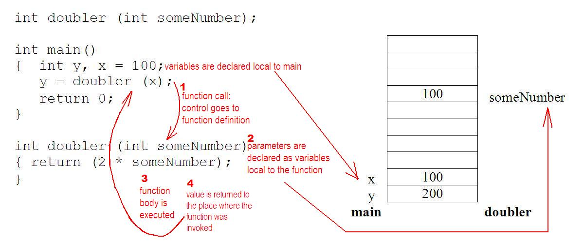
Difference between CBV & CBR parameters:

CBV
In the case of a call-by-value parameter only the value of the argument is passed to the function. So the argument given to a function with a call-by-value parameter can be anything that returns a value of the type needed, including:
- A literal value of the type required.
- A variable that evaluates to the type required.
(Note that if a variable is passed, its value in main does not change!)
- An expression that evaluates to the type required.

CBR
In the case of a call-by-reference parameter the address (memory location) of the variable argument is passed to the function. So the argument given to a function with a call-by-reference parameter must be a variable. (Only variables have addresses.)

Note that name of a CBR paramter is an alias for the name of the variable in main. So the function can change the value of a variable in main! You should use call-by-reference parameters when you want to change the value of a variable in main.

Syntax to create a CBR parameter
Use ‘&’ after the datatype

void getInput(double& receive);
/*
Preconditions: a declared double variable.
(It doesn’t need to have a value.)
Postconditions: the variable passed to the function gets a value from the user via the keyboard.
*/
int main()
{
double amtReceived;
getInput(amtReceived);
cout << “This is the amount received: ”
<< amtReceived << endl << endl;
return 0;
}

void getInput (double& receive)
{
cout << “\nWhat is the value of the amount received? ”;
cin >> receive;
return;
}

Remember you can have functions that….
- do or don’t return values
- do or don’t take arguments
- do or don’t perform actions
- do or don’t change the value of a variable passed to it
…and any combination of the above.

Vocabulary (Let’s make sure we have it straight.)
(formal) parameters are the placeholders used in the function header of the function definition.
(They can also show up in the function declaration/function prototype but they don’t have to.)
They are used in the function body. They will either have the same value of the same memory location as the arguments passed in the function call /invocation.

arguments are what are used in the function call. They must be of the correct datatype.

If the parameter is call-by-value, it gets initialized to the value of the argument.
So the argument is anything that evaluates to a value of the required type. If the argument is a variable, its value won’t change.

If the parameter is call-by-reference, it gets assigned the same memory location as the argument.
So the argument must be a variable. Any change made to the parameter in the function body will also be made to the variable in main.

Overloading functions
You might want a function that averages some numbers.
But it will be different if you want to average 2 numbers or 3 or 4.

One solution is to define 3 different functions:
double average2numbers (double num1, double num2)
double average3numbers (double num1, double num2, double num3)
double average4numbers (double num1, double num2, double num3, double num4)

C++ has another solution: have one function name that can handle all three situations.
This is called overloading which means you can use the same name for different functions that do similar actions. It works because the signature is different.

The signature is the number, type and order of the arguments.
(Note: You can’t overload based on const or &. Some compilers will allow you to do it on basis of const, but you shouldn’t.)

When there is a function call, the compiler will just use the definition of the function whose parameters matches the number and types of arguments in the call.

Sometimes there is ambiguity. The general rule for resolving any ambiguity in overloading:
If there is not an exact match, but a function can be found that matches by using automatic type conversions, then that function is used.

Default arguments
You can specify default values for arguments in CBV parameters.
When the corresponding argument is omitted in the function call, the default value is used.

The defaults are given only once, usually in the function declaration, not in the function definition. If there is no declaration, then it is in the function definition.

All default arguments must start from the rightmost parameter and proceed leftward. You can’t skip a parameter. If you leave out the argument in the function call, the default values are used. (Again, you have to start from the rightmost position and proceed left. You can’t skip a parameter.
Testing and Debugging Programs
An assertion is a statement that is either T or F.
A precondition or a postcondition might be examples of an assertion.
e.g. the precondition for one of the coins programs is that a variable called coinValue is b/w 1 and 100.

C++ has a predefined macro (function) called assert.
It is a void function that takes one CBV bool argument.
If the argument is true, nothing happens.
If the argument is false, program ends and an error message is issued.

So a example of testing it would look like this:
assert (1 < coinValue && coinValue < 100);
If this is not true the program ends and an error message is issued.

You need #include<cassert> to use assert.

Drivers
Each function should be designed, coded and tested separately. A driver program is a small program (main) written for the express purpose of testing a function. Once a function is tested, it can be used in the driver for another function.

Stubs
Every function should be tested in a program in which every other function in that program has already been fully tested and debugged.

Sometimes it is impossible to test a function without using some other function that has not yet been written or tested. So use a very simplified version of the missing or untested function. These simplified functions are called stubs.

A stub is a simplified version of a function that is used in place of the function so that other functions can be tested.

e.g.
double unitPrice (int diameter double price)
{
return 9.99;
}

Using a program outline with stubs allows you to test and then flesh out the basic program outline, rather than write a completely new program to test each function.

Common approach:
Use driver programs to test some basic functions.
Then use a program with stubs to test the remaining functions.
The stubs are replaced by functions one at a time.
