ENGN 38
Introduction to Computing for Engineers
Math Algorithm for Numerical Method
Newton-Raphson Method of Equation Solution

Problem:
We want to be able to find the solution to any equation. Sometimes an equation cannot be solved analytically. So we need to use other methods. The Newton-Raphson Method of Equation Solution is one such method.

Consider the equation: x³ + 5x + sin(x) = 6.2x²

Solve for 0: ⇒ x³ – 6.2x² + 5x + sin(x) = 0
let f(x) = x³ – 6.2x² + 5x + sin(x)
f(x) = 0

The values of x that make f(x) = 0 are the solutions to the original equation.
To solve the original equation, we just need to find the “zeros” of f(x)!

Algorithm:
- Make a wild guess for a solution, x_{o}.
It doesn’t matter what your guess is.
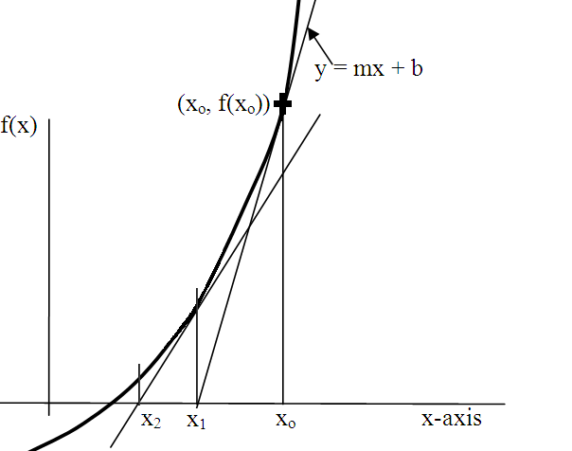
- Test to see if the guess is right:
f(x_{o}) = 0.001 ? (or some small acceptable error)
If it is then no need to go on.
If it isn’t, then find a better guess.
- Find the straight line tangent to curve f(x) at (x_{o} , f(x_{o}) )
- Find the value, x₁, where this line crosses the x-axis.
This is a better guess!
- Test it:
f(x₁) = 0.001 ?
If not then keep reiterating
the process until it is.

NOTE:
f(x) = 0 is actually not a good test. A better one is |f(x)| < 0.001?
Do you know why?
Also do you understand why the absolute value bars are needed?
Development:

Step 1:
Ask the user to guess a solution. Use this value for x_{o}.

Step 2:
Test: |f(x_{o})| > 0.001
If false, you have solution! If true, find a better value of x.

Step 3:
Find line tangent to curve f(x) at the guess, x_{o}:
y = mx + b
m = f′(x_{o})
⇒ y = f′(x_{o}) x + b

To find b, substitute the point (x_{o}, f(x_{o}) ) into this line:
y = [f′(x_{o})] x + b
f(x_{o}) = [f′(x_{o})] x_{o} + b
⇒ b = { f(x_{o}) – [f′(x_{o})] x_{o} }

Hence the line is:
y = f′(x_{o}) x + { f(x_{o}) – [f′(x_{o})] x_{o} }

Step 4:
Now find the value, x₁, where this line crosses the x axis. i.e. find x where y = 0:
0 = f′(x_{o}) x₁ + ( f(x_{o}) – f′(x_{o}) x_{o} )
⇒ x₁ = x_{o} – f(x_{o})/f′(x_{o})
This will be a better guess!

Step 5:
|f(x₁)| > 0.001?
If false you have found solution. If true, repeat Steps 3 and 4 until it is.

Let’s try it!
Let’s find the square root of 64:
x ∗ x = 64
x ∗ x – 64 = 0
f(x) = x ∗ x – 64
f′(x) = 2*x

For any wild guess of x we know that a better guess is:
x_{better} = x – [ f(x) / f′(x) ]

Let’s write the code:

#include <iostream>
#include <cmath>
using namespace std;

int main()
{
double x, fx, fpx;

cout << "Take a wild guess as to what the square root of 64 might be! ";
cin >> x;

do
{
fx = x*x-64 ;
fpx = 2*x;
x = x-fx/fpx;
} while (fabs(fx)>0.001);

cout << "\nThe square root of 64 is: " << x << endl;
return 0;
}

C++ code template for equation solution using Newton-Raphson method
- This Template program can be used to solve any equation with real solutions.
It will also display the interim steps.
- For a different equation you can use this template.
You just need to change the equation and its derivative as required.
- Notice that the "stop" criteria for the do...while loop involves choosing an acceptable error.
In this case 0.001%.

#include "stdafx.h"
#include <iostream>
#include <cmath>
#include <iomanip>
using namespace std;

int main()
{
double x, fx, fpx;

cout << "\nWhat is your initial guess for the square root of 64? ";
cin >> x;

// The following section is to set up the formatting and display column headers
cout.setf(ios::fixed | ios::showpoint | ios::right);
cout.precision(6);
cout << setw(15) << "x"
<< setw(15) << "f(x)"
<< setw(15) << "d/dx of f(x)"
<< setw(15) << "error"
<< setw(15) << "next x" << endl;

do
{
fx = pow(x,2) - 64; // You may put any function here
fpx = 2*x; // Put the derivative to the function here

// This next code formats and displays the output of each column for each iteration
cout << setw(15) << x // Displays the first guess
<< setw(15) << fx // Displays value of f(x) at the present guess
<< setw(15) << fpx // Displays value of df(x)/dx at the present guess
<< setw(15) << fx/100 << "%"; // Displays the error

x = x - fx/fpx; // This gets a value for x that is better
cout << setw(15) << x << endl;// Displays the better value in the last column

} while ( fabs(fx) > 0.00001);
//Choose an acceptable error. This one gives an error of < 0.001%!

cout << "\nThe square root of 64 is: " << x << endl;
return 0;
}
Beware! There are some limitations.

This will get into an infinite loop with no solution.

If there is more than one solution you will only get one of them with this method, depending on your first guess.

There may be no solutions!
Finding the solution to simultaneous equations:
y₁ = f₁(x)
y₂ = f₂ (x)

We want to find points that are on both curves.
So we want to find values of x such that f₁(x) = f₂(x)

So let f(x) = f₁(x) – f₂(x)
The zeros of f(x) give values of x_{p} and x_{q}.

x_{p} and x_{q} are solutions to both equations.

f₂(x) f₁(x)

x_{p} x_{q}

