ENGN 38
Introduction to Computing for Engineers
Chapter 10: Pointers & Dynamic Arrays

First review a few facts about how variables are stored in memory
- The computer’s memory is divided into bytes
- 1 byte holds 8 bits of data, i.e. a sequence of 8 binary digits, 0s and 1s.
- Each byte has an address assigned to it.
- This address is a hexadecimal number. It might look like this: AF45
- When a variable is declared, a specific number of bytes in memory are allocated for it.
The number of bytes is determined by the data type of the variable .
- The name of the variable is assigned to the address of the first byte of the memory locations that store that variable.
- In other words, the name of a variable is an alias for the address of the first byte of memory allocated for that variable.

pointer variables (aka “pointers”)
A pointer is a type of variable in C++.
It holds a value which is a hexadecimal number.
So the value of a pointer variable is an address in memory!

Thus, the pointer variable “points” to another variable – the variable stored at that address.
A pointer identifies another variable by telling where the variable is, rather then telling the variable’s name or value.
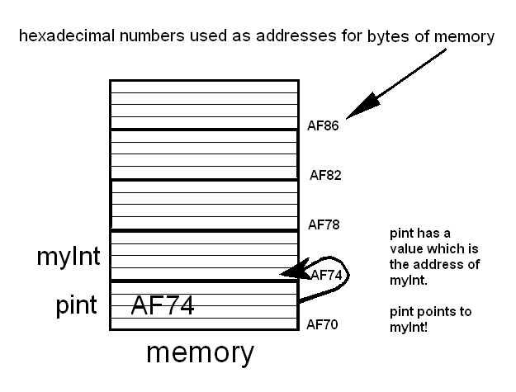

We’ve seen pointers before:
- a call-by-reference argument is given to the function in the form of a pointer to the variable.
- an array argument is given to a function by giving a pointer to the first array element.
We will now learn how to directly manipulate pointers rather than letting the system manipulate them for us.

There are many different kinds of pointer variables
There are many different types of pointer variables, each depends on what it is pointing to.

A pointer variable that points to an int variable is different than a pointer variable that points to a double variable, and this is different than a pointer variable that points to a class type variable, etc.

All of these pointer variables are the same size because they all hold a value which is a hexadecimal number.

Syntax for declaring a pointer variable that points to a variable of type double
These all declare a pointer variable named ptrDbl:
double *myptDbl; // This style is preferred by author
double * myptDbl;
double* myptDbl;
ptrDbl is a variable that can hold one pointer (memory address) that points to a variable of type double.
Beware:
double* myptDbl1, myptDbl2; //What do you think this does?
//myptDbl1 is a pointer to a double variable
//myptDbl2 is a regular double variable

Syntax for declaring a pointer variable that points to a variable of other types
int *myptInt;
char *myptChar;
Vehicle *myptMyRedHonda;

The value of a pointer variable
The value of a pointer is a memory address which is a hexadecimal number.
A hexademimal number is considered to be an integer.
So is the value of a pointer variable also an integer? Can you store this value in an int variable?
Answer to both questions is NO!
The reason is because a hex number is not considered to be an integer or any numeric type by the compiler. (Like zip codes.)

If you try to store a pointer in a variable of type int, you may or may not get an error or warning message.

Where are pointers used?
A pointer type is a full-fledged type and can be used as any other types are used:
- as a declared variable in main
- as a function parameter
- the return type of a function

address of operator
Consider:
int *p1, v1(13), v2;
p1 = &v1; // p1 now points to the variable v1
& is called the address-of operator.
It returns the address of the variable it operates on.
When you see & in front of a variable say to yourself: “the address of” …

dereferencing operator
Futher consider:
v2 = *p1; // v2 now has the value of v1
* is called the dereferencing operator
It returns the variable pointed to of the pointer variable it operates on.
When you see * in front of a pointer say to yourself: “the variable pointed to by”…
The pointer variable is said to be dereferenced.

What do you think the following code will output?
int *p1, *p2 , v1;
// declares two pointers to int variables and one int variable
v1 = 0;
// assigns the value of 0 to the integer variable v1
p1=&v1;
// assigns the value of the address of v1 to the pointer variable p1
*p1=42;
// assigns the value of 42 to the variable pointed to by p1
p2 = p1;
// assigns the value of p1 to the pointer variable p2
cout << v1 << endl << *p1 << endl << *p2 << endl;

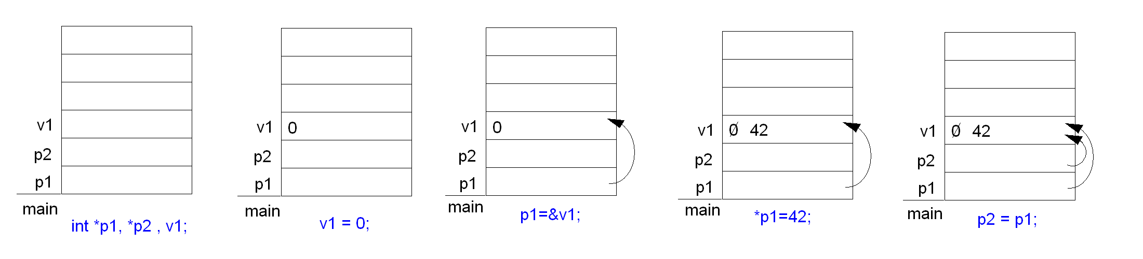

Out put on the screen will be:
42
42
42

The new operator
A pointer can refer to a variable even if it doesn’t have an identifier, i.e. a name!
The operator new is used to create a variable that doesn’t have a name.
It allocates memory for a new, nameless variable in a special area called the freestore, or the heap*.
New also returns a pointer that points to this new variable.
(*The heap is a reserved area of memory used for dynamic memory management.)

Syntax to use the new operator:
ptrVar = new datatype; // the datatype specified must be the type that the ptrVar points to
Example:
int *myPint;
myPint = new int; // this assigns to the pointer pint an address in the heap.
This address is where a new int variable is stored.
You can initialize the variable that myPint points to at the same time memory is allocated for it:
myPint = new int(9); // initializes *myPint, i.e. the variable pointed to by myPint, to 9

The new variable doesn’t have a name. It is referred to as *myPint.
Anything you can do to an int variable can be done to *myPint.
*myPint is called a dynamic variable.

When the new operator is used to create a dynamic variable of a class type, a constructor for the class is invoked: (either the default constructor or another one with arguments)
Vehicle *ptMyRedHonda;
ptMyRedHonda = new Vehicle; // Calls default constructor (no arguments)
-or-
ptMyRedHonda = new Vehicle(1800, 50.7); // Calls the constructor with 2 arguments

When Heap gets filled up
If the heap gets used up your program should terminate with additional calls to new.
However, older compilers won’t do this.
Instead they will return a special value named NULL if the new operator is used when the heap is full.

This will never hurt:
int *myPint;
myPint; = new int;
if (myPint;== NULL)
{ cout << “Error: Insufficient memory in heap.\n”;
exit (1);
}
What is NULL?
- NULL is a special constant pointer value (NULL == 0)
- It is used to give a value to a pointer variable that would not otherwise have a value.
- NULL can be assigned to a pointer variable of any type.
- To use NULL you need #include <iostream> or #include <cstddef>

Esoteric: The definition of NULL is handled by the C++ preprocessor which replaces NULL with 0. Thus, the compiler never actually sees “NULL” and so there is no namespace issue and no using directive needed.

Summary of the new operator
You can think of the new operator like a function.
//Precondition: a pointer variable has been declared
//Postcondition: an action is executed and a value is returned
- The action is to allocate memory in the heap for a variable of the type specified.
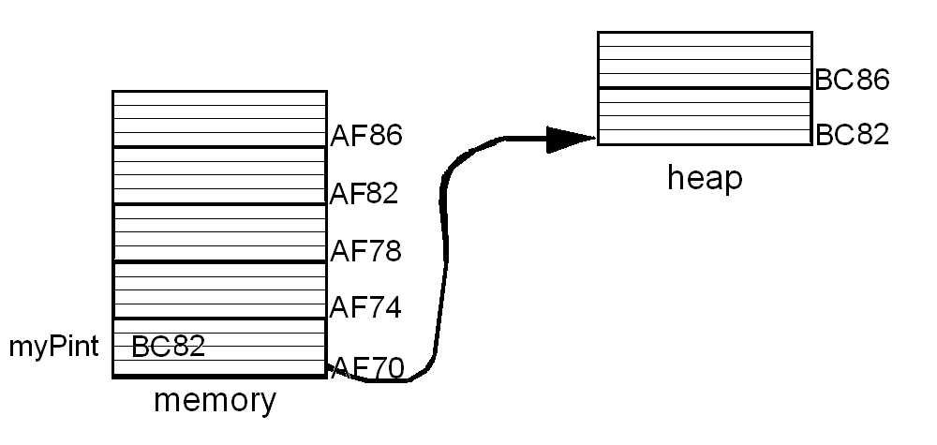
- The value it returns is the address of that memory location in the heap, provided there is enough //space. If there is not, the new operator should abort the program, but it might just return //NULL.

myPint = new int

The delete operator
The delete operator eliminates a dynamic variable and returns the memory to the freestore. The memory can then be reused. We say the memory is returned to the freestore manager.

Syntax for the delete operator:
delete myPint;
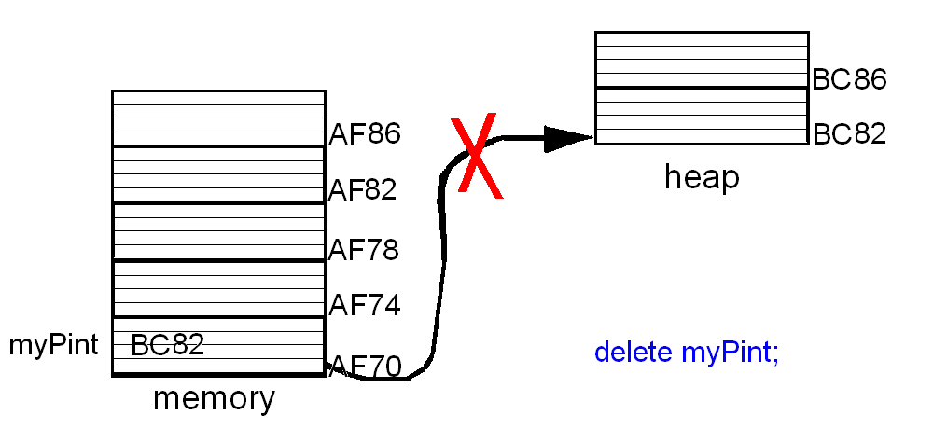
Dangling pointers
The delete operator does not delete the pointer variable.
It de-allocates the memory that the pointer was pointing to.
The pointer variable still exists, but it is no longer pointing to anything.
It has no value. It is called a dangling pointer.
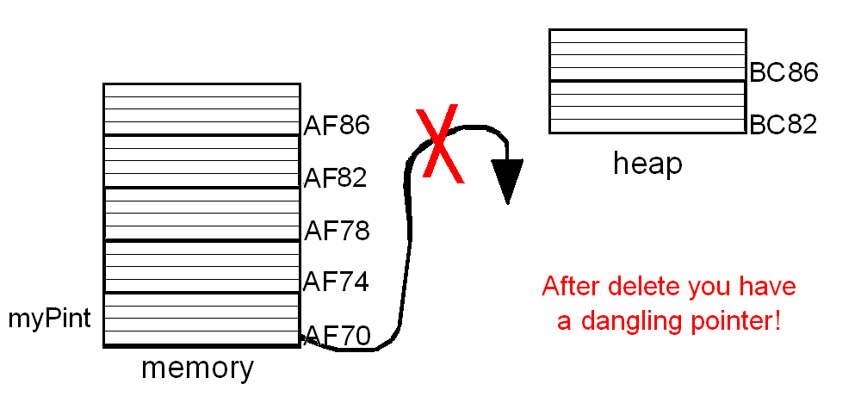

What will happen if you try to use *myPint somewhere in your code? Usually something bad!
You should always set your dangling pointer variables == NULL after the use of delete.
Or give them another value.

Beware: If there were any other pointers that pointed to the same memory they also have no value and are now dangling pointers. It is up to the programmer to keep track of all dangling pointers.

Dynamic variables –vs- automatic variables
automatic variables are the local variables of a function.
They are created when the function in which they are declared is called and automatically destroyed when the function call ends.

dynamic variables are created by the new operator.
They are also called dynamically allocated variables. The heap is reserved for these variables.
They are created when you use new and destroyed when you use delete.
So they are created and destroyed while the program (i.e. the function main) is running!
You have control over when dynamic variables are created and destroyed within a function.
(They will be deleted when the program ends.)

global variables are variables declared outside any function or class definition, including main.
These are also called statically allocated variables because they are truly static in contrast to dynamic and automatic variables. (Note: the word static here is different than when used as a modifier in the declaration of member variables of a class.)

Giving aliases to data types with typedef
typedef int* IntPtr; // Usually put before main so it is global to your program
This just defines an alias for any datatype.

Now we can do this:
IntPtr myPint;
instead of this:
int* myPint;

It is useful for pointers because otherwise the syntax gets confusing.
Using the new name, IntPtr, for a pointer to an int avoids the type of mistakes you could get with this:
int *p1, p2; // only p1 is a pointer
Do this instead:
IntPtr p1, p2; //both are pointers

And also for call-by-reference parameters for a pointer variable:
Instead of this:
void sampleFunction (int& *pointerParm);
We can do this:
void sampleFunction (IntPtr& pointerParm);

Arrays and pointers
In C++ an array variable is actually a pointer variable that points to the first indexed variable of the array.
int a[10];
typedef int* IntPtr;
IntPtr p;
Both a and p are pointer variables.
- p can be treated as if it were an array identifier.
- a can be treated as if it were a pointer variable.
With one exception: You cannot change the pointer value in an array variable!
- This is OK: p = a; // The address of a pointer can be changed
- This is not: a = p; // The address of an array cannot be changed
// Why not? Because a is actually a const int*

Dynamic arrays (aka dynamically allocated arrays)
These are arrays whose size is determined while the program is running.

Recall that we have to specify the size of an array when we declare it. So we need to make sure that we declare the largest size we think we will need. There are 2 problems with this:
- wastes space
- what if we are wrong about the max possible size?

The solution: dynamically allocated arrays (or just dynamic arrays.)
These let you enter the size as the program is run.

To create and use a dynamic array:
- Typedef double* DoublePtr; // This is optional
- DoublePtr d; // Declare a pointer variable
- d = new double[int_exp]; // Create an array in the heap pointed to by d.
//The int_exp doesn’t have to be a constant!
- Use d like any ordinary array.
- delete [] d; // When finished you should free up space in the heap// //Note the [] used when deleting an array

Note:
This last statement delete destroys the dynamically allocated array pointed to by d.
It does not destroy the pointer variable d. It just makes it a dangling pointer.
You should not assign any other value to the pointer variable d until delete is used.
Otherwise you’ll confuse the system when you delete the dynamic array.

Can a function return an array?returning a pointer to an array
Recall that we said “not exactly”. A function can’t return an array. BUT. It can return a pointer to an array with is almost exactly the same thing.

pointer arithmetic
This is arithmetic of addresses, not of numbers.

pointer addition
Typedef double* ptrToDoubl;
ptrToDoubl d;
d = new double[10]; //d now contains the address of the indexed variable d[0]

d | is interpreted by the compiler as | &d[0]
d + i | is interpreted by the compiler as | &d[i]
*(d + i) | is interpreted by the compiler as | d[i]

And recall that &d[i] is calculated from the formula: &d[0] + i * (no_bytes_req’d_for_datatype)

pointer subtraction
You can also subtract an integer, i, from a pointer. Works just like addition.

If you subtract two pointers of the same type, the result is the number of indexed variables between the two addresses. (The two pointers must be in the same array!)

increment and decrement operators for pointers
d++ returns the address of next indexed variable
d -- returns the address of previous indexed variable

Multiplication and Division
Can’t.

Engine Basics for a 4 stroke engine
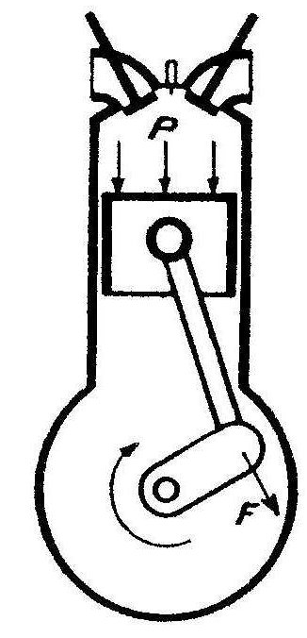
Cylinder pressure is converted
to a rotating force or torque in the crankshaft
Vocabulary:
cylinder
piston
piston rings (seals)
piston pin

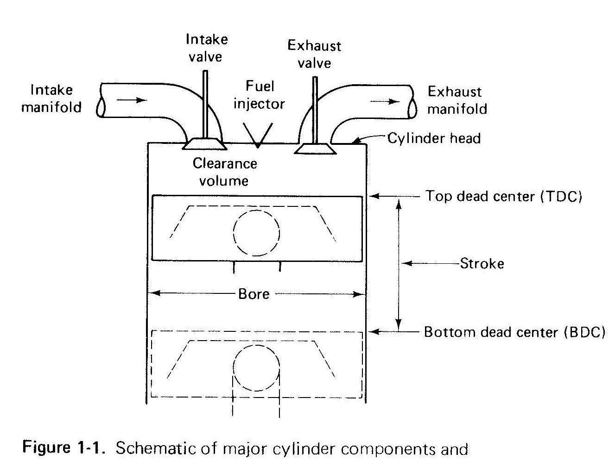
connecting rod

crank pin

crank
crankshaft

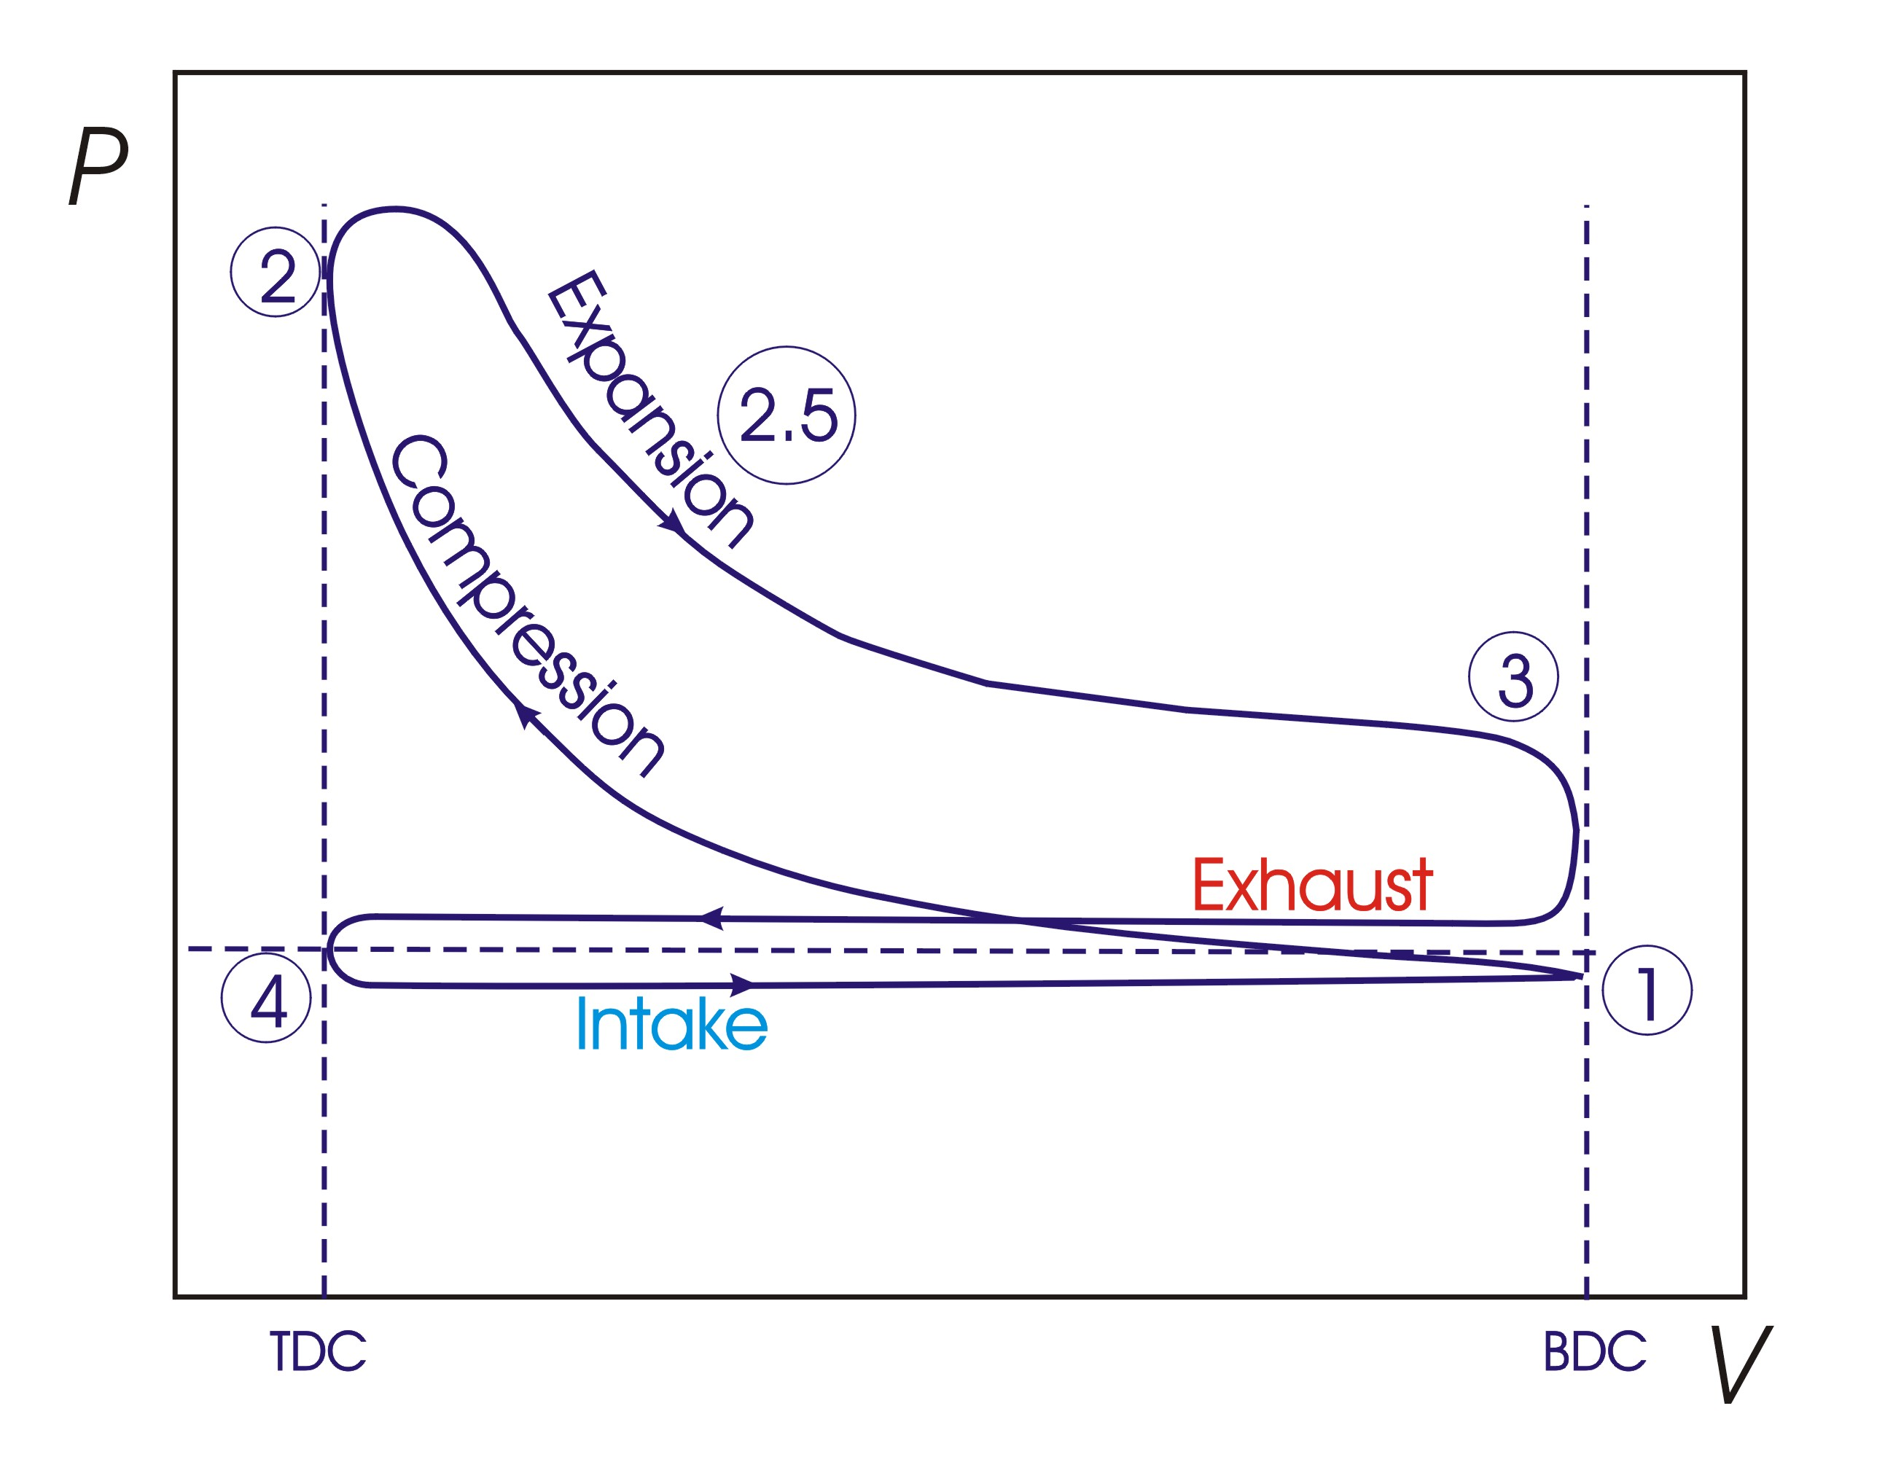

Stoke Process
4-1 intake (suck)
1-2 compression (squeeze)
2-3 combustion & expansion (bang)
3-4 exhaust (blow)

Note: 4 strokes = 2 revolutions

Work and Power
Work = ∫ P dV
Power = rate of doing work = (Work done) / (time to do the work)

To calculate the power for an IC engine: Power = (Work done in one cycle) / (time for one cycle)

To calculate (Work done in one cycle) integrate P vs. V for one cycle.

To calculate the (time for one cycle), use the engine speed, usually given in RPM:
(time for one cycle) = ( 1min / RPM rev) x (60sec/1min) x (2rev/1cycle)

This will end up with the answer in units of sec/cycle.
This is exactly what you want.
Numerical Integration
Engineers don’t usually solve complex mathematical equations such as differential equations or integrations directly. They use numerical techniques.

We will learn numerical integration.
Suppose you want to integrate f(x) between a and b,
i.e. obtain the area under the curve between a and b.

∫_{a}^{b} y dx = lim ∑ y_{i} Δx
Δx→0
n →∞ y y = f(x)

You choose n or Δx:
n = (b – a) /Δx
or Δx = (b – a) /n

$\int_{a}^{b}{\text{ydx}=}$ a b x

sum of all the rectangles between a and b
$\int_{a}^{b}{\text{ydx}=}f(a)Δx+f(a+Δx)Δx+ ⋅⋅ +f(b−1)Δx=\sum_{i=1}^{n}{f(x_{i})Δx}=\sum_{i=1}^{n}{y_{i}Δx}$

Numerical Approximation can give overestimates or underestimates

y y = f(x) y y = f(x)

a b x a b x

Use trapezoidal rule for less error: area = ½ ( y₁ + y₂) Δx
$\int_{a}^{b}{\text{ydx}=}\frac{1}{2}[f(a)+f(a+Δx)]Δx+ ⋅⋅ +\frac{1}{2}[f(b−1)+f(b)]Δx=\sum_{i=1}^{n−1}{\frac{1}{2}[f(x_{i})+f(x_{i+1})]Δx}$

The code to calculate the area under the curve y = x² from a to b

/* This program calculates the area under the curve y = x² from a to b.
The user is asked for the values of a, b, and delX.
The number of intervals is calculated from delX: n = (a – b) / delX
It will need to be rounded off to nearest integer
*/

int main ()
{ double a, b, x,
delX, delArea,
area = 0.0;
int i, n;

cout << "\nThis program will integrate the function y = x^2.\n";

cout << "\nWhat value of x do you want to start at? ";
cin >> a;
cout << "\nWhat value of x do you want to end at? ";
cin >> b;
cout << "\nEnter the value for delta x ";
cin >> delX;

n = static_cast<int>(floor((b-a)/delX + .5));
x = a;

for(i=0; i<n; i++)
{
delArea = pow(x, 2) * delX;
// delArea = (1 / 2.) * ( pow(x, 2) + pow(x+delX, 2) ) * delX;
area = area + delArea;
x = x + delX;
}

cout << "The area under the curve y = x^2 between "
<< a << " and " << b << " is " << area << endl << endl;

return 0;
}
Bar Graphs
You will need to know scale and zero position
independent variable
x
dependent variable y

void barPlot(double arrayToPlot[], int numberInArray, double yScale);
//Preconditions: arrayToPlot has numberInArray values, yScale has a value
//Postconditons: A bar plot is printed to the screen showing the values of
// each element in arrayToPlot on subsequenct lines
// as bars of asterisks on each line
// where the length of the bar is yScale units per asterisk

int main()
{
double myArray[30] = {1,2,3,4,5,6,7,8,9,10,9,8,7,6,5,4,3,2,1,0,1,2,3,4,5};
int noElements = 25, myScale = 0.5;

barPlot(myArray, noElements, myScale);

return 0;
}

void barPlot(double arrayToPlot[], int numberInArray, double yScale)
{
int numberOfAsterisks, i, j;

for(i=0; i<numberInArray; i++)
{ numberOfAsterisks = static_cast<int>(arrayToPlot[i]/yScale + .5);

for (j=0; j<numberOfAsterisks; j++)
cout << "*";
cout << "\n";
}
}

