Chapter 2
Atomic Structure and Atomic Bonding

We will first look at structure on the atomic level. We begin this by looking at the structure of the atom and then at atomic bonding.

Atomic bonding describes the interactions between the atoms in a material, and more specifically, the interactions between their electrons. The type of atomic bonding in a material will significantly affect the properties of a material.

For example, graphite and diamond, both made of Carbon, have very different properties attributable to different types of atomic bonding. Diamond is one of the hardest substances in the world, and graphite is used as a dry lubricant because of its ability to have adjacent layers slide over each other.

Chemistry Review – Basic Vocabulary

We begin with the basic vocabulary of the individual atom.

element – Fundamental chemical species, represented in the periodic table. All materials are made of elements or combinations of these elements.

atom – The smallest building block of an element, consisting of a central nucleus of protons and neutrons with electrons orbiting the nucleus.

nucleus – The central portion of the atom containing the protons and neutrons.

protons – Positively charged particles of 0.16 x 10⁻¹⁸ C and a mass of 1.66 x 10⁻²⁴g.

neutrons – Neutral particles having approximately the same mass as protons.

electrons – Negatively charged particles with a mass of 0.911 x 10⁻²⁷ g. The charge is the same magnitude as that on the proton. The electrons reside in orbits around the nucleus.

Note: The mass of the electron is on the order of 1000 times smaller than protons and neutrons. Hence the mass of the atom resides primarily in the nucleus. However, the volume is determined by the electron orbitals.

If the nucleus were the size of a pin head, the closest electron would be approximately a football field’s length away. The vast majority of the atom is space! In this picture, if you were a pinhead standing at the goalpost, the electron would be at the far end of the field. What is in-between? Think about this! What does it say about the nature of the material world?



atomic number, Z – The number of protons in an atom. For an electrically neutral and complete atom this is equal to the number of electrons. The atomic number is the basis of chemical identification for an element.

atomic mass, A – The number of protons plus the number of neutrons in an atom.

isotopes – Atoms of the same atomic number that have different numbers of neutrons.

atomic weight – This is not a weight! It is the weighted average of the atomic masses for all isotopes of an element. This is why the atomic weight of carbon is 12.011 and not 12.00. (Most carbon is C¹² , however about 1.1% of naturally occurring carbon is C¹³)

amu – atomic mass unit approximately equal to the mass of a proton or a neutron. Strictly speaking, it is defined to be 1/12 of the atomic mass of C¹² - the isotope of carbon with 6 protons and 6 neutrons.

Avogadro’s number, N_{A} – 6.02 x 10²³ – This is the number of protons in 1 gram. Hence 1g = 6.02 x 10²³ amu.

gram-atom – 6.02 x 10²³ atoms of a element. This is the same as the element’s atomic weight expressed in grams.

mole – 6.02 x 10²³ molecules of a compound. This is the same as the compound’s molecular weight expressed in grams.

Quantum Mechanics

Quantum Mechanics is a set of principles and laws that govern all physical systems; however, it is most relevant for systems of atomic and subatomic entities. It was developed because classical mechanics failed to explain certain phenomenon.

Classical mechanics focused solely on the particle-like behavior of electrons whereas quantum mechanics addresses the fact that matter has wave-like properties in addition to particle-like properties. Furthermore, waves have particle-like properties in addition to their wave-like properties. This is called the wave-particle duality of matter and radiation.

Another difference between classical mechanics and quantum mechanics is that quantum mechanics predicts probabilities in situations where classical mechanics predicts certainties.

The Bohr Model of an atom (or sometimes called the planetary model of the atom) is an early outgrowth of quantum mechanics. This model represents electrons as particles revolving around the nucleus much like planets around a sun.

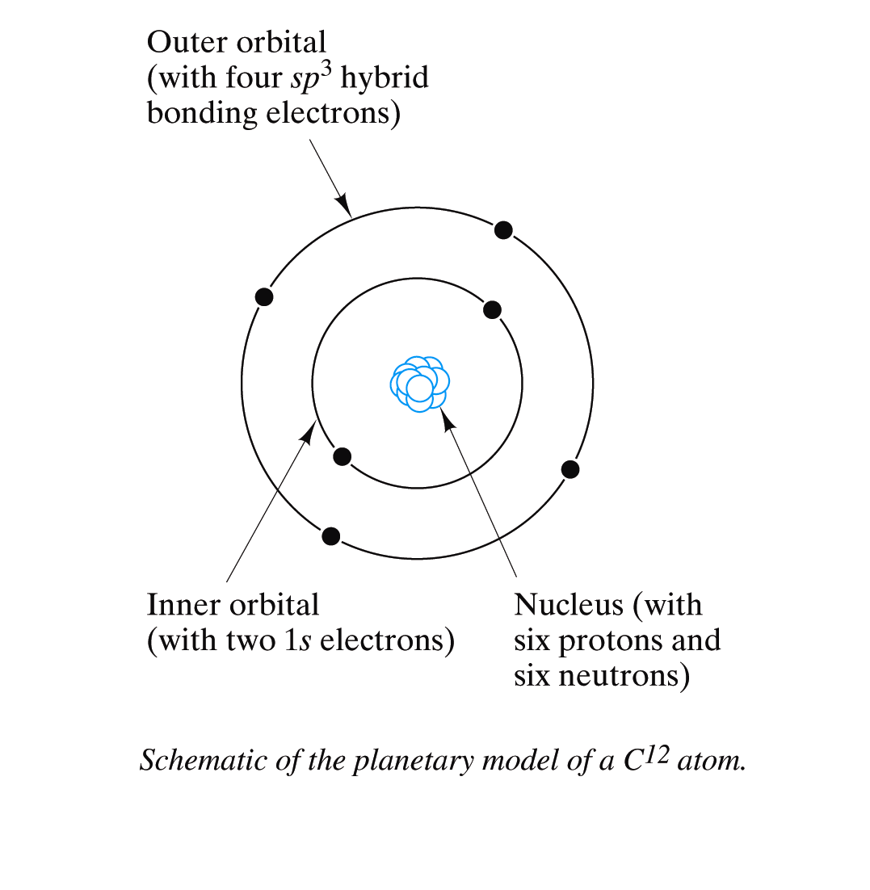

The electrons can only take on certain discrete values of energy. These energy levels correspond to the fixed binding energy between the electron and its nucleus. Any value other than these permitted values is forbidden.
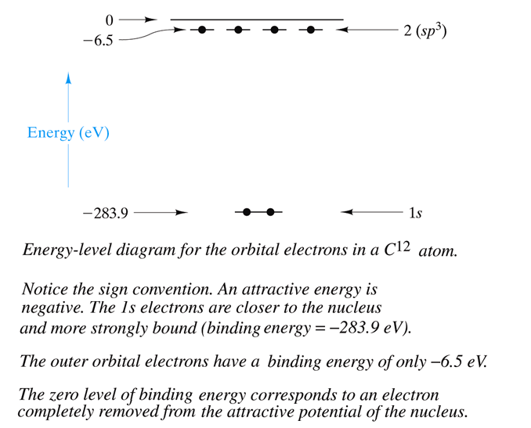

As brilliant as this Bohr model was, it did not completely describe the electrons surrounding the nucleus of an atom. Further observations revealed that electrons move more like a cloud surrounding the nucleus rather than like an individual planet in orbit. In other words the position of the electron is described by a probability distribution around the nucleus rather than a specific path. This probability distribution or “cloud” is called an orbital, sometimes referred to as an energy state. There are different types of orbitals, each with a distinctive shape.

The electron cloud model is a newer, better version of the Bohr model.
- In this electron cloud model the discrete energy levels of the Bohr model are now called shells.
- Each shell has subshell(s).
- The higher the shell (and hence higher energy), the more subshells it will have.
- Each subshell has a fixed number of orbitals it can hold.
- Each orbital can hold only two electrons.
- An orbital is also called an energy state.

Subshells and orbitals
The first subshell of any shell is called the s subshell which can only hold one orbital.
So a fully-filled s subshell will contain only two electrons.
The shape of this orbital is spherical.
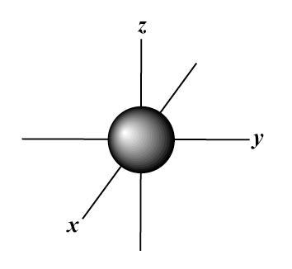

The next subshell is called the p subshell which can hold three orbitals.
A fully-filled p subshell will contain six electrons.
The shapes of these three p orbitals are like dumbbells, arranged at right angles to each other. Or a teardrop petal shape with the point towards the nucleus.
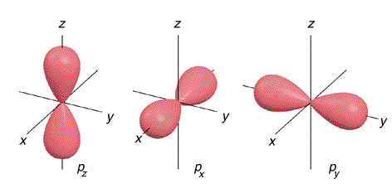

The next subshell is called the d subshell which can hold five orbitals.
A fully-filled d subshell will contain ten electrons.
The shape of the five d orbitals are similar to the p orbital shape, but with more 'petals' like a clover leaf. They can also have ring shapes around the base of the petals.
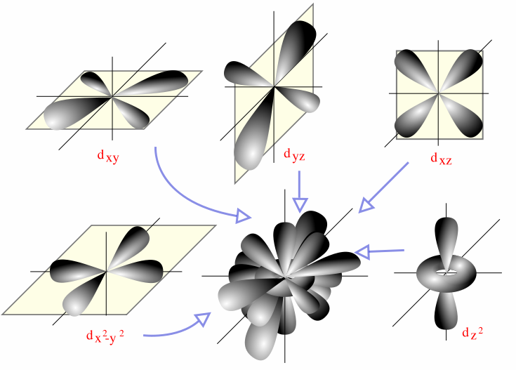

The next subshell is called the f subshell which can hold seven orbitals.
A fully-filled f subshell will contain fourteen electrons.
These are the shapes of the seven f orbitals. They tend to look similar to d orbitals, but with even more 'petals'.
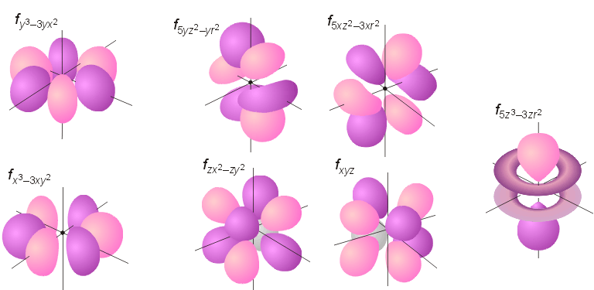

Further subshells are designated alphabetically: g, h, i, etc.

Esoteric note:
An atomic orbital is actually a mathematical function that describes the wave-like behavior of an electron in an atom. This function can be used to calculate the probability of finding any electron of an atom in any specific region around the atom's nucleus. The term "orbital" has become known as either the "mathematical function" or the "region" generated with the function. Specifically, atomic orbitals are the possible quantum states of an individual electron in the electron cloud around a single atom, as described by the function.

Quantum Numbers

The electrons in the orbitals surrounding an atom can be characterized by a unique set of four parameters called quantum numbers. The four quantum numbers, n, l, m and s can be used to describe any electron in a stable atom. These numbers determine the shell (energy level), the subshell and the orbital of the electron along with something called the spin which indicates whether the electron is spinning clockwise or counter-clockwise.

Principle Quantum Number, n
The first of these quantum numbers is the principle quantum number, n, which designates the main shell or main energy level.

The values of n are the integers from 1 to 7.
They value of n can also be designated by letters:
- n=1 corresponds to n=K
- n=2 corresponds to n=L
- n=3 corresponds to n=M
- n=4 corresponds to n=N
- n=5 corresponds to n=O
- n=6 corresponds to n=P
- n=7 corresponds to n=Q

Higher values of n mean more energy for the electron and the corresponding radius of the electron cloud or orbital is further away from the nucleus.

This is the only quantum number that the Bohr model accounts for.

Azimuthal Quantum Number, l
The second of these quantum numbers is called the angular momentum quantum number, the azimuthal quantum number or the subsidiary quantum number, l, which designates the subshell or sub-energy level.

The number of subshells is determined by the value of n.
The allowable values of l are the integer values from 0 to (n - 1).
The values of l can also be designated by letters:
- l=0 corresponds to l=s
- l=1 corresponds to l=p
- l=2 corresponds to l=d
- l=3 corresponds to l=f
- l=4 corresponds to l=g
- l=5 corresponds to l=h
- l=6 corresponds to l=i

This quantum number is related to the shape of the electron cloud.

Magnetic Quantum Number, m
The third of these quantum numbers is called the magnetic quantum number, m, which designates the orbitals for each subshell. (Orbitals are also sometimes referred to as energy states.)

The number of orbitals (states) is determined by the value of l.
The allowable values for these states are the integers from –l to +l.

In the absence of an external magnetic field, the states (orbitals) within each subshell are identical. However, when a magnetic field is applied these orbitals split, each one assuming a slightly different energy.

This number determines the orbital's orientation in space. For example, p orbitals correspond to l=1, can have m values of -1, 0, 1. This would represent three different orientations in space for the twin petals of the p orbital shape. They are usually defined to be p_{x}, p_{y}, p_{z} to represent the axes they align with.

Electron Spin Quantum Number, s
The third of these quantum numbers is called the electron spin quantum number, s, which designates the spin moment.

There are only two values: +½ and -½.
These are also referred to as 'spin up' and 'spin down'.

This number is used to explain behavior of individual electrons as if they were spinning in a clockwise or counterclockwise.

Two rules about how electrons fill orbitals
Pauli Exclusion Principle – Each electron state (orbital) can hold no more than two electrons and they must have different spins. In other words, no two electrons in an atom can have the same four quantum numbers.

Hund’s Rule – Electrons will avoid sharing the same state. i.e. every orbital in a subshell is singly occupied with one electron before any one orbital is doubly occupied, and all electrons in singly occupied orbitals have the same spin.

In summary:
- Electrons in an atom reside in discrete energy levels represented by a set of 4 quantum numbers (n, l, m, s).
- The Bohr energy levels are represented only by the principle quantum number, n.
- Quantum mechanics separates the Bohr levels into subshells as dictated by the subsidiary quantum number, l.
- The magnetic quantum number, m, dictates the number of energy states (orbitals) within each subshell.
- An orbital can hold only 2 electrons each with a different spin number.
- The size, shape and spatial orientation of an electron’s probability density are specified by the first three quantum numbers n, l, and m.
- In general electrons will fill up the lower energy orbitals first.
- An electron shell can accommodate 2n² electrons.
Allowable Values of Quantum Numbers

main quantum number  n | 1 | 2 |  |  |  | 3 |  |  |  |  |  |  |  |  | 4
Subsidiary quantum number  l | s | s | p |  |  | s | p |  |  | d |  |  |  |  | s | p |  |  | d |  |  |  |  | f
magnetic quantum number  m_{l} | 0 | 0 | -1 | 0 | +1 | 0 | -1 | 0 | +1 | -2 | -1 | 0 | +1 | +2 | 0 | -1 | 0 | +1 | -2 | -1 | 0 | +1 | +2 | -3 | -2 | -1 | 0 | +1 | +2 | +3
electron spin number  m_{s} | Each magnetic quantum number has 2 spin numbers: +1/2 and -1/2 (sometimes just designated as up and down)

Allowable Values of Quantum Numbers (cont.)

main quantum number  n | 5
Subsidiary quantum number  l | s | p |  |  | d |  |  |  |  | f |  |  |  |  |  |  | g
magnetic quantum number  m_{l} | 0 | -1 | 0 | +1 | -2 | -1 | 0 | +1 | +2 | -3 | -2 | -1 | 0 | +1 | +2 | +3 | -4 | -3 | -2 | -1 | 0 | +1 | +2 | +3 | +4
electron spin number  m_{s} | Each magnetic quantum number has 2 spin numbers: +1/2 and -1/2 (sometimes just designated as up and down)

Electron Configuration
The configuration of electrons in an atom is the manner in which electron states (orbitals) are occupied. In general electrons will fill up the lower energy orbitals first.

The energy of the orbitals increase with both the principle quantum number, n, and the subsidiary quantum number, l, however, there is some overlap as you can see in this diagram.

7p
6d
5f
7s
6p
5d
4f
6s
5p
4d
5s
4p
3d
4s
3p
3s
2p
2s
1s

energy is increasing in this direction
Here is another diagram showing the order of increasing energy for orbitals.
However, it also gives you an easy way to determine the order.
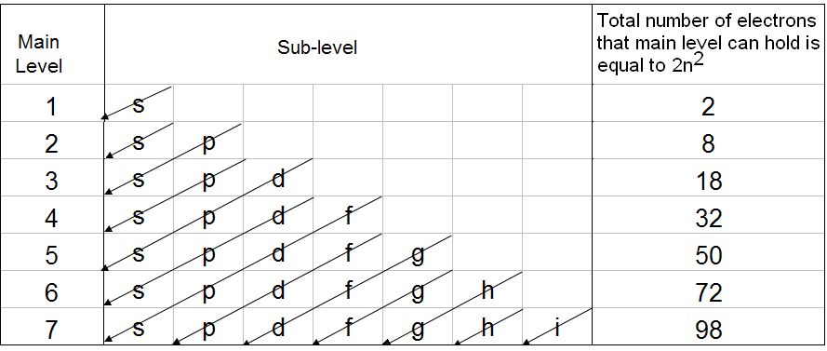

An electron configuration is a code that describes how many electrons are in each energy level of an atom and how the electrons are arranged in the orbitals within each energy level.

For example the electron configuration of Na which has 11 electrons is
1s²2s²2p⁶3s¹

Chemistry Review – More Vocabulary & Concepts

photon –a discrete bundle (or quantum) of electromagnetic energy.

Other facts about photons:
- they can be destroyed/created when radiation is absorbed/emitted
- they are elementary particles with zero mass and zero rest energy
- they are electrically neutral
- they are always in motion with constant velocity of light in free space
- they can have particle-like interactions (i.e. collisions) with electrons and other particles.
- fun fact: they are one of the rare particles that are identical to their antiparticle, the antiphoton.

Electrons are able to move from one energy level to another by emission or absorption of a quantum (discrete amount) of energy, in the form of a photon. The amount of energy can be calculated by Planck’s equation:
ΔΕ = hν = h c/λ

where:

h = Planck’s Constant, 6.63x10⁻³⁴Js

ν = frequency of photon

c = speed of light, 2.99 x 10⁸m/s

λ = wavelength of photon

This equation gives the amount of energy (in the form of electromagnetic radiation) needed for an electron to transition from one energy level to another. If the electron transitions to a higher energy level, i.e. farther from the nucleus, energy is absorbed, if the electron transitions to a lower energy level, energy is released.

ionization energy – The energy necessary to remove an electron from its orbital to an infinite distance from the nucleus of the atom.

ground state - The state in which all the electrons of an atom are in the lowest energy levels.

valence electrons – Electrons in the outermost orbitals of atoms that take part in bonding.

hybrid sp^{n} orbitals – Sometimes the s and p orbitals combine. n = number of p orbitals involved in the combination. The driving force behind this is a lower energy state for valence electrons.

For example, we would expect C¹² to have the electron configuration: 1s²2s²2p². But the s orbital and the three p orbitals combine to give 4 orbitals of equal energy called sp3 orbitals. So the electron configuration is 1s²2sp3⁴.

Note: It is this sp3 hybrid orbital that determines the 109º (or tetrahedral) bond angle found in the polymeric chains.
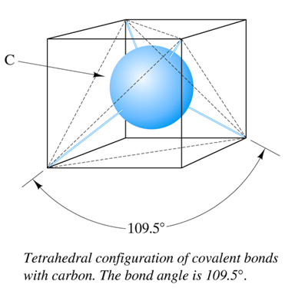

The Periodic Table

The periodic table is a brilliant arrangement of the elements according to their electron configurations.
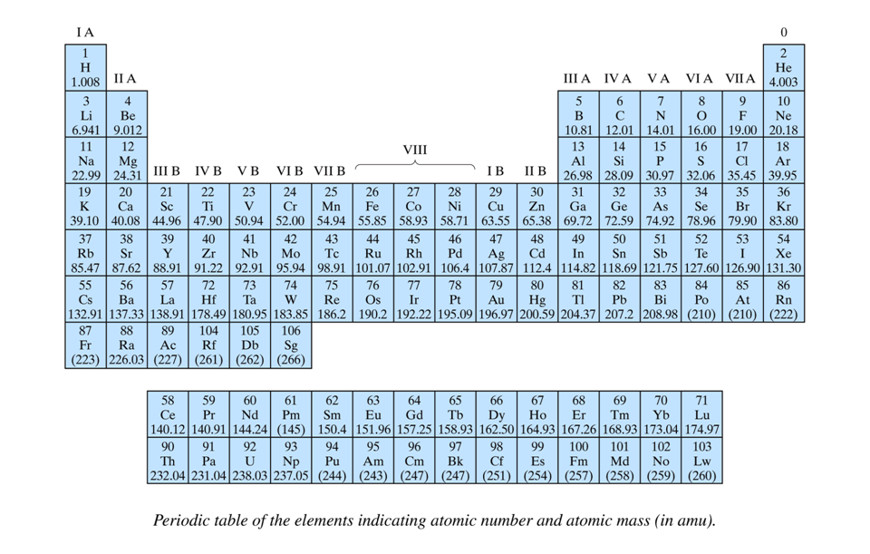

periods – The rows of the periodic table. The first element in a period of the Periodic Table introduces a new principle (main) energy level.

groups – The columns of the periodic table. These elements have similar electron configurations, and hence, have similar properties.

stable electron configuration – one in which the outermost orbitals of an atom are completely filled.

inert gasses – Group 0 elements. These elements have very high chemical stability due to the fact that their outermost orbitals are completely filled, i.e. they have stable electron configurations.

Halogens – Group VII elements. These elements have one less electron than needed for a stable electron configuration.

Alkali metals – Group IA elements. These elements have one more electron than needed for a stable electron configuration.

Alkali earth metals – Group IIA elements. These elements have two more electrons than needed for a stable electron configuration.

Transition Metals – Elements in the period between IIIB and IIB. These elements have partially filled d electron states.

electropositive element – One that has tendency to give up electrons in a chemical reaction to produce cations. Electropositive elements are metallic in nature.

electronegative element – One that has tendency to accept electrons in a chemical reaction to produce anions. Electronegative elements are non-metallic in nature.

positive oxidation number – The number of electrons that an element gives up in a chemical reaction.

negative oxidation number– The number of electrons that an element accepts in a chemical reaction.

electronegativity – The degree to which an atom attracts electrons. The scale goes from 0 to 4.1. The higher the electronegativity, the more electronegative or nonmetallic, the element is. The lower the electronegativity, the more electropositive or metallic, the element is.
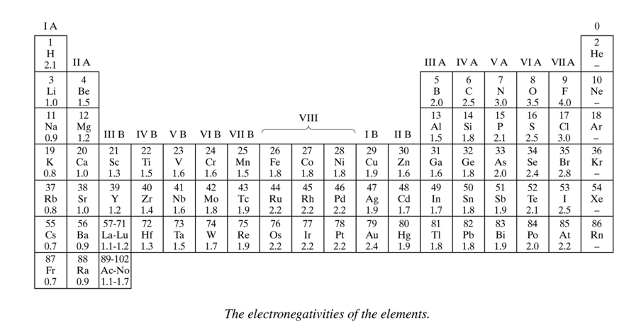
Bond Forces and Bond Energies

The following discussion applies to all types of atomic bonds, primary and secondary.

Consider two atoms approaching each other. As their separation distance, a, decreases, the forces acting between the two atoms change.

The net force, F_{N}, is the sum of an attractive force, F_{A}, and a repulsive force, F_{R}.
F_{N} = F_{A} + F_{R}
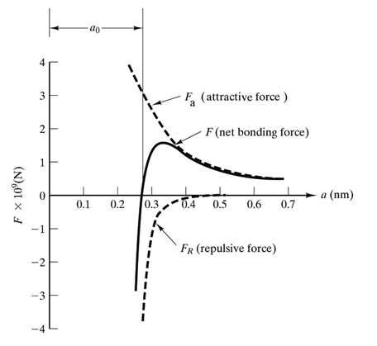

The attractive force, F_{A}, depends on the type of bonding involved. However, the shape of the curve is the same for all bonding. For the specific case of ionic bonding the attractive force is a Columbic force of attraction.
F_{c} = -k_{o} Z₁q Z₂q / a² where k_{o}=9x10⁹Vm/C

The repulsive force, F_{R}, is from the Columbic repulsion of the electron fields around the atoms.
F_{R} = λe^{-a/ρ} where λ and ρ are constants

The potential energy between the two atoms is given by: E = ∫ F da or F = dE/da
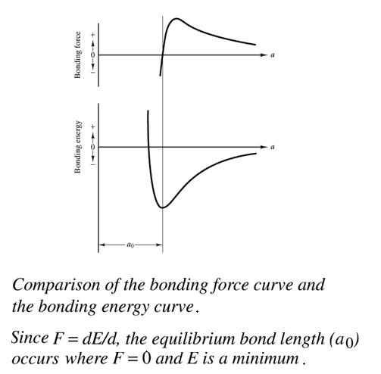

When F_{N} = 0, the configuration is stable and the atoms are at their equilibrium separation a_{o}. At this point E is at a minimum value, E_{o}, called the bond energy for the two atoms involved in the bond.

When there are more than two atoms in a bond, the picture is more complex, however, there is still a bond energy. This energy will depend on the type of atomic bonding.

Many material properties depend on the bond energy curve:
- Materials with large E_{o} will typically have high melting temperatures.

- Materials with steeper slopes around a_{o} will be “stiff”. Shallower slopes mean more flexible materials.

- Materials with deep and narrow troughs will have low coefficient of thermal expansion and relatively small dimensional alterations for changes in temperature.
Primary Atomic Bonds

There are three types of primary atomic bonds.

Ionic

Covalent

Metallic

These bonds involve the transfer or the sharing of valence electrons. The bonding type will be determined by the electron configuration of these valence electrons.

Ionic Bonding
Ionic bonding is between a metal and a nonmetal. Alternatively, one can say it is a bond between electropositive and an electronegative elements.

Electrons are transferred to produce a more stable electron configuration in each of the bonding atoms. The result is cations and anions.

The force of attraction is Columbic in nature for ionic bonding.
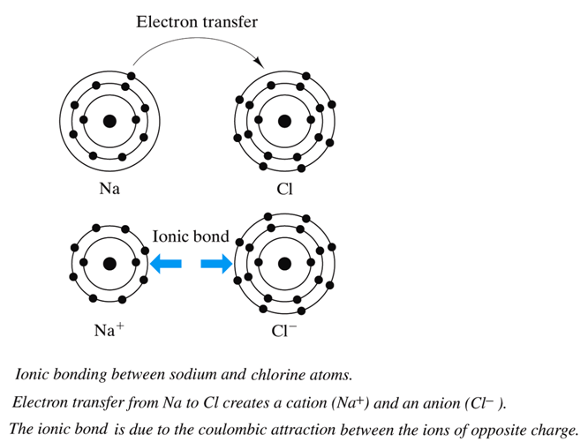
The bond length is a_{o} = r_{ion} + r_{cation} where r_{ion} and r_{cation} are the radii corresponding to the average electron density in the outermost electron orbital.
The bond is non-directional, i.e. the magnitude of the bond force is the same in all directions around an ion.
The fact that this type of bonding is a non-directional bond means that it tends to maximize packing efficiency. This leads to large coordination numbers.
(The coordination number, CN, of an atom is the number of nearest neighbors at equal distances.)
E_{o} is relatively large giving high melting temperatures to these materials.
Materials with this type of bonding tend to be hard and brittle. Also electrically and thermally insulative.

Note that the ionic radii differ from the atomic radii more than one would expect:
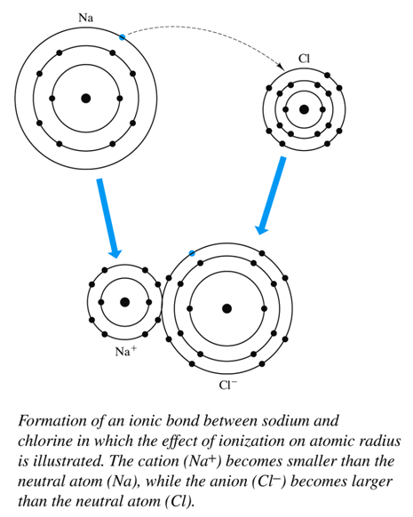

Coordination Numbers predicted from Radius Ratios
For non-directional bonds, CNs are predicted by the radius ratio which is the ratio of the smaller ion to the larger ion in the bond, r/R.

Since ionic bonding tends to maximize packing efficiency, the CN is limited only by the relative size of the ions and by the need to maintain charge neutrality for the solid.

Considering only the radius ratio (and ignoring the need to maintain charge neutrality for now) we can predict the CN for atoms in ionic bonds.
We need to consider many larger ions will “fit” around the smaller one. (Since this is a more restrictive case.)

Consider a CN of 1. What is the minimum r/R?
Answer: 0! (The smaller ion can have essentially a zero radius.)
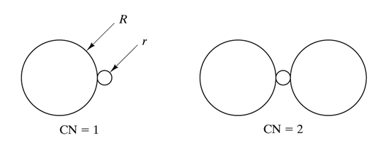
For a CN of 2, what is the minimum r/R?
Answer: 0! (The smaller ion can have essentially a zero radius.)

For a CN of 3, what is the minimum r/R?
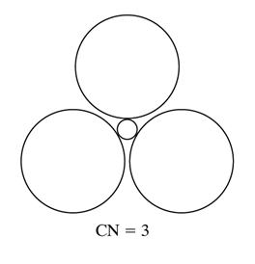
It is restricted by the geometry. With some geometry and trig calculations you should be able to conclude that r/R ≥ 0.155 giving a minimum radius ratio of 0.155 for a CN of 3.
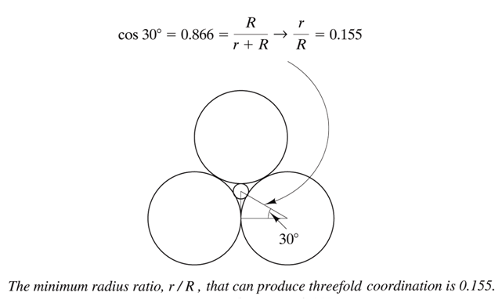
Table of CN and corresponding range for r/R
Here is a table giving the Coordination number corresponding to different ranges of radius ratios. Note that the lower bound of the range is the radius ratio for the CN. The upper bound is just the lower bound on the next CN.

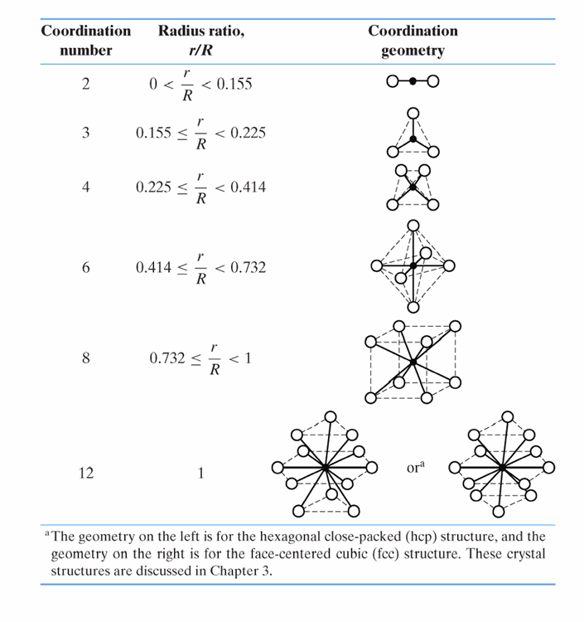
Covalent Bonding
Covalent bonding is between elements whose electronegativities are not too different.

Electrons are shared so that each atom attains a stable electron configuration.

A covalent bond is an instance of a pair of electrons being shared by two atoms. (For example in chlorine gas.)
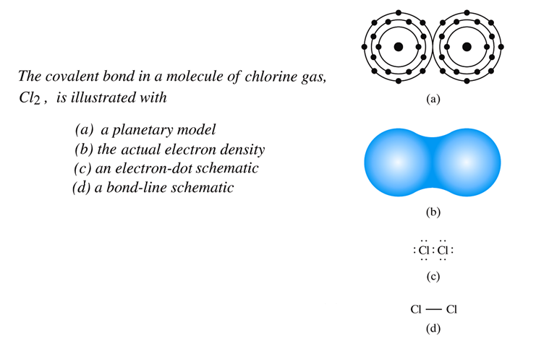

Atoms can share more than one pair of electrons. If they share two, we have a double covalent bond. (For example in the ethylene molecule.) Three makes for a triple covalent bond. Carbon has four covalent bonds between each atom.

The number of covalent bonds possible is 8 – N’ where N’ is the number of valence electrons.

This is a highly directional bond, i.e. it exists between specific atoms and may exist only in the direction between one atom and another that participates in the electron sharing.

The directionality means that this bonding does not maximize packing efficiency and so CN tend to be low. For example Diamond has CN = 4, not 12 as would be predicted by r/R = 1. This is due to the highly direction nature of the bond angle. There are 4 equally spaced sp3 orbitals around the carbon atom make for a bond angle of 109º.

E_{o} can be strong or weak.

Most covalent bonding has some ionic character and visa-versa. The greater the difference between the electronegativities, the more ionic the bond will be. The percentage of ionic character is given by this equation:
% ionic character = (1 - e ^{–0.25(xA - xB)2}) x 100

Metallic Bonding
Valence electrons are not bonded to any particular atom but belong to the whole solid. These electrons are termed “delocalized” or “free”. They are also referred to as a “sea” or “cloud”. They act as glue for the positive ion cores.

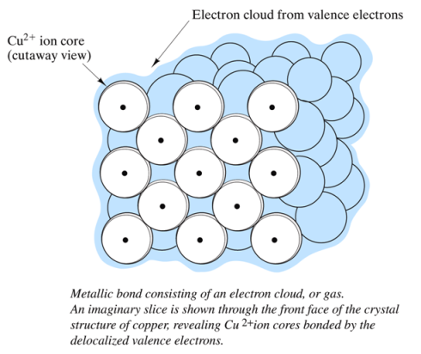

The metallic bond is non-directional. Therefore it tends to maximize packing efficiency. CNs are determined primarily by efficient packing considerations. This is why most metals have CN = 12 (as predicted by r/R =1).

E_{o} can be strong or weak.

The free electrons are the basis for high electrical and thermal conduction values.

In general, the fewer the valence electrons per atom involved in the bond, the lower the bond energy and melting temperature.

Metals are ductile because they can slide without completely disrupting the structure.
Secondary Bonding
Secondary bonding is also called van der Waals bonds. The primary bonding types are considered chemical bonds. Secondary bonding is considered to be or physical bonds.

Secondary bonding arises from molecular (electric) dipoles and their columbic attraction for each other.
μ = q d (q d (units are debye = 3.34 x 10⁻³ Coulomb-meters)
This is much weaker than primary atomic bonding although the bonding force and bonding energy curves have the same basic shapes.

Secondary bonds may be between:
- induced dipoles and induced dipoles (also called temporary or fluctuating dipoles)
- induced dipoles and permanent dipoles (polar molecules)
- permanent dipoles and permanent dipoles

The attraction of inert gasses is an example of number 1.
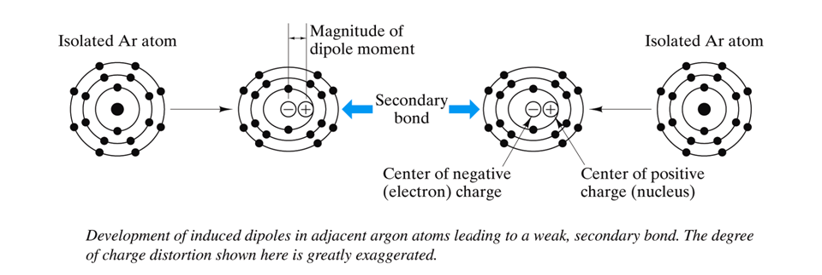
In fact it is these temporary dipole moments that cause inert gases to deviate from being true ideal gasses. (An ideal gas has absolutely no inter-atomic attractive forces.)

Hydrogen bonding is a special case of number 3.
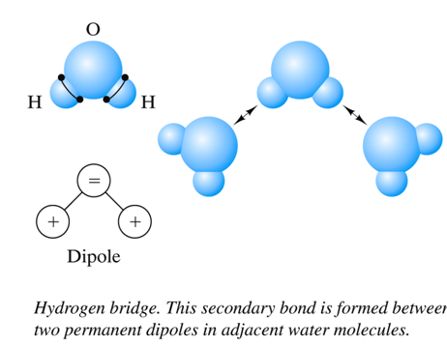

When Hydrogen is covalently bonded, there is a “naked” proton that strongly attracts the negative end of an adjacent molecule. This is a relatively strong force. Because of Hydrogen bonding, HF and water are liquids at ambient temperatures instead of gasses. Life as we know it would not be possible without this Hydrogen bonding. (Sometimes called a Hydrogen Bridge.)

A molecule is considered to be a group of atoms bonded together by strong primary bonds. So ionic and metallic solids are sometimes considered to be one large macromolecule. However, covalent substances are not because the large molecules have secondary bonding between them.

Mixed Bonding

As so often in life, things are not always pure. Many atomic bonds have mixed character.

Ionic-Covalent Mixed Bonding
Sometimes covalent bonding has ionic character or visa-versa. The amount of ionic character in a bond can be calculated by: % ionic character = (1 - e ^{–0.25(xA - xB)2}) x 100

Metallic-Covalent
The transition metals have mixed metallic-covalent bonding involving dsp orbitals.
Note that the group 4A elements have a gradual transition from pure covalent bonding (C – diamond) to some metallic character (Si, Ge) to primarily metallic bonding.

Metallic-Ionic
If there is a significance difference in the electronegativity of elements that form an inter-metallic compound, there may be a significant amount of electron transfer and hence some ionic character in the bonding.

Ionic-Covalent-Metallic

Sometimes there can be characteristics of all three types of primary bonds in a single atomic bond.

