Imperfection in Solids
Nothing is perfect. The crystalline structures that we have looked at all have imperfections. We will quantify these imperfections here.

Crystalline Defects
A crystalline defect is a lattice irregularity having one or more of its dimensions on the order of an atomic dimension. There are 5 major categories of crystalline defects:
- Zero dimensional: Point defects
- One dimensional: Linear defects (dislocations)
- Two dimensional: Planar (surface) defects
- Three dimensional: Volume (bulk) defects
- Vibrations

Point Defects
Point defects allow for diffusion to occur in the solid state.

There are different categories of point defects:
- vacancy
These are produced by thermal vibrations of the crystal lattice and/or from need to maintain charge neutrality.
- self-interstitial or interstitialcy
A position on the crystal lattice that is not normally occupied is called an interstitial site. If it is occupied by the same atomic species it is a self-interstitial or self-interstitialcy. It creates large distortions in the crystal lattice and so the concentrations are small.
- impurities
- solid solutions – homogeneous single phase materials that are completely analogous to a liquid solution (alcohol and water)
- solute /solvent /solubility – miscibility
- random solid solution vs. ordered solid solution
- substitutional solid solution (Cu/Ni) vs. interstitial solid solution (Fe/C -
α Iron has 0.025% C and γ iron has 2.08% C)
- nonstoichiometric compounds (Fe_{1-x}O)
- second phases – completely analogous to a liquid mixture (oil and water)
- Hume-Rothery Rules – used to predict solubility (miscibility):
- less than 15% difference in atomic radii
- same crystal structure
- similar electronegativities
- same valence

- Schottky defect - a pair of oppositely charged ion vacancies
- Frenkel defect - a vacancy-interstitialcy combination

Linear Defects (Dislocations)
A line defect is a lattice distortion created about a line formed by the solidification process, plastic deformation, vacancy condensation or atomic mismatch in solid solutions.

Dislocations explain the observation of plastic deformation at lower stress than would be required in a perfect lattice. They also explain the phenomenon of work hardening.

There are different categories of point defects:
- Edge dislocation
- b is perpendicular to dislocation line
- there will be tensile & compressive strain fields in the crystal lattice in their vicinity
- Screw dislocation
- b is parallel to dislocation line
- there will be shear strain fields in the crystal lattice in their vicinity
- Mixed dislocation
- b is at an oblique angle to dislocation line
- strain fields will be T, C and S
The Burgers Vector, b, quantifies the magnitude and direction of the structural defect. It is the displacement vector necessary to close a step-wise loop around the defect. For common metals this is the repeat distance along the highest atomic density direction. Equivalently, the Burgers vector denotes the direction and magnitude of the atomic displacement that occurs when a dislocation moves.

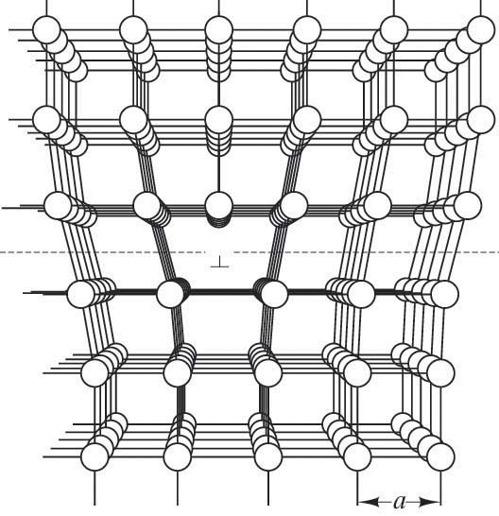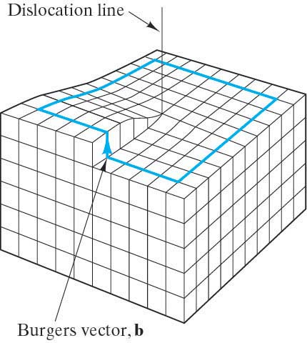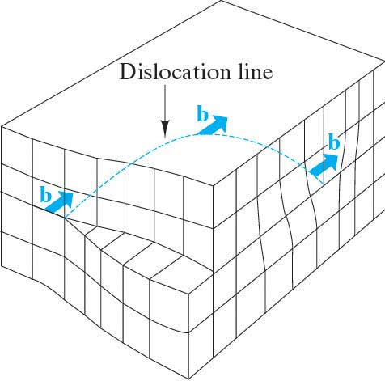

Planar (Interfacial) Defects
- External surfaces
Atoms at any surface are not in their perfect crystal positions because they will have different CN than the atoms inside the volume of the material. Hence these atoms will be at higher energies. During solidification materials try to minimize this.
- Grain boundaries
Grains are formed during the solidification process. A grain boundary is the area of mismatch between volumes of material that have a common orientation of the crystallographic axes. The atoms at grain boundaries are not in their perfect crystal positions and hence the grain boundary is less dense. These atoms are at higher energies than the atoms inside the volume of a grain. The thickness in on the order of 2-5 atoms wide.
There are different categories of grain boundaries:
- low angle tilt boundary – a few isolated edge dislocations
- high angle tilt boundary – more complex
- coincident site lattice (CSL) – there is registry between the two adjacent crystal lattices in the vicinity of the boundary region.
- Σn boundary means 1 in n atoms are coincident with an adjacent grain’s lattice. Σ5 is a common boundary of 36.9º
- These boundaries will tend to consist of regions of good correspondence (where n in Σn is low) separated by grain boundary dislocations (GBD)
- GBDs are linear defects within the boundary plane. They might be secondary in that they have Burgers vectors different from those found in the bulk material (primary dislocations)
At ambient temperatures, grain boundaries give strength to a material. So in general, fine grained materials are stronger than coarse grained ones because they have more grain boundaries per unit volume. However, at higher temperatures, grain boundaries act to weaken a material due to corrosion and other factors.
Grain size can be quantified by
- ASTM grain size number
- Average grain diameter
- Grain density
The size and shape of grains are determined by a number of factors during solidification:
- Lots of nucleation sites ⇒ fine grains
- Fewer nucleation sites ⇒ coarse grains
- Equal growth in all directions ⇒ equiaxed grains
- Thermal gradients ⇒ elongated or columnar grains
- Slow growth ⇒ coarse grains
- Rapid growth ⇒ fine grains
Most materials are polycrystalline (or polygranular). There are some applications where the expense and time to produce single crystal materials (and hence no grain boundaries) is justified:
- Turbine blades
- Silicon wafer chips
- Twin boundaries – a special type of grain boundary across which there exists a mirror image of the crystal lattice. It is produced by mechanical shear stresses and/or annealing some materials
- Stacking faults – the interruption of the stacking sequence of close packed planes.
- Phase boundaries - The surface area between the grains in multiphase materials
- Ferromagnetic domain walls – The boundary between regions that have a different orientation of magnetic dipoles.

Volume (Bulk) Defects
These are introduced during processing and fabrication.
- Pores
- Cracks
- Foreign inclusions

Noncrystalline solids
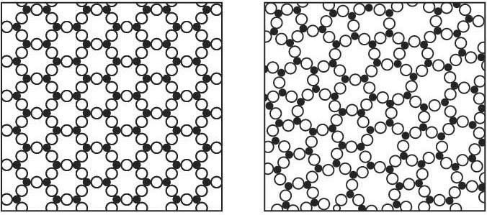
- The Zachariasen model is the visual definition of the random network theory of glass structure (which is analogous to the point lattice associated with crystal structure). It is “perfectly” random, although it does have short-range order (SRO) as the building block of the crystal is retained. (e.g. AlO₃³⁻ triangles)
- Synonyms for noncrystalline: amorphous, vitreous, glassy, short-range order
- Materials processed to avoid crystallization can have desirable unique props.
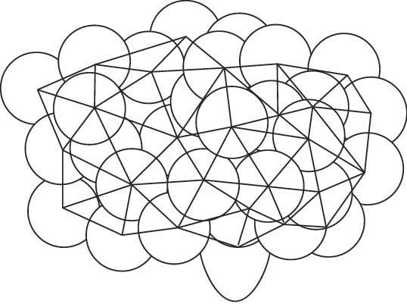
- Amorphous Metals (Metallic glasses) have high strengths and corrosion resistance due to lack of grain boundaries (but the process is expensive). The Bernal Model is helpful in visualizing this structure.
- Amorphous semiconductors – economical (but complex electronic props).

- Medium-range order refers to a tendency for some structural order to occur in the medium ranges of a few nanometers. This can occur in common glasses containing significant amounts of modifiers such as Na₂O and CaO. For example CaO-SiO₂ glass has CaO₆ octahedra share edges in a regular arrangement. This is in contrast to the random distribution of Na⁺ ions in the random network model that describes vitreous SiO₂

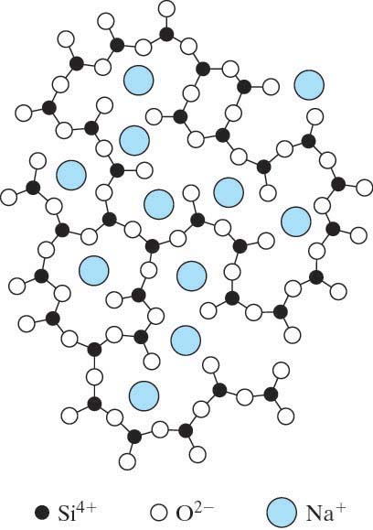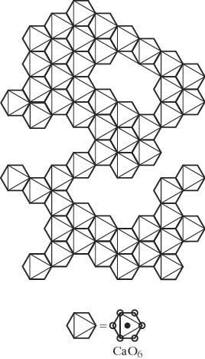
Atomic Vibrations
At any temperature above absolute zero, the atoms in a solid are vibrating very rapidly about their lattice positions. These vibrations are considered to be defects in the material. At room temperature a typical vibration frequency is 10¹³ vibrations/sec and the amplitude is 0.003 nm.

Temperature is a measure of the average vibrational energy of the atoms in a material. In other words, an average energy, E_{ave}, is associated with the atoms in a material at any given temperature. The higher the temperature, the higher is this average energy.

However, not all of the atoms have the average energy associated with the given temperature. Some will have an energy that is lower; others will have an energy that is higher. There will be a statistical distribution of the energies of all the atoms about the average energy for that temperature. Furthermore, an individual atom’s vibrational energy will vary randomly with time.

The percentage of atoms with energies above the average for a given temperature can be found with the Maxwell-Boltzmann distribution:

P ∝ e ^{- (E* - Eave) / kT}

P is the probability of finding an atom with energy E*. (E* is above E_{ave}, the average energy characteristic of a particular temperature.)

For a given E*, the probability of finding atoms with that energy will increase as the temperature increases. And of course for a given temperature, the probability of finding an atom with energy E* will be high if E* is close to E_{ave}.

