Diffusion
Diffusion is the material transport by atomic migration. Atoms move from an area of higher concentration to one of lower concentration. This is easy to imagine for gasses and liquids. It is harder to imagine in solids, but diffusion does occur in solids, just very slowly. For solids, diffusion requires the presence of point defects.

Point Defects
Point defects occur as a direct result of the thermal vibrations of atoms in the crystal structure. Hence as temperature increases, the number of point defects increases exponentially according to the Maxwell-Boltzmann distribution.

Hence, the concentration of point defects
(i.e. the number of defects / total number of atomic sites in the crystal lattice) is given by:

n_{defect} = Ce ^{– (Edefect) /kT}
n_{sites}

where
E_{defect} is the activation energy required to form the point defect
k is Boltzmann’s constant
T is absolute temperature

For a vacancy:
n_{v} = Ce ^{– (Ev) /kT}
n_{sites}

where E_{v} is the activation energy required to form the vacancy

There are only two mechanisms by which diffusion may occur in solids
- Vacancy Migration
  - Atoms move from a normal lattice position to a vacancy in the crystal lattice
  - Q_{vacancy migration} = E_{vacancy formation} + E_{motion}
- Random Walk
  - This involves an atom moving from one interstitial position to another in the crystal lattice
  - Not a common mechanism for self-diffusion
  - Usually faster than vacancy migration because atoms are smaller
  - Q_{random walk} = E_{motion}

Interdiffusion is the diffusion of an atomic species that is different than the atoms of the
crystal lattice that they are moving through.

Self-diffusion is the diffusion of an atom in its own crystal lattice.

Fick’s Laws quantify the process of diffusion
Diffusion is a complicated thing to quantify and describe because it is a function of many variables:
- temperature
- time
- position in the solid
- diffusion mechanism (vacancy, interstitialcy, interdiffusion, self-diffusion)
- crystal structure of the solvent
- path of diffusion (surface, grain boundary, volume, dislocation)
- concentration of the solute (usually negligible)

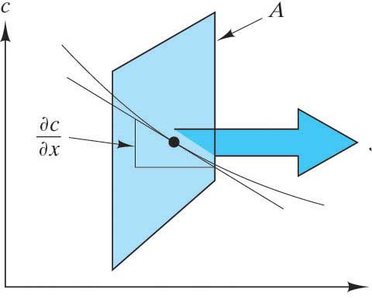
Fick’s 1st Law is for steady state processes:
(Steady state means that J_{x} does not change with time.)

${}_{J_{x}=−D\frac{∂c}{∂x}}$

J_{x} is the diffusion flux x
It is the number of atoms moving across a plane of area A in the x direction in a specific time interval.
It is also called the rate of mass transfer
$$\frac{1}{A}\frac{\text{dM}}{\text{dt}}$$
(units: atoms/m²/sec or kg/m²/sec)

c is the concentration of the diffusing atoms
It is a function of c_{o}, T, t, and x.
(units: atoms/m³)

∂c is the concentration gradient = Δconcentration = Δatoms/volume
∂x Δlength Δlength
It is the slope of the concentration profile.
(units: atoms/m⁴)

D is the Diffusion Coefficient, also called the Diffusivity
It is the proportionality constant between the diffusion flux and the concentration gradient for a steady state process
(units: m²/sec)

Diffusivity
The Diffusivity is a function of temperature. Since diffusion is a thermally activated process (it depends on point defects whose creation and motion are thermally activated processes) it stands to reason that the Diffusivity, D, would vary with temperature according to an Arrhenius form:
$D=D_{o}e^{−\frac{Q}{\text{RT}}}$

In this equation Q is the activation energy of diffusion and will depend on the diffusion mechanism – whether it is vacancy migration or random walk. It will also depend on the crystal lattice of the solvent.

Both Q and D_{o} are constants that will depend on the system of diffusion (solute and solvent) and the path of diffusion (surface, grain boundary, volume).

In general: Q_{volume} > Q_{grain boundary} > Q _{surface}
D_{o volume} < D_{o grain boundary} < D_{o surface}

Usually the volume diffusion dominates, however, for fine grained materials Q_{grain boundary} will dominate and for powders Q _{surface} will.

Particular values of activation energy will be found to be characteristic of process mechanisms. There may be many mechanisms occurring simultaneously and each will have a characteristic activation energy. The fact that one is representative of the experimental data means simply that a single mechanism is dominant. If the process involves several sequential steps, the slowest step will be the rate-limiting step.

Fick’s 2nd Law for non-steady state processes:
(This is more general and in fact, Fick’s 1st Law is a special case of Fick’s 2nd Law.)
$\frac{∂c_{x}}{∂t}=\frac{∂}{∂x}(D\frac{∂c_{x}}{∂x})$ = (if D in not a function of concentration)$D\frac{∂^{2}c_{x}}{∂x^{2}}$

The solution of this 2nd order partial differential equation is beyond the scope of this course. However we will consider a special case:

For the boundary conditions of:
- semi-infinite solid
- surface concentration, c_{s}, is constant

The solution is:
$$\frac{c_{x}−c_{0}}{c_{s}−c_{o}}=1−\text{erf}(\frac{x}{2\sqrt{\text{Dt}}})$$

where
x is the distance into the solid
c_{x} is the concentration of diffusing species at distance x
c_{o} is the initial bulk concentration of the diffusing species in the solid
c_{s} is the surface concentration (constant)
D is the Diffusivity
t is time
erf is the Gaussian Error function. (Your calculator might have it. If not, you can find tabulated values in the text book.)

This solution is applicable to the plating of metals or for the saturation of materials in reactive atmospheric gasses (e.g carburization).

