Kinetics and Heat Treatments in Metals
Phase Diagrams are limited in their usefulness because they can only predict the microstructure that will result for equilibrium conditions, i.e. very very slow cooling. Non-equilibrium cooling will result in different microstructures hence altered properties.

Let’s investigate what non-equilibrium cooling do to the microstructure and properties of metals. These non-equilibrium cooling processes are also called heat treatments or thermal processing. They are the temperature vs. time history.

Kinetics is the field of study that takes into account the time dependent aspect of a transformation. TTT diagrams are the tools that we can use to take into account the kinetics of the transformation. They show the relationship between time, temperature and (percent) transformation. There are two types of TTT diagrams:
- isothermal transformation (IT) TTT diagrams
- continuous cooling transformation (CCT) TTT diagrams

The IT TTT diagram for eutectoid steel
Recall the eutectoid reaction is:  (0.76wt% C) →  (0.022wt% C) + θ (6.67wt%C)
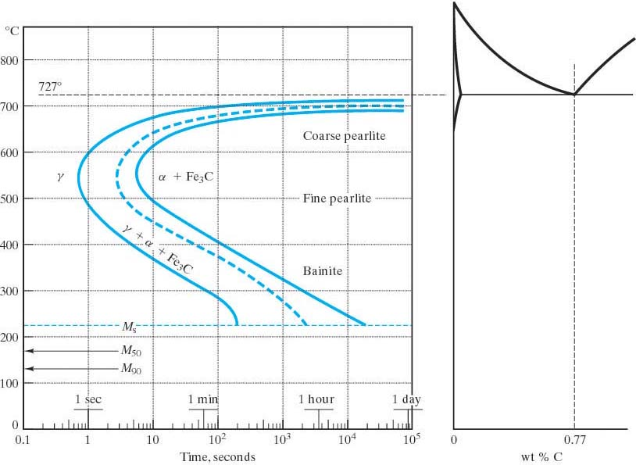

The presence of other alloying elements other than carbon (Cr, Mo, Ni, W, Mn, Si) may cause significant changes in the IT TTT. These include:
- shifting the nose to the right (longer times for the transformation to complete.)
- forming a separate banite nose
- shifting the T up or down.
Note that each TTT diagram is for a particular composition of steel.
A word about the shape of these “nose” curves (aka shoulder or knee curves):
The nose character is a result of reaction kinetics. The higher temperatures have sufficient diffusion rates for fast transformations, but lack the driving force of being far from the equilibrium temperature at which the reaction takes place. The lower temperatures have a high driving force since there is a great deal of undercooling, however, the diffusion rates are low. Hence it is the intermediate temperatures where the fastest reaction rates occur.

Mictostructures of Steel:
- Austenite – the fcc phase of Fe that can have up to 2% C in interstitial solid solution.
- Pearlite – the eutectoid microstructure of ferrite and cementite. There is coarse pearlite and fine pearlite. (These are relative terms as all eutectoid microstructures are typically fine grained.)
- Bainite – another eutectoid microstructure of ferrite and cementite. It has a different grain morphology than Pearlite. There is upper bainite and lower bainite that differs in the grain morphology as well. As you would expect, lower bainite is a finer grained material.
- Martensite – a metastable (non-equilibrium) single phase, supersaturated, interstitial, solid solution of C in Fe. It can be bct or bcc depending on the amount of C. It is the result of a diffusionless (time independent, instantaneous) transformation. (These types of transformations are sometimes called martensitic transformations, even when there is no martensite involved.) Martensite is extremely hard and extremely brittle. Think of a glass hammer. It is not really a practical material. It needs to be made more ductile in order to be able to use it. The microstructure of martensite will depend on the amount of C. Lathe martensite results with <0.6% C. It is long, thin grains called laths. Plate or lenticulor martensite is needle like or plate like grains. In general martensite is acicular or needlelike grains which is why it is so brittle.
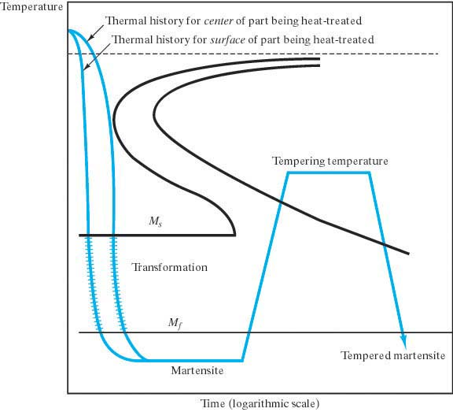
- Tempered Martensite – martensite that is given a heat treatment to increase the ductility. It is heated to a temperature below the eutectoid transformation temperature for a period of time. The specific temperature and length of time are variable. A corresponding decrease in strength will result, although the material is still very strong. The microstructure of tempered martensite is extremely small and uniform cementite in a continuous ferrite matrix. Be careful: Some steel alloys (Mg, Mi, Cr, An, P, Ar, Sn) will result in lower ductilities with a temper treatment. These shift the ductile to brittle transition temperature to a higher temperature. This is called temper embrittlement.
- Spheroidite – another structure of ferrite and cementite. It is formed by reheating pearlite or bainite to just below the eutectoid temperature to get a softer and more ductile material. The cementite becomes sphere-like particles in a continuous ferrite matrix. There is no change in composition or amounts of the ferrite and cementite.
The CCT TTT diagram for eutectoid steel
(Superimposed on an IT for comparison)
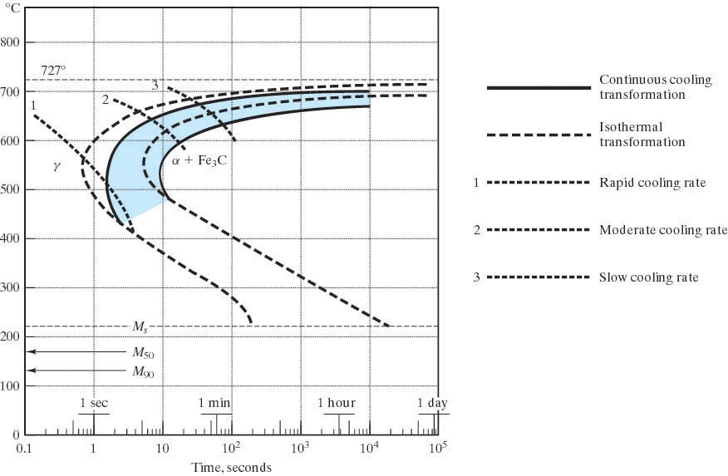
1 2 3 4

Consider the cooling rates 1-4. What will be the resulting microstructures?
Answer:
- 100% martensite (This is called the critical cooling rate. It is the slowest cooling rate that will produce 100% martensite.)
- ½ martensite, ½ pearlite (This is called a split transformation.)
- fine pearlite
- coarse pearlite
Note: there will be no bainite with a CCT.

There are some specific heat treatments for steel:
Martempering (marquenching) Austempering What microstructure
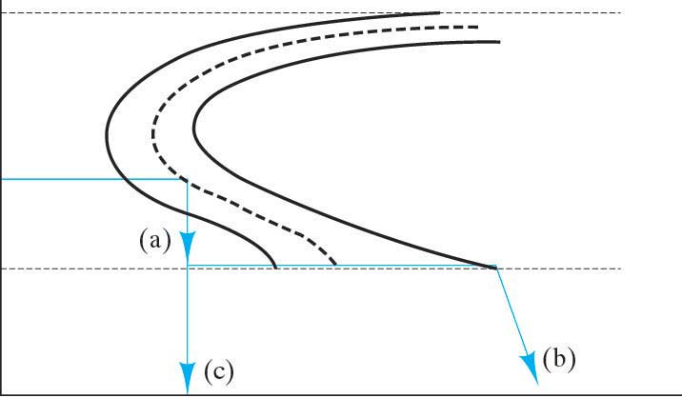
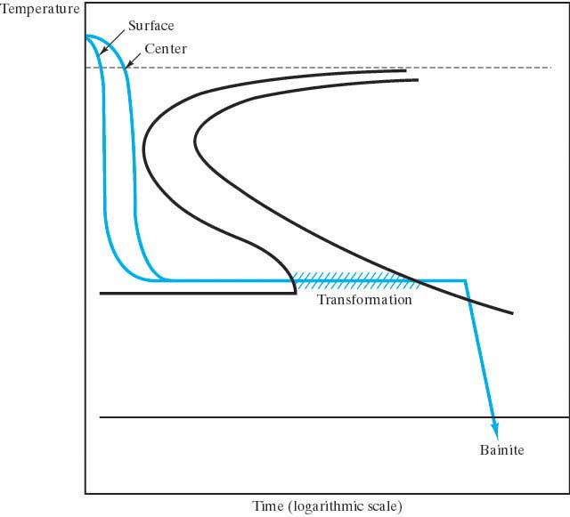
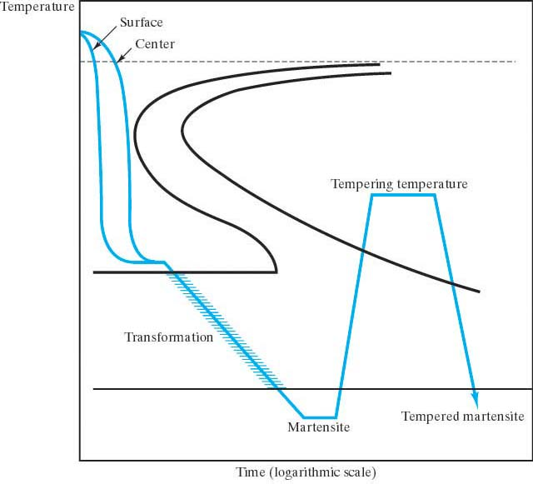
Resulting microstructure Resulting microstructure will result from these
is martensite. is bainite. heat treatments?

In General, we want the steel microstructure to result in Martensite!
This is because martensite is very hard and strong. To get Martensite, of course you must first austenitize and then quench. But to what extent are you assured of a Martensitic microstructure throughout? The factors that determine Martensite formation in a specimen:
- composition
- quench rate (furnace, air, water, oil)
- geometry
- size

The questions to ask are:
- What cooling rate is necessary to produce Martensite in the steel?
- What are the cooling rates that different points inside the specimen will experience?

Hardenability
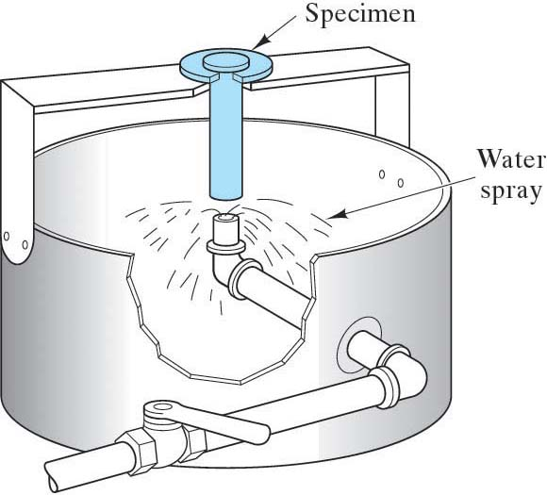
Is the relative ability of steel to be hardened by quenching. It is essentially a measure of the cooling rate at which martensite will form. If martensite will form for slow cooling rates, then the steel has a high hardenability.

The Jominy End Quench test is used to obtain Hardenability Curves
A Hardenability Curve for a particular steel will give the hardness as a function of cooling rate.
(Cooling rate is correlated to distance from the quenched end, d_{qe}.)

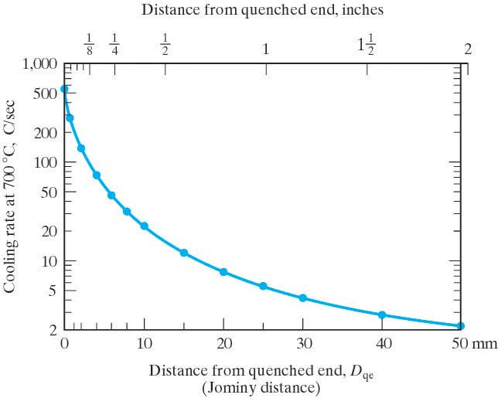
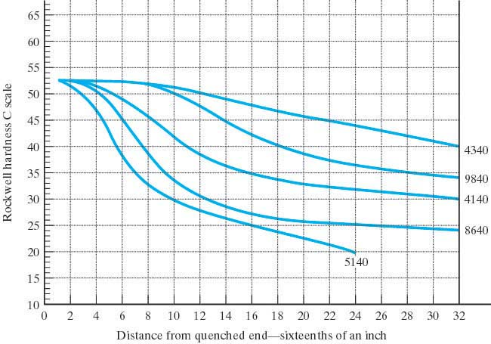

There are plots in the literature that you can use that will give you the cooling rates experienced for any point in a steel specimen of a particular size, geometry and quench. (The standard quenches are water or oil. Once the cooling rate is known, the hardness can be determined from the Hardenability curve.

Note: the larger the surface area to mass ratio of the specimen, the faster the cooling rates will be inside. So irregular shapes may have high hardenabilities.
Precipitation Hardening
aka Age Hardening or Precipitation Strengthening

Precipitation Hardening is a heat treatment in which the strength of an alloy is increased from introducing particles that act as obstacles to slip motion. Not all alloy systems are amenable to this strengthening mechanism. The alloy system must have:
- a terminal solid solution with decreasing solid solubility as temperature decreases
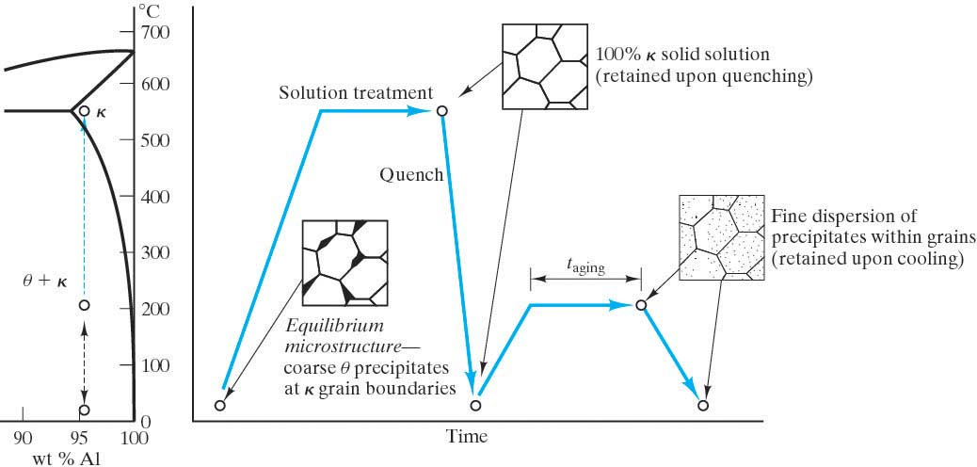
- a second phase that will act to impede the dislocation motion.

The procedure to produce the microstructure of a precipitation hardened alloy is:
- Solution Treat (Solutionize)
Heat to the point where you have a single phase solid solution.
- Quench
To get a metastable super-saturated solid solution.
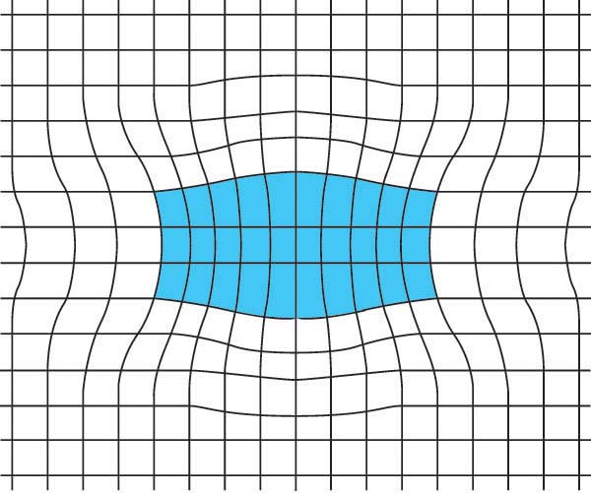
- Age (Precipitation heat-treat)
Heat at an intermediate temperature such that diffusion is appreciable for an appropriate amount of time in order to precipitate out the second phase particles. The nature of these second phase precipitates depend on the time and temperature of the aging process. You want the second phase particles to be of optimal size to produce the maximum obstacle to slip motion. This turns out to be when the size of the precipitate is such that the crystal structure of the precipitate and the matrix phase are coherent. These are called Gunier-Preston Zones.
- Cool

Be careful:
- Do not overage. (When ppts grow to a size where they do not add significant strength.)
- Do not put the material in an application where temperature may overage it.
- Be careful of natural aging (aging that can occur at room temperature. (As opposed to artificial aging which is when the material is inadvertenly put at an elevated temperature.)

Strain Hardening and Age Hardening can be combined.
Usually the steps are:
- Solutionize
- Quench Why this order?
- CW
- Age
Annealing
Annealing is a general term that refers to heating a material and then cooling it. The amount of heating, the time at the elevated temperatures, the rate of cooling are all essential to the final product. Care must be taken during the cooling because of the thermal gradient which might induce plastic deformation, warping, cracking.
For metals an annealing process will increase the ductility and decrease the strength. This could range from merely relieving residual stresses (recovery) to returning it to the condition it had before any plastic deformation was done to it so that it has a new, stress free low energy crystal structure (recrystallization.)

The 3 stages of a full annealing heat treatment:
- Recovery
  - Residual stresses and internal strain energy is relieved by dislocations moving into lower energy configurations
  - Strength decreases slightly and ductility increases slightly
- Recrystallization
  - Formation of new strain-free, low energy, equiaxed, low dislocation density grains
  - T_{Rex} = temperature at which recrystallization just reaches completion in one hour. Usually this is about 1/3 – ½ the melting temperature.
  - The temperature of recrystallization is a function of
    - time
    - prior CW
    - purity
    - initial grain size
  - The more plastic deformation a material has undergone, the more nucleation sites it has. Hence a finer grain structure will result for highly CW materials after the recrystallization process has completed.
  - Strength decreases and ductility increases to the previously CW condition.
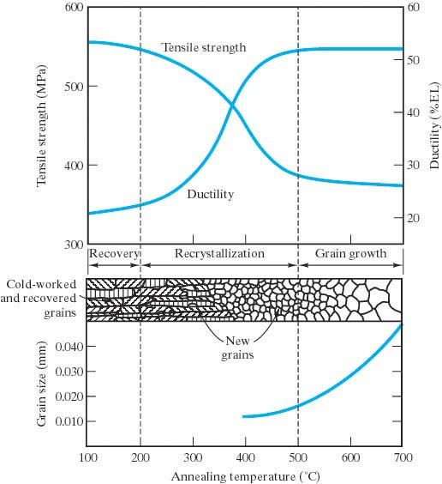
- Grain Growth
Once the process of recrystallization has occurred and the structure is made of completely new crystal grains, the grains will continue to grow. The driving force here is the lowering of the energy of the material because there will be less high energy grain boundaries per volume. The grain boundaries will migrate and the larger grains will grow at the expense of the smaller ones. (Much like soap bubbles.)
Some annealing procedures for Ferrous Alloys:

Stress Relief Anneal
- used only to relieve residual stresses (from plastic deformation, machining, nonuniform cooling, phase transformation to different density phases.)
- done at low T so that results of CW and other heat treatments are not affected

Process Anneal
- used to negate the effects of CW
- recovery and recrystallization but no grain growth
- results in a fine grain microstructure
- to avoid surface oxidation, heat to just below T_{ReX}

Normalizing
- used to refine grains
- heated to 55º – 85º above the upper critical temperature then air cooled
- results in fine pearlite

Full Anneal
- used on low and medium carbon steels to make them ductile
- 15 º – 40 º above the upper or lower (depending on carbon content) critical temperature and then furnace cooled
- results in coarse pearlite

Spheroidizing
- used to get spheroidite, a steel microstructure with even more ductility
- heated just below the lower critical temperature
- Fe₃C coalesces to form spherical particles

