Ceramics
(keramikos - “burnt stuff” - desirable props are achieved by firing)

Traditional Silicate Ceramics Advanced/Engineering Ceramics
Combinations of clay, feldspar and silica (cheap) Nearly pure compounds of
oxides, carbides or nitrides (expensive)

Non-silicate oxide ceramics Non-oxide ceramics
-Al₂0₃ Alumina -Si₃N₄ Silicon nitride
-ZrO₂ Zirconia -SiC Silicon carbide

Structural Clay Products Whitewares
-brick more carefully controlled compositions
-tile -pottery
-sewer pipe -porcelain
-cement -sanitary ware

Ceramics
- Inorganic nonmetallic materials which consist of electropositive/electronegative compounds that are bonded primarily by ionic bonds, sometimes with covalent character.
- Ceramic crystal structures can be relatively simple to very complex.
- Ceramics can range from the more traditional & inexpensive to the advanced & highly sophisticated.
- The fabrication of ceramics and glasses must be different than for metals because of their high melting temperatures, (hence, difficult to cast) and low ductility, (hence, difficult to form). Most are formed from powders (or particulate collections) and then dried and fired.

- Applications:
- insulators
- capacitors
- semiconductors
- abrasives
- refractory
- ferroelectrics
- piezoelectrics
- nuclear fuels
- Processing Techniques:
- fusion
- slip casting
- sintering
- hot isostatic pressing(HIP)
- sol-gel
- biomimetic
- SHS (self-propagating high-temp synthesis)

- General properties:
- hard and strong
- brittle (low ductility)
- low toughness & fracture toughness
- low impact resistance
- low electrical and thermal conductivity
- high melting temperatures
- high chemical stability
- high compressive and tensile strengths (CS>>>TS by 5-10x)
- fatigue life is rare

Ceramics (Keramikos- “burnt stuff” -desirable props are achieved by firing)

Traditional Silicate Ceramics Advanced/Engineering Ceramics
Combinations of clay, feldspar and silica (cheap) Nearly pure compounds of
oxides, carbides or nitrides (expensive)

Non-silicate oxide ceramics Non-oxide ceramics
-Al₂0₃ Alumina -Si₃N₄ Silicon nitride
-ZrO₂ Zirconia -SiC Silicon carbide
Structural Clay Products Whitewares
brick more carefully controlled compositions
-tile -pottery
-sewer pipe -porcelain
-cement -sanitary ware
Clays
- Aluminosilicates (Al₂O₃ and SiO₂ and chemically bound H₂O)
- Broad range of compositions, structures, impurities
- Usually the structure is layered with water between the sheets making it plastic (hydroplasticity)
- Can be mixed with water and easily formed and then dried and fired to increase strength

Whitewares and Structural Clay Products
- Made from clay, flint and feldspar
- Flint is finely ground quartz, a filler that is hard and chemically unreactive with a high melting temperature.
- Feldspar is an aluminosilicate mineral that contains K⁺, Na⁺ and Ca⁺. It acts as a fluxing agent. (i.e. it spreads out heat and helps things to flow.)

Refractories
- Materials that are able to withstand high temperatures without melting or decomposing.
- They are able to maintain insulative properties at high temperatures.
- They remain inert and unreactive at high temperatures.
- The four main categories: fireclay, silica (acid), basic and special.
- A decrease in the porosity of refractories will
- increase strength
- increase corrosion resistance
- increase load-bearing capacity
- decrease insulativeness
- resistance to thermal shock

Abrasives
- Extremely hard materials used for cutting, grinding, and polishing other materials.
- Due to high heat generated during the process, these materials also must have some refractory properties.
- Examples are diamond, SiC, WC, Corundum, and silica sand.

Cements
- materials that form a paste when mixed with water and then hardenedby chemical reactions
- examples include cement, plaster of paris and lime

Note: Concrete is a composite material made up of cement, large aggregates (gravel), and small aggregates (sand). The cement in concrete is similar to the glassy phase in ceramics. It bonds the other phases together.

Portland cement
- One of the most commonly used cements.
- Made by following process:
- calcination: grinding and mixing clay and lime-bearing minerals
- heating to obtain a material called clinker
- grind this to a powder
- add gypsum (CaSO₄-2H₂O) to retard setting process
- Principle constituents are tricalcium silicate (3CaO-SiO₂) and dicalcium silicate (2CaO-SiO₂). There can be many different compositions.
- Hardening occurs by complex hydration reactions that form complex gels or crystalline substances. This process is known as curing. If there were no water the reactions could not proceed and drying would occur. Drying is bad. Curing is good.
(Portland cement is a hydraulic cement because water is involved in the reactions. Lime is a nonhydraulic cement because other compounds (CO₂) are involved in the hardening reactions.)
Ceramic Crystalline Structures
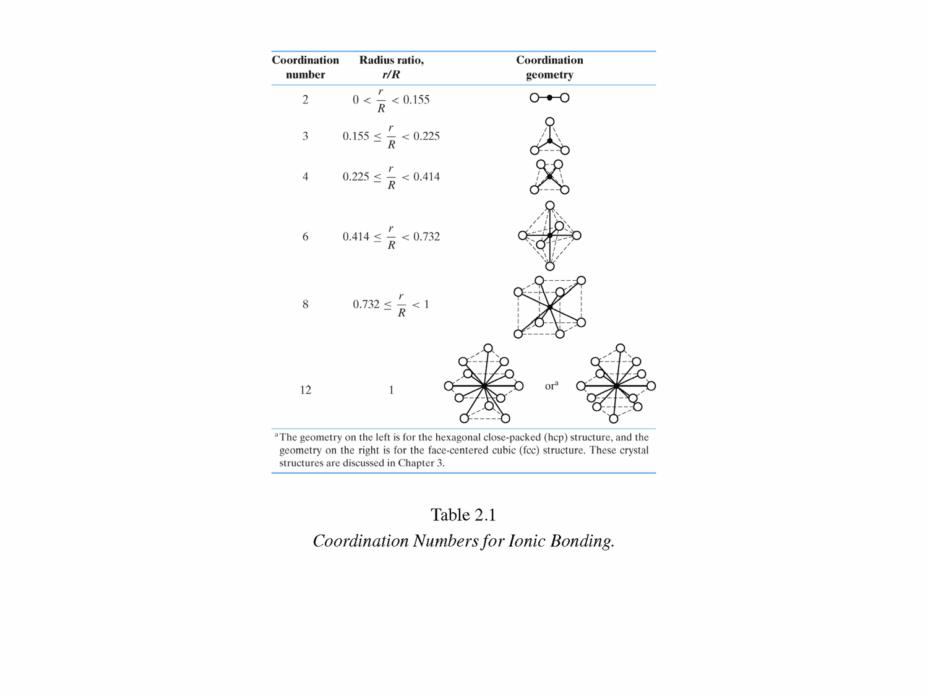
Crystal structures of ionic compounds tend to maximize packing efficiency. (This lowers the overall energy.) The limitations to dense packing are the radius ratio and the need to maintain charge neutrality. The radius ratio can help to predict the CN (and hence the crystal structure.)

If the bonding has some covalent character, then the packing will be less efficient. You can determine the amount of ionic character in a bond by knowing the electronegativities, X_{A} & X_{B,} of the elements in the bond and the following equation: % ionic character = [1 – e ^{-1/4(XA-XB)}] x 100%

A tetrahedral position is an interstitial site that if occupied, would have 4 neighbors.
An octahedral position is an interstitial site that if occupied, would have 6 neighbors.

Where are the octahedral and tetrahedral sites in the fcc crystal structure?
Where are the octahedral and tetrahedral sites in the hcp crystal structure?

Some relatively simple ceramic structures:
- Sodium Chloride structure (NaCl)
- Cesium Chloride structure (CsCl)
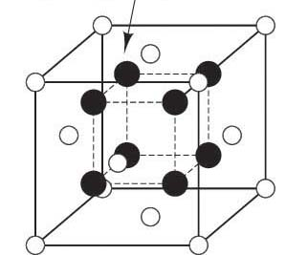
- Zinc Blende structure (ZnS and Compound Semiconductors) ?
- Fluorite structure (CaF₂)
- Perovskite structure (CaTiO₃)
- Diamond Cubic structure (Carbon and Elemental Semiconductors)
- Graphite (Carbon)
- Fullerenes (Carbon)
- Cristobalite structure (SiO₂)
- Corundum Structure (Al₂O₃)
- Spinel Structure (MgAl₂O₄)/Inverse Spinel

Silicate Structures
Silica (SiO₂) has half ionic and half covalent character. (The percent of ionic character is about 50% as calculated from the above equation.) A CN of 4 is predicted for the radius ratio of 0.29 for ionic compounds. A bond angle of 105º is predicted for covalent bonding. Silica is allotropic with at least five different crystalline forms depending on temperature and pressure conditions. However, each form has every corner of an SiO₄ tetrahedra (every oxygen atom) shared. The sharing of oxygen atoms between the tetrahedra give the overall formula of SiO₂. The structures are not dense and have high melting temperatures.

Silicates (or silicate ceramics) are Silica (SiO₂) based ceramic clays that contain SiO₄⁴⁻ tetrahedra in various arrangements. Many naturally occurring minerals such as clays, feldspars and micas are silicates. Many ceramic materials contain silicate structures. They include glass, cement, brick, electrical insulative materials, etc.

The general nature of silicate structures is the connection of the SiO₄⁴⁻ tetrahedra. Additional oxides tend to break up the continuity of these tetrahedra. The remaining connectedness may be in the form of islands, chains or sheets:
- Network silicate structures – these structures connect all 4 corners of the SiO₄⁴⁻ tetrahedra to form a network. The Oxygen atoms are shared which accounts for the overall chemical formula of SiO₂ not SiO₄.
- Island silicate structures – when positive ions bond with the oxygens of the SiO₄⁴⁻ tetrahedra
- Chain or ring silicate structures – when 2 corners of each SiO₄⁴⁻ tetrahedra are bonded with corners of other tetrahedra with unit chemical formula SiO₃⁻².
- Sheet silicate structures – when 3 corners in the same plane of a silicate tetrahedron are bonded to the corners of 3 other silicate tetrahedra with chemical unit Si₂O₅⁻².

Electrical Properties of Ceramics

Ceramics are used in many electrical applications as:
- Insulators
- Capacitors
- Semiconductors
- Ferroelectrics
- Piezoelectrics

Insulators
prevents the flow of charge or heat. Ceramics make good insulators because the ionic and covalent bonding restricts electron and ion mobility.

Capacitors
store electrical energy by virtue of separating oppositely charged plates with an insulator (also called a dielectric) in between. An example of a ceramic material used as the dielectric for a capacitor is Barium Titanate, Ba₂TiO₃

Some material properties of insulators (also called dielectrics):
- Capacitance (actually this is a property of a device, not the material)
- Dielectric constant
- Dielectric breakdown strength
- Dielectric loss factor

Some examples of ceramic insulators are
- Electrical Porcelain (50% clay, 25% silica, 25%feldspar)
- Steatite (90% talc, 10% clay)
- Fosterite (Mg₂SiO₄)
- Alumina (Al₂O₃ crystals in a glassy matrix of clay, talc, alkaline earth fluxes)

Semiconductors
have an intermediate value of electrical conductivity. The most commonly used ceramic semiconducting materials are sintered oxides of Mn, Ni, Fe, Co, and Cu. By varying the amounts of these oxides in the material the desired value of the electrical conductivity can be obtained. These are used for NTC thermistors. A Negative Temperature Coefficient Thermistor is a device that measures temperature by a change in the resistance of the material. As temperature increases, resistance decreases.

Ferroelectrics
have behavior similar to a ferromagnetic material. The relationship between the electric dipole moment density (Polarization, P) and the electric field strength (E) looks exactly like the relationship between magnetic dipole moment density (Magnetization, M) and magnetic field strength (H).

Piezoelectrics
have the distinct property whereby an applied stress induces an electrical voltage. The reverse piezoelectric effect is the phenomena whereby an applied voltage across the material results in a dimensional change. BaTiO₃
Mechanical Properties of Ceramic Materials

Ceramics are strong
However, their principle drawback is a disposition to catastrophic fracture in a brittle mode. Hence, the effort in research of these materials is to make them tougher. An example of an advancement in this area is the transformation toughening of partially stabilized Zirconia (PSZ).

Fine grain size ceramics are stronger than coarse grain size ceramics
The reason is different than for metals: If fracture does not initiate at a crack, flaw, pore or inclusion, it will originate at a flaw in a grain boundary. Finer grain size ceramics will have smaller flaw at the grain boundaries. Hence, the finer grain ceramics will be stronger.

The Flexural Strength is an alternate property to Tensile Strength for ceramics
The flexural strength (or modulus of rupture, fracture strength, bend strength) is the (calculated) tensile stress at failure of a specimen subjected to a three or four point load. This is an easier test to carry out for brittle materials than the traditional standard Tensile Test.

Ceramics are brittle
Ceramics have very low toughness values and also fracture toughness values. Recall that brittle fracture consists of formation and propagation of cracks through the cross section in a direction perpendicular to the applied load. Usually the crack growth is transgranular and along specific crystallographic directions.

The reasons that ceramics are so brittle:
- Ceramic materials inherently have cracks, flaws, pores and inclusions. These act as stress risers and failure initiates at one of these and propagates quickly (because there is no energy absorbing mechanism as there is in metals,) causing brittle fracture.
- The covalent bond is directional and electrons are shared. Hence, bonds will not reform easily and so brittle fracture will occur.
- Since the crystal structures tend to be complex, there are limited slip systems and large Burgers vectors. (called complex dislocation structures)
- Potential slip planes may involve like charges moving over each other which will cause separation and so brittle fracture will occur.

Ceramics are much stronger in compression than in tension.
Why?

Some ceramics are subject to Static Fatigue or Delayed Fracture
This is when ceramics fail by slow crack propagation under a static load. The mechanism is a stress-corrosion process at a crack tip.

Ceramics rarely have any sort of fatigue failure
This is due to the lack of plasticity in ceramics; however, there have been recent advances in compressive-compressive stress cycling of polycrystalline alumina.

Ceramics have high hardness values
This makes them excellent abrasive materials used for cutting, grinding and polishing. Alumnia (aluminum oxide, Al₂O₃) and silicon carbide, SiC are two of the most commonly used manufactured ceramic abrasives. Improvements on these are made by combining zirconium oxide with aluminum oxide. Another important ceramic abrasive is cubic boron nitride (Bortazon).

Ceramics have high melting temperatures
This makes them excellent materials to be used for high temperature applications. Materials used at high temperatures are call refractory materials or refractories. However, creep will occur at these temperatures and so one must be aware of the material’s creep behavior.

Porosity has an adverse affect on a ceramic’s properties.
The modulus of elasticity and the flexural strength will both decrease with porosity.

There is much scatter in the data measuring the properties of ceramic materials
The reason is because much of the data depends on flaw density and size. This, in turn, will depend on fabrication technique, processing and size of the specimen. Hence, the scatter.

*clay – A hydrated Aluminum silicates with other oxides. Provides workability before firing hardens it. (eg Al₂O₃ 2Si0₃ 2H₂O) feldspar – A naturally occurring, industrial important, network silicate with a low melting temperature. It becomes glass upon firing and bonds the refractory components together. Some Si⁺⁴ ions are replaced with Al⁺³ in substitional positions and some Na⁺, K⁺, Ca⁺, Ba⁺ ions are in interstitial positions. (eg K₂O Al₂0₃ 6Si0₂) silica – (aka flint or quartz) SiO₂ is a polymorphic compound. (quartz, tridymite and cristobalite are some of its forms.) It acts as the refractory component of traditional ceramics.
*clay – A hydrated Aluminum silicates with other oxides. Provides workability before firing hardens it. (eg Al₂O₃ 2Si0₃ 2H₂O) feldspar – A naturally occurring, industrial important, network silicate with a low melting temperature. It becomes glass upon firing and bonds the refractory components together. Some Si⁺⁴ ions are replaced with Al⁺³ in substitional positions and some Na⁺, K⁺, Ca⁺, Ba⁺ ions are in interstitial positions. (eg K₂O Al₂0₃ 6Si0₂) silica – (aka flint or quartz) SiO₂ is a polymorphic compound. (quartz, tridymite and cristobalite are some of its forms.) It acts as the refractory component of traditional ceramics.

