GLASSES
Inorganic noncrystalline materials with compositions comparable to crystalline ceramics - usually silicates with other oxides

General properties
- Hard and Brittle
- Transparent (because of their amorphous structure)
- Corrosive resistant
- Chemically resistant

Glass composition
Most inorganic glasses are based on the glass-forming oxide silica, SiO₂. In these glasses SiO₄⁻⁴ tetrahedra are joined corner to corner to form a loose network with no long-range order. The sharing of oxygen atoms between the tetrahedra give the overall formula of SiO₂. Other oxides can join the in one of three ways: Network formers, network modifiers and intermediates.

A oxide that can form a polyhedra which can connect with the network of SiO₄⁻⁴ tetrahedra is considered a network former. B₂O₃ is such an oxide and is an important addition to Borosilicate glasses and Aluminborosilicate glasses which are lower expansion glasses.

A oxide that does not form a polyhedra but, instead, breaks up the glass network are known as network modifiers. They lower viscosity so that it can be worked and formed easier.

An intermediate Oxide is one which cannot form a glass network by itself but can join into an existing network. They are added to silica glass to obtain special properties such are being able to withstand higher temperatures.

There are also non-silicate glasses but they are not very common and are used only for special purposes. One example is chalcogenide glasses which are semiconductors. Another example is Zirconium tetrafluoride (ZrF₄) glass fibers which have superior light transmission properties in the infrared region.

Examples of common glasses
- Vitreous silica – can withstand over 1000ºC
- Soda-lime-silica glasses (15wt% Na₂O, 10wt% CaO, 70wt%SiO₂) – basis for bulk of glass industry
- Borosilicate glasses - durable
- E-glass – used for glass fibers in composites
- glazes – coatings for ceramics (for appearance and improves imperviousness)
- enamels – coatings for metals to provide protection from corrosion

Glass and Ceramic Fabrication Techniques
The fabrication of ceramics and glasses must be different than for metals because of their high melting temperatures, (hence, difficult to cast) and low ductility, (hence, difficult to form). Most are formed from powders (or particulate collections) and then dried and fired.

Glasses are easier to form than ceramics. They are usually formed at high temperatures and then cooled.

Glass Ceramics
Initially formed as glasses and then crystallized in a carefully controlled way. (Devitrified glasses.) They yield gine grained polycrystalline materials that have low coefficients of thermal expansion, high thermal conductivity, are transparent or opaque, and are eaisly fabricated.

Most important commercial example is Li₂ - Al₂O₃ – SiO₂
Glass Solidification Behavior & Glass Deformation Mechanisms
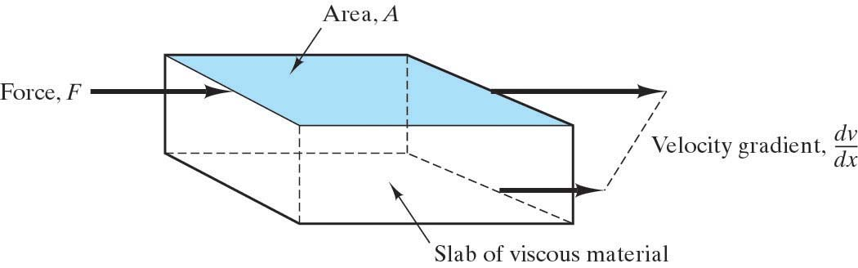
Crystalline materials deform by the motion of dislocations.
Noncrystalline materials deform by viscous flow, the same type of deformation found in liquids.
With applied stress, groups of atoms slide past each other.

Viscous flow is characterized by this equation:
⧫ =  dv/dy
where  is the material property of viscosity.

As we can see from this equation, viscosity is the proportionality constant between the applied shear stress and the velocity gradient. The units of viscosity are poises (P) or Pascal-seconds (Pa-sec): 1P = 0.1 Pa-sec (Note:  is the reciprocal of the material property of fluidity.)

The behavior of glasses is compared with crystalline materials in this plot of specific volume vs. T:

Specific Volume liquid
supercooled liquid
glass

viscous
elastic deformation
deformation (liquid-like) crystalline solid
(rigid solid)
(specific volume shrinks
due to efficient packing)

T_{g} T_{m} Temperature

The supercooled liquid is the material just below T_{m} where it still behaves like a liquid – deforming by viscous flow mechanism. It is in a rubbery, soft plastic state above T_{g}, the glass transition temperature.
The term supercooled liquid is often used synonymously with glass. Strictly speaking, however, the term supercooled liquid is the material between T_{g} & T_{m} and the term glass is the material below T_{g}, where it has become a truly rigid solid, (although still noncrystalline,) deforming by an elastic mechanism. Below T_{g} it is in a rigid, brittle glassy state.

Note: the slope of this curve is related to the thermal expansion coefficient. The thermal expansion coefficient above T_{g} is comparable to that of a liquid. Below T_{g} it is comparable to a solid.

At a temperature above T_{g} the material will reach a point where it becomes so fluid that it can’t support the weight of a probe. This is the softening temperature.
Viscoelastic Deformation of Glasses
The viscosity of a typical soda-lime-silica glass as a function of temperature is shown here. As T increases, the viscosity decreases and viscous flow becomes easier. At room temperature, the glass is elastic. Above T_{g} it is viscous. Hence the deformation behavior of glasses is termed viscoelastic.

Various reference points of viscosity are defined that are useful in the processing and manufacture of glass products:

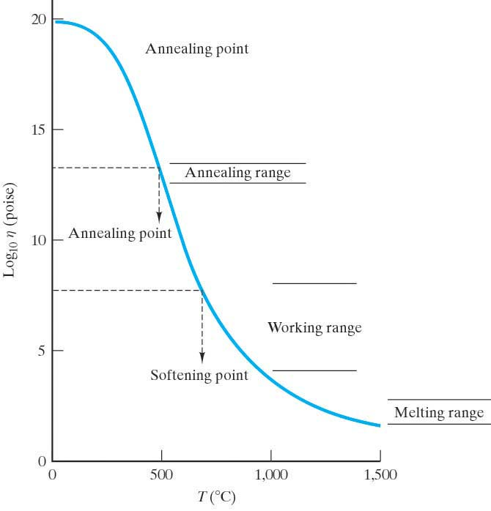
- Melting point – The temperature where the material is fluid enough to be considered a liquid. This corresponds to a viscosity of about 100 P. (The melting range is  between 50 and 500. Compare with water which has  = 0.01P)
- Working point – The temperature corresponding to 10⁴ P. At this temperature glass fabrication operations can be carried out. (The working range is  between 10⁴ and 10⁸ P)
- Softening point – 10^{7.6} poises. At this temperature the glass will flow at an appreciable rate under its own weight.
- Annealing point – 10^{13.4} poises. Internal stresses can be relieved in about 15 minutes at this temperature. This is roughly T_{g}. (The annealing range is 10^{12.5} to 10^{13.5})
- Strain point – 10^{14.5} poises. Below this temperature the glass is rigid and stress relaxation occurs only at a slow rate. In other words, there is little plastic deformation before failure. The interval between the annealing and strain points is commonly considered the annealing range of a glass.

A hard glass has a high softening point
A soft glass has a low softening point.
A long glass has a large temperature difference between its softening and strain points.

Above T_{g}, viscosity follows an Arrhenius form:  = _{o} e ^{+Q/RT} where Q is the molar activation energy for viscous flow. (The sign on the exponent would be negative if we considered fluidity instead of )

Thermal Shock is fracture due to rapid cooling. Fracture occurs because thermal stresses are induced due to temperature gradients which create different expansions. Glasses are particularly vulnerable to thermal shock because of their brittleness. To avoid thermal shock, anneal in the annealing point temperature range.

To make glass stronger, we introduce residual compressive stresses in the surface.
The breaking strength of the glass will then be the sum of the tensile strength of the glass plus the residual compressive stresses introduced into the surface. The two methods to do this are heat treating (to get tempered glass) and chemically treating (to get chemically strengthened glass.)
Tempered glass:
Consider the process for producing tempered glass:
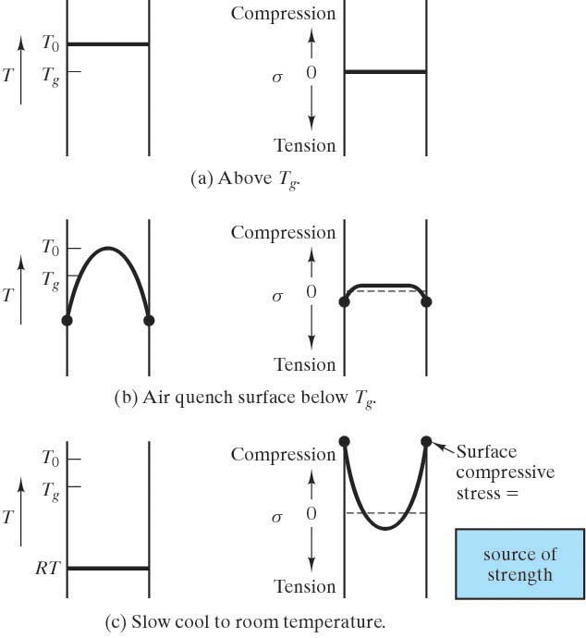

Bring glass to equilibrium above T_{g}

  - Surface quench it to form a rigid surface “skin” that is below T_{g} while the interior is still above T_{g}
- this results in interior compressive stresses that are largely relaxed, and a modest tensile stress present in the skin.
  - A slow cool to room temperature allows the interior to contract considerably more than the surface causing a net compressive residual stress on the surface balanced by a smaller tensile residual stress in the interior.

Chemically strengthened glass:
The process of chemically treating glass is to chemically exchange the larger radius K⁺ ions for the Na⁺ ions in the surface of a sodium-containing silicate glass. The larger ions produce compressive stresses in the surface.

Not to be confused with the term enamel as applied to polymer-based paints.
The term supercooled liquid is confusing. In the context of glasses, supercooled liquid refers to the material between T_{g} and T_{m} and it is an equilibrium product. However, another way the term is used is to refer to a material that is cooled so fast that it remains a liquid below its melting point. In this case, the material is a non-equilibrium product. That is not what we are referring to here.

