Polymeric MATERIALS (POLYMERS)

General Structure
- The name “polymer” gives an indication of the structure of these materials. Poly means “many” and mer means “units”. Polymeric structures are either long chains of repeating molecules (called macromolecules) or large networks of repeating molecules. Usually the chain or network has a carbon backbone with hydrogen and other elements arranged on it such as O, N, F, Si, S. Hence most polymers are organic materials. There are also inorganic polymers that we will not discuss here.
- Covalent bonds act between the molecules on the chains or networks (intra-molecular forces); secondary bonds act between the chains and in the networks (inter-molecular forces).
- Polymers can be anywhere from 5 - 95% crystalline. If they do crystallize, the structures tend to be very complex. In general crystallinity will affect the properties by increasing the packing and hence the secondary bonding forces, making the material stronger and more rigid, and hence, less ductile.
General Properties
- Lightweight
- Low strength
- Insulative
- Ductile
- Good noise and vibrational dampers

Three Main Classifications of Polymeric Materials
- Thermoplastic Polymers or Thermoplasts
These materials soften when heated and eventually liquefy. They harden when cooled. These processes are reversible so that they can be reheated and reformed. Hence they are recyclable.
They are usually soft and ductile and can be easily fabricated by heat and pressure.
They usually have a linear structure with flexible chains and come from chain polymerization.
Examples include polyethylene, polyvinyl chloride (PVC), polypropylene (PP), Polystyrene
Common possessing techniques include injection molding and extrusion molding.
- Thermosetting Polymers or Thermosets
These materials become permanently bonded or “set” by chemical reactions that take place when heated or provided with a catalyst. Hence they become more rigid when heated. However, they do not soften when the temperature is returned to ambient because these reactions are irreversible. (So they are not recyclable. - This is opposite to thermoplastic behavior which become softer when heated and then harder when the temperature returns to ambient because the process is reversible.) Thermosets usually do not liquefy at higher temperatures, but instead “char”. They are usually harder, stronger, more brittle, more dimensionally stable, and more resistant to heat and creep than thermoplastics.
They usually have a rigid cross-linked or network structure from condensation polymerization.
Examples include vulcanized rubber, epoxies, phenolic resins, polyester resins.
They are not easily processed. Common processing techniques include compression molding and transfer molding.
- Elastomers
These can be elastically deformed a very large amount. (200 - 1000%) There are both thermoplastic elastomers and thermosetting elastomers.
Alternative Classification of Polymeric Materials
- Engineering Polymers
Any polymer with sufficient strength and stiffness to be serious candidates for structural applications once dominated by metals.
- General purpose polymers
Includes various films, fabrics and packaging materials.
- Elastomers

As always, these are imperfect categorizations and there is overlap.
Polymerization Reactions
Polymers are made or “polymerized” by chemical reactions. These reactions bond small simple hydrocarbon (organic) molecules from coal and petroleum products, usually in the gaseous state, into large macromolecules (long chains or networks) that are solids. There are two types of polymerization reactions.

1. Addition (Chain Growth) Polymerization
- involves a rapid “chain reaction” of chemically activated mers
- each reaction sets up the condition for another to proceed
- each step needs a reactive site (a double carbon bond or an unsaturated molecule)
- the three stages are: initiation, propagation, termination
(In the case of the polymerization of polyethylene, initiation can come from a free radical – a single unit that has one unpaired electron such as an OH¯ molecule. H₂O₂ can break up into 2 OH¯ molecules. Each can act to initiate and to terminate the reaction. The termination here would be called recombination.)
- the composition of resultant molecule is a multiple of the individual mers
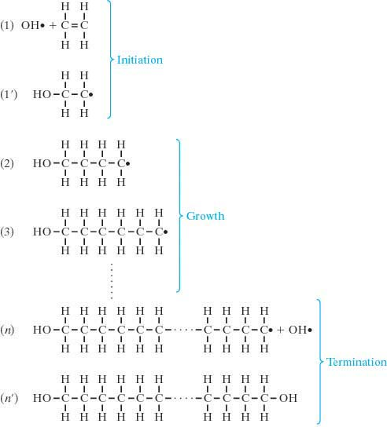
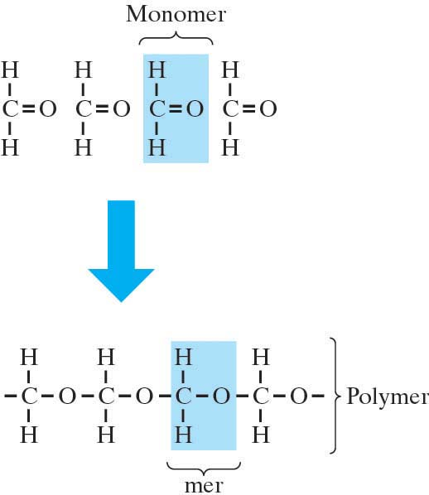
- these reactions most commonly produce linear structures but can produce network structures

- Condensation (Step Growth or Stepwise) Polymerization
- individual chemical reactions between reactive mers that occur one step at a time
- slower than addition polymerization
- need reactive functional groups
- a byproduct such as water or carbon, oxygen or hydrogen gas is formed
- no reactant species has the chemical formula of a mer repeat unit
- most commonly produces network structures but can produce linear structures

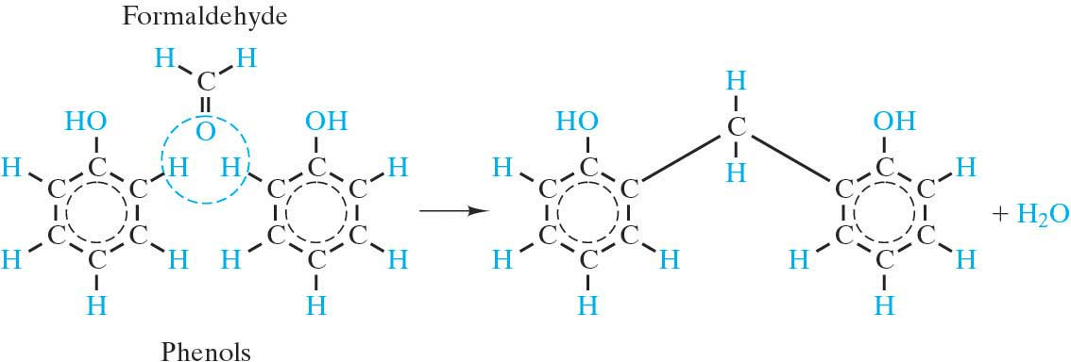

Some of the common simple hydrocarbons that go into the polymerization reactions:

- Ethylene - C₂H₄ note the ‘ene’ ending indicates an unsaturated molecule
- Acetylene - C₂H₂ i.e. a molecule with one or more double or triple bonds
As MW↑
so does Tm

- Methane - CH₄
- Ethane - C₂H₆
- Butane - C₄H₁₀ This is the paraffin family C_{n}H_{2n+2}
- Pentane - C₅H₁₂ note the ‘ane’ ending indicates a saturated molecule
- Hexane - C₆H₁₄ i.e. a molecule with only single bonds

Carbon has four electrons in sp³ orbitals that can each form a covalent bond. If each of these electrons bond with a different atom, the bonds will all be single bonds. If two (or three) of these electrons bond with the same atom, then there will be a double (or triple) bond.

Some common polymers that result from these polymerization reactions:
- Polyethylene (PE)
- Polytetrafluoroethylene (PTFE) aka Teflon - a member of the fluorocarbons
- Polyvinyl Chloride (PVC)
- Polypropylene (PP)
- Polystyrene (PS) vinyl polymers or vinyls (one H on each mer is replaced)
- Polyacrylonitrile
- Polyvinylacetate
- Polymethylmethacrylate (PMMA) vinylidene polymers or vinylidenes
- Polyvinylidene chloride (two H atoms on each mer are replaced)

Size of Polymeric Molecules
Molecular size is quantified by the degree of polymerization, DP (the number of mers on a molecular chain) or as its molecular weight.
Since there are varying sizes of molecules, a statistical distribution must be used to quantify it.
The four methods are:
- weight average degree of polymerization, n_{n}
- number average degree of polymerization, n_{w} As n or M increases,
- weight average molecular weight, M_{w} temperature so does melting point
- number average molecular weight, M_{n} and “solidness”. (Why?)

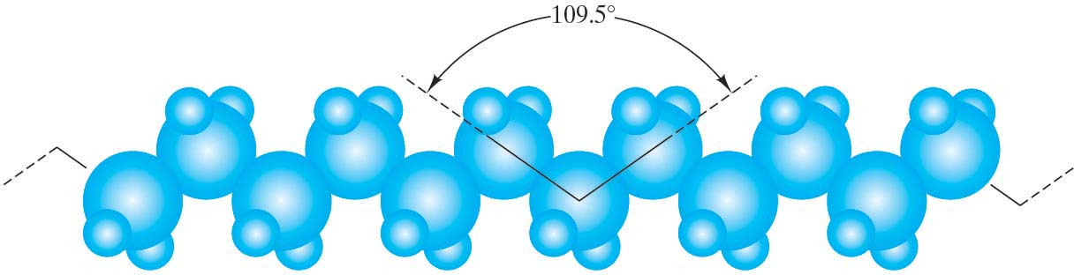
The molecular length is obtained by considering the fact that the bond angle for the sp³ hybrid orbitals of Carbon is 109º. This gives the chain a zig-zag configuration. The extended length of the molecule can be calculated as: L_{ext} = ml [sin (109º/2)] where l is the length of a single bonds in the backbone of hydrocarbon chain and m is the number of bonds. (note m=2n)

However, there is more to the story as you consider that a single bond along the chain can rotate 360º to give a very kinked, coiled and twisted conformation. The effective length of the molecule, from a statistical analysis of a freely kinked linear chain, is therefore L = l √m called the root mean square length.
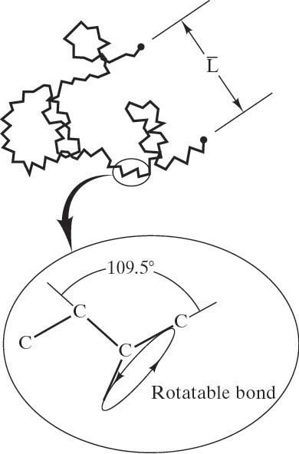

Polymer Molecular Structure
Linear or chain structures are formed from bifunctional mers. These can have side groups attached.
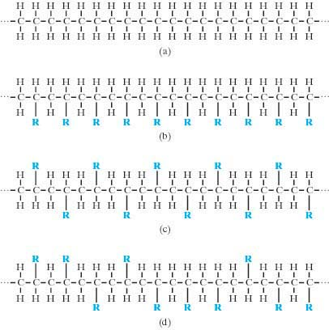
  - Isotactic
side group mers are all on the same side
  - Syndiotactic
side group mers alternate on different
sides of the chain
  - Atactic
side group mers are positioned randomly
on one side or the other
  - Homopolymers
The chain has the same mers along the entire length. Analogous to a pure metal.
  - Copolymers
The mers are different along the length of the chain. Analogous to a metallic solid solution.
There are four types of copolymers:
    - Random
    - Alternating
    - Block
    - Graft
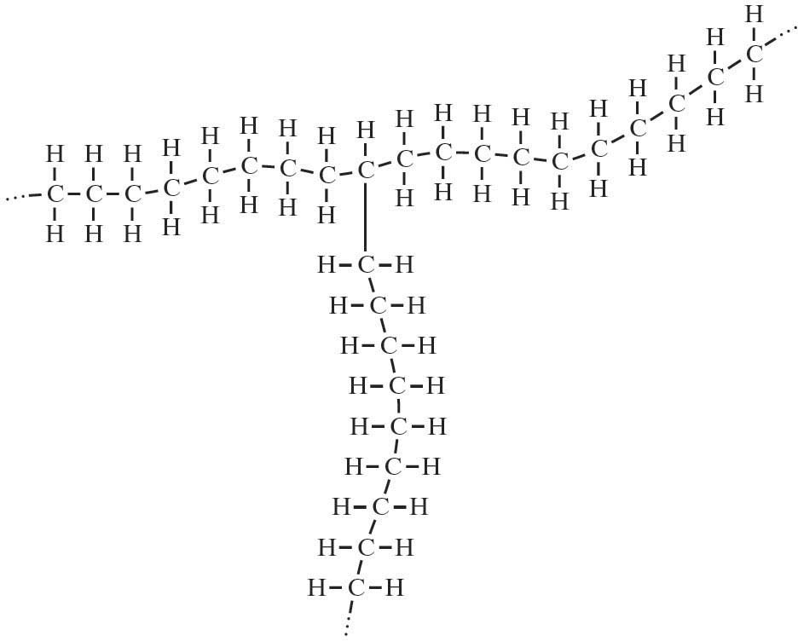
  - Blends
Different types of polymeric molecules are mixed together. (Analogous to metallic alloys with limited solid solubility.)
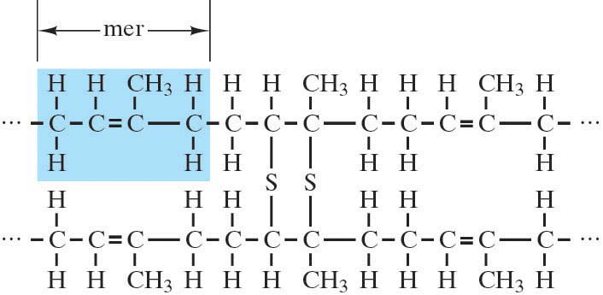
Branched structures
are structures where a
chain is attached to a
point on another linear chain.
Crosslinked structures are structures where chains are connected at various points. For example an important process in elastomers is called vulcanization which is essentially just crosslinking. It is a nonreversible chemical reaction at high temperature in which Sulfur atoms bond with adjacent polymer backbones. Light crosslinking that is widely dispersed throughout material gives the best properties. (Silicone rubbers replace the -C- with -Si–O- on the backbone)

Network structures are formed from trifunctional or polyfunctional mers.
Note that in general rigidity and melting point tend to rise with:
- higher MW
- more side groups
- more branching
- crosslinking
- more networked structures
This effect is due to hindrances to molecular sliding and greater secondary bonding forces acting.

Polymer Crystallinity
The polymer structures tend to be very complex because they involve large molecules. In fact the unit cell might only include a portion of a molecular chain. Due to the complexity of the structure, the chain disorder, misalignment, etc. 5-95% of the volume of a polymer can be non-crystalline.
Semi-crystalline structures can be compared to two-phase metals. The percent crystallinity can be found by measuring the density and knowing the density of the crystal phase and the amorphous phase:
The degree of crystallinity will increase with:
- Slower cooling rates
- Simplicity of chain structure note: the more randomness
- Simplicity of mer chemistry and irregularity,
- Less side branching the less crystallinity
- Chain regularity (isotactic or syndiotactic)
As crystallinity increases so does:
- Density
- Strength
- Heat resistance
- Creep resistance

Polymer Crystal Models
- Fringed-Micelle model
- Earliest
- Small crystal regions embedded in an amorphous matrix
- A single molecule could be in both regions
- Chain-folded model
- Regular shaped thin platelets (lamellae) in a layered structure
- Chains fold back and forth in the lamellae
- Spherulites
- Each “spherulite” is made of an aggregate of ribbon-like chain folded crystallites (lamellea) that radiate out from the center and are separated by amorphous regions that are linked by tie molecules. They grow spherical in shape until they hit each other and become like a Maltese Falcon design.
- Examples of polymers with this structure are PE, PP, PVC & PTFE
Melting Temperature & Glass Transition Temperature of Polymers
T_{m} & T_{g} usually define, respectively, the upper and lower temperature limits for applications of semi-crystalline polymers. T_{g} may also define the upper use temperature for amorphous materials.

Methods used to increase T_{m} & T_{g}:
- Increase MW
Melting can take place over a range of temperatures due to the variation of MW
- Increase secondary bonding
polar side groups, crystallinity, ether or amide linkages on the main chain
- Decrease chain flexibility/increase chain stiffness
double bonds, aromatic groups, bulky and large side groups
- Increase crosslinking
- Increase density of branching
A small amount of branching may lower T_{m} & T_{g} because it will decrease crystallinity.
- Increase the thickness of the lamellae
Crystallizing the solid at a low temperature or annealing just below T_{m} will do this.
- Increase the rate of heating

Specific glassy rigid supercooled liquid liquid
Volume brittle solid leathery → rubbery (viscous
(elastic behavior) (visco-elastic behavior)
behavior)
non-crystalline

semi-crystalline
crystalline regions in a supercooled liquid (or viscous solid) matrix.

crystalline – more efficient packing causes sudden decrease in specific vol

T_{g} T_{m} Temerature

The viscosity, η can specify the behavior of polymers in these various regions. The viscosity is the material property that measures resistance to flow by shear forces. It is the proportionality constant between the shear stresses and the velocity gradient:  =  dv/dy

Viscoelasticity is a combination of viscous and elastic behavior. It is both time dependent (a form of anelasticity) and temperature dependent. (Think of silly putty.)

The phenomenon of viscoelastic Creep a result of viscoelasticity.
It is the time-dependent deformation of polymers when the stress level is maintained constant.
It will depend on temperature and can even have significant effects at room temperature for polymeric materials. Creep tests are conducted in same manner as for metals.
A common parameter to quantify this behavior of polymeric materials is the creep modulus, E_{c}(t) = σ_{o}/ε(t) where ε (t) is the measured time dependant strain and σ_{o} is the constant stress level at a specific temperature.

The phenomenon of stress relaxation is also a result of viscoelasticity.
It is the time-dependent relaxation of stress when the strain level is maintained constant.
It will depend on temperature and can even have significant effects at room temperature for polymeric materials.
A common parameter to quantify this behavior of polymeric materials is the relaxation modulus, E_{r} = σ(t)/ε_{o} where σ(t) is the measured time dependant stress and ε_{o} is the constant strain level at a specific temperature.

Mechanical Properties of Polymeric Materials
- Tensile modulus (or Elastic Modulus or just “modulus”) is the same as Young’s Modulus for metals but the values tend to be much lower for polymers. For semi-crystalline polymers the tensile modulus can be considered to be a combination of the modulus of the crystalline regions and the amorphous regions.
- Tensile Strength, Impact Strength (Izod or Charpy Impact Strengths), Fatigue Strengths are defined in the same way as for metals and also have values that tend to be much lower for polymers.
- Ductility values are usually much higher for polymers than metals.
- Fatigue curves are same as for metals. Some polymers have fatigue limits, others do not. The values tend to be lower than for metals and much more dependent on loading frequency.
- Tear Strength is the energy required to tear apart a cut specimen that has a standard geometry. (Related to TS)
- Hardness, like metals, measures the resistance to penetration, scratching, or marring the surface. Durometer and Barcol are common Hardness tests for polymers.

Polymer properties are very sensitive to:
- Temperature ( ↑T ⇒ ↓TS ↓E and ↑Ductility)
- Strain rate (↓strain rate has the same effect as ↑T)
- Environment (moisture, oxygen, UV radiation, organic solvents)

Typical stress-strain curves for the three different types of polymers:

σ Brittle Polymers
(fail while elastically deforming)

Plastic Polymers
(like metals, they have elastic region, yielding, and then plastic behavior)

Elastomers
(rubber-like elasticity: large recoverable strains at low stresses)

ε
Deformation of Polymers
Polymers in general experience large elastic and plastic deformations. (Hence the term “plastics”.)
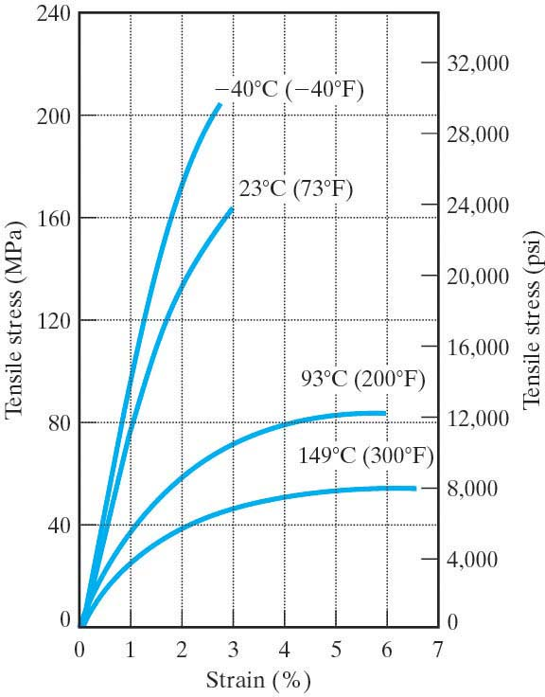

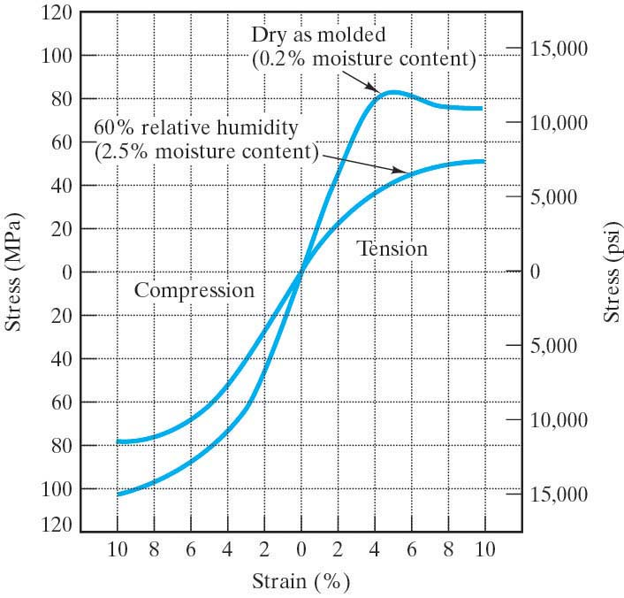

Elastic deformations in thermoplastics come from chains uncoiling and stretching. This is reversible. When forces are removed, the chains revert to their original conformations. On the atomic level the primary bonds are being stretched but not broken.

Plastic deformations come from the chains moving past one another. On the atomic level the secondary bonds are being broken and reformed. Finally, with enough stress, the primary covalent bonds within the chains are broken.

Any double bond on a chain is rotationally rigid and so will restrict ability of chain to rotate freely, making the material more rigid.
Bulky side groups will also restrict chain rotation (called steric hindrance) making the material more rigid.
The property of a polymer can vary greatly with T. Consider the plot of modulus of elasticity as a function of temperature for a typical thermoplastic with approximately 50% crystallinity:
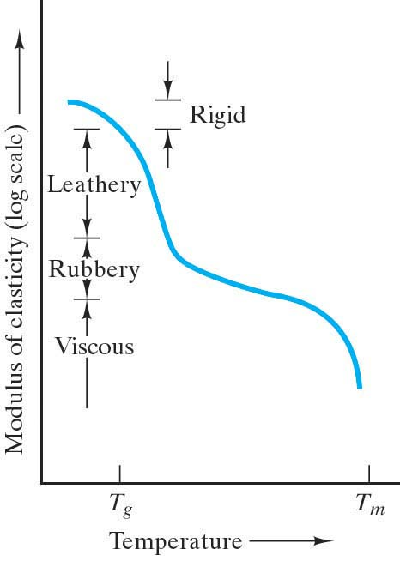
Below T_{g} the polymer behaves like a metal or ceramic. (Although the value of the modulus is substantially lower.)

In the T_{g} range, the modulus drops precipitously and the mechanical behavior is termed leathery – it can be extensively deformed and slowly returns to original shape upon removal of the stress.

Just above T_{g} a rubbery plateau is observed. In this region extensive deformation is possible with rapid spring back to the original shape upon removal of the stress.

Notice that with polymers we have extensive nonlinear elastic deformation.

When T_{m} is reached, the modulus again drops precipitously and we enter the liquid-like viscous region. (A more precise term would be decomposition point rather than a melting point.)

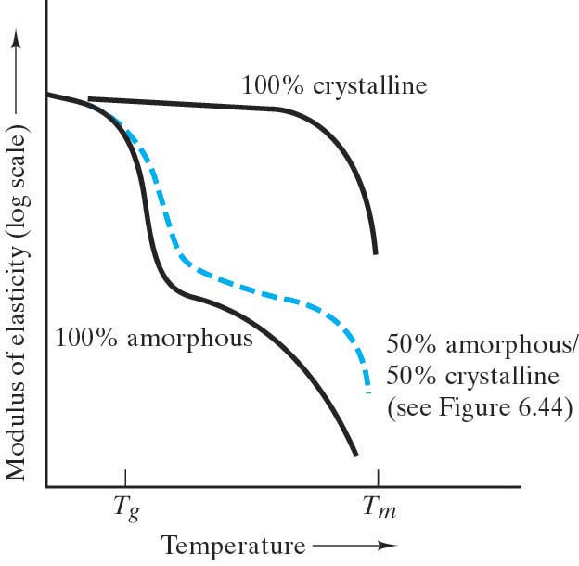
The behavior of the 50% crystalline thermoplastic is midway between the fully crystalline material and a fully amorphous material.

50% amorphous/50% crystalline
(See previous figure)

A structural feature that will affect the mechanical behavior in polymers is cross-linking of adjacent linear molecules to produce a more rigid, network structure. The effect is similar to increasing crystallinity.
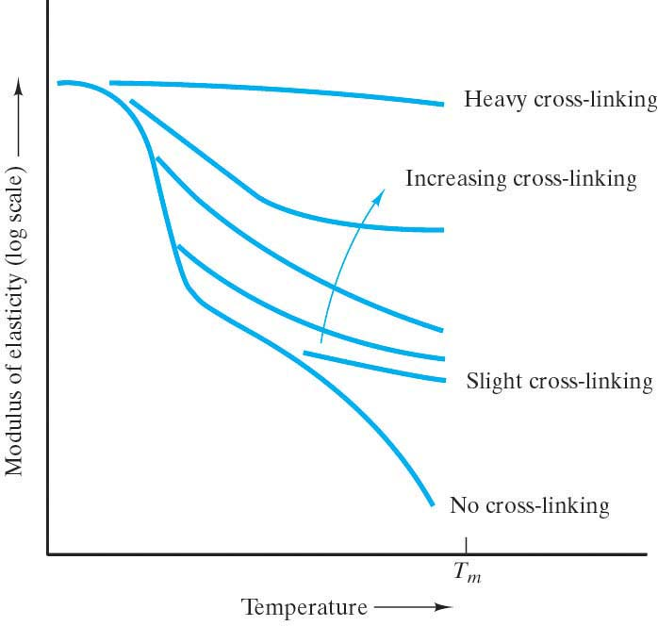

Elastomers
are materials that experience vast elastic deformations. The huge elastic strains in these materials are primarily due to uncoiling of the long chained molecules. Deformation is also due to the sliding of molecular chains over each other (breaking and reforming secondary bonds) and then finally the stretching of primary bonds along the backbone of the carbon chain. Hence the elastic modulus increases with increasing strain as shown here in the stress – strain curve for a typical elastomer:

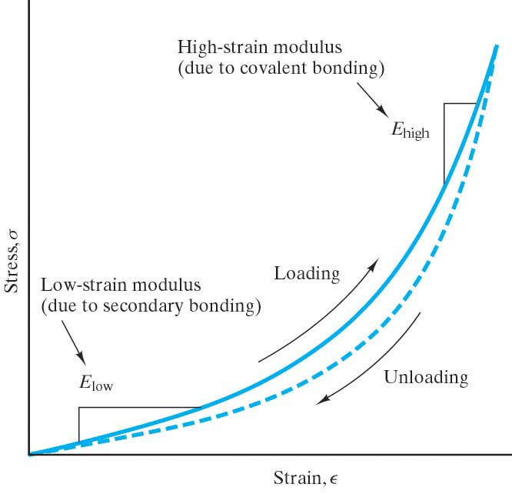
The low strain modulus has a low value because the forces needed to uncoil the molecular chains are small. The high-strain modulus has a higher value because stronger forces are needed to stretch the primary (covalent) bonds. Both regions involve overcoming secondary bonding, which is why the elastic modulus for these materials is significantly less than for metals or ceramics.

Tabulated values for the elastic modulus for elastomers are usually for the low strain regions.

Note that the recoiling of the molecules (during unloading) has a slightly different path than the uncoiling (during loading). This defines hysteresis. Hysteresis is behavior in which a material property plot follows a closed loop. In other words, it does not retrace itself upon the reversal of an independent variable, in this case the stress. The area of the loop is proportional to the energy absorbed in each cycle of the loading.

Deformation of Elastomers
Elastomeric deformations are very large and recoverable. The tensile modulus of elastomers is typically small and varies with strain. (i.e. it is non-linear)

This behavior comes from the elastomeric structure:
- Highly amorphous with twisted, coiled and kinked chains. During deformation, these partially straighten. Upon release of stress, they return to their original conformations.
- Chain bond rotations are free.
Cross-linking provides a mechanism to delay plastic deformation by acting as anchors (chains sliding past one another)
Consider the plot of modulus of elasticity as a function of temperature for a typical elastomer:
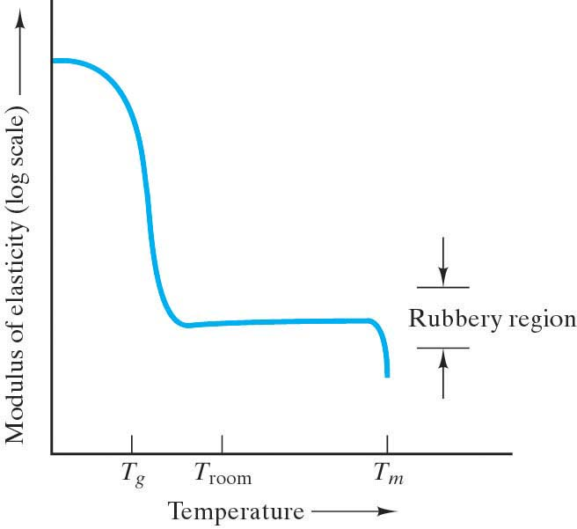
The rubbery plateau is pronounced and establishes the normal room-temperature behavior. (T_{g} is below room temp.)

The plot of modulus of elasticity as a function
of temperature for some commercial elastomers:
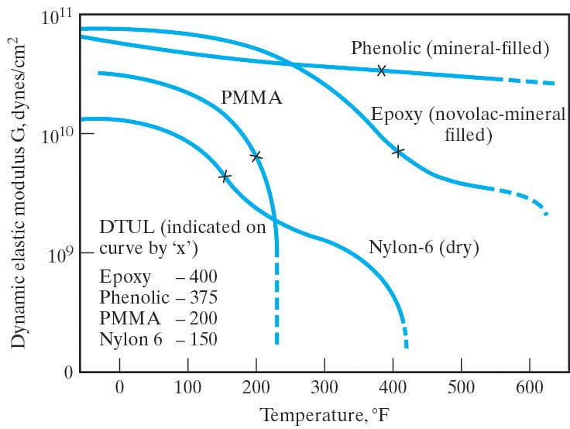
Note: DTUL in these curves is the deflection temperature under load, a parameter frequently associated with T_{g} . (It is defined as the temperature at which a standard test bar deflects a specified distance under a load. It is used to determine short-term heat resistance. It distinguishes between materials that are able to sustain light loads at high temperatures and those that lose their rigidity over a narrow temperature range.)

Drawing
- The polymer analogy to the strain hardening of metals is called drawing. A polymeric tensile specimen develops a neck, like metals do, but the necking extends to the entire length and starts at yielding. In the neck region molecular chains are oriented in the direction of stress and hence the material has become stronger in that direction. (Steps 2 - 4 above.)
- The resulting properties are highly anisotropic. The Tensile Modulus can increase by 3 times in the direction of drawing but be 1/5 the original value at 45º to drawing. The resulting TS in the direction of drawing can be 2-5 times the original TS but in the direction perpendicular to drawing it can be reduced by 1/3 – ½.
- If drawing is done to an amorphous polymer, the temperature must quickly be brought to ambient temperatures, otherwise the effects will be lost.
- Heat treating an un-drawn polymer structure will ↑TM, ↑YS, ↓ Ductility because it will change crystallite size and perfection and the spherulite structure. (Note that this is opposite to what annealing does to a metal.) However, heat treating a drawn polymer structure will do the opposite.

Fracture of Polymers
Elastomers usually have ductile failures but can be brittle below T_{g}.

Thermoplastics can fail in either ductile or brittle mode.
Below T_{g} thermoplastics tend to have elastic behavior and fail in the brittle mode.
Above T_{g} thermoplastics tend to behave plastically or viscously (sometimes called visco-elastic behavior) and fail in the ductile mode.

Thermosets usually have brittle failures.

Strain rate will also affect which mode plastics will fail in: high strain rate will cause brittle failure, low strain rates will cause ductile failure.

Strengthening Mechanisms for Polymeric Materials
To strengthen Thermoplasts:
- Increase MW (However MW does not affect E)
- Increase the secondary bonding forces
(polar side groups, crystallinity, polar atoms such as O, N & S on main chain in the form of amide or ether linkages)
- Decrease chain flexibility/Increase chain stiffness
(double bonds, aromatic groups, bulky and large side groups that all cause steric hindrance)
- Increase cross-linking
- Increase the density of branching
(A small amount of branching may lower strength because it will decrease crystallinity but a lot will increase the strength by reducing chain mobility.)
- Add glass fibers
- Drawing

But, as usual, there will be a corresponding decrease in the ductility.

To strengthen Thermosets:
1. Increase the network.
2. Add glass fibers.

Polymer Additives
Foreign substances to modify and enhance the properties of polymers
- Reinforcements/ fillers
To add strength, stiffness, abrasion resistance, toughness, dimensional & thermal stability, reduce cost. (Examples are wood flour, sand, glass, clay, talc, & limestone.)
- Plasticizers
To increase flexibility, ductility and toughness. Will also lower strength and stiffness.
- Stablizers/Heat Stablizers
To prevent degradations from uv radiation, oxidation and/or heat.
- Colorants
pigments or dyes, to give color, opacity and weatherability.
- Flame Retardants
To reduce combustibility.
- Lubricants
To aid flow and prevent adhesion to metal surfaces.

Polymer Forming Techniques
- Compression & Transfer molding
- Injection molding
- Extrusion
- Blow molding
- Casting
Common Polymeric Materials

General Purpose Thermoplastics
- Polyethylene (PE)
- Polyvinyl Chloride, PVC
- Polypropylene (PP)
- Polystyrene (PS)
- Polyester
- Nylons
- Acrylics (Polymethylmethacrylate, PMMA a.k.a. Lucite or plexiglass)
- Styrene-acrylonitrile (SAN)
- Polyacrylonitrile

Engineering Thermoplastics
- Polyamides (Nylons)
- Acrylonitrile butadiene styrene (ABS)
- Polycarbonates
- Florocarbons (PTFE, PCTFE a.k.a. teflon)
- Phenylene Oxide-based Resins
- Acetals
- Polysulfones
- Polyphenylene Sulfide
- Polymer Alloys
- Thermalplastic Polyesters (PET, PETE)
- Epoxies

Thermosets
- Phenolics
- Epoxy Resins
- Unsaturated Polyesters
- Amino Resins (Ureas & Melamines)

Elastomers
- Natural Rubber (Polyisoprene)
- Synthetic Rubbers
- Styrene Butadiene Rubber
- Nitrile Rubber (Acrylonitrile-butadiene rubber)
- Chloroprene (Neoprene)
- Silicone Rubber (Polysiloxane)

Advanced Polymers
- Ultra high molecular weight polyethylene (UHMWPE)
- Liquid Crystal Polymer
- Thermoplastic elastomers (TPE or just TE)

The word “plastic” is used in many different ways and so can be very confusing. Sometimes it is used as a synonym for the word polymer although this is not strictly correct. Sometimes it is used as a synonym for thermoplastic polymers which is just one of the three classifications of polymers. Sometimes it is used to mean a polymer that has elastic, yielding and plastic regions in the s-e curves, similar to metals. Sometimes it is used to mean the largest category of polymer applications.

