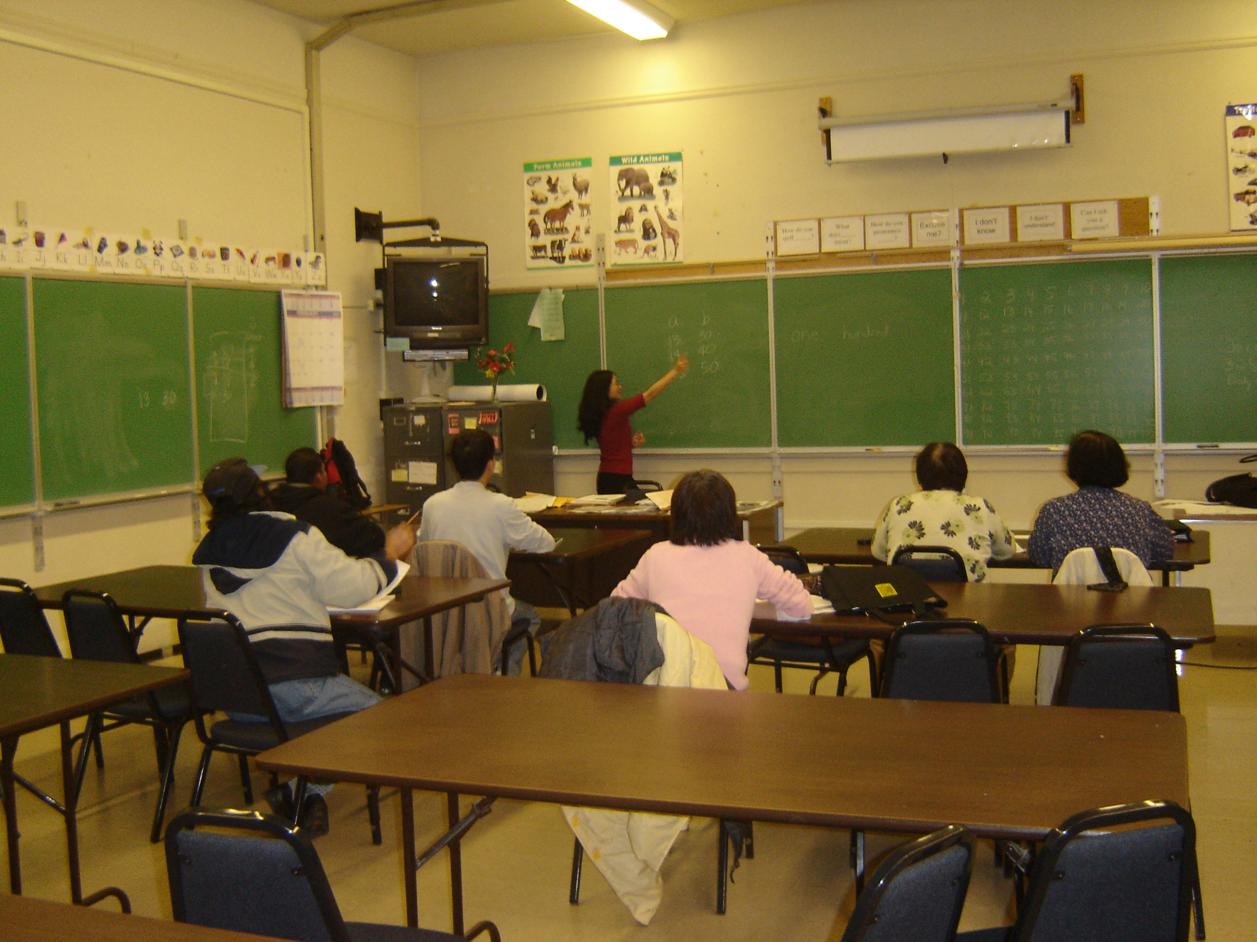

Podcast 11: What time do you wake up?

Open Safari and go to : http://dianewallis.podomatic.com

Click on the episode: What time do you wake up?

Directions: Listen to the conversation and write the times you hear.

 | Question: | Time:
1. | What time do you wake up?
2. | What time do you eat breakfast?
3. | What time do you leave the house?
4. | What time do you start work?
5. | What time do you eat lunch?
6. | What time do you finish work?
7. | What time do you study English?
8. | What time do you get home?
9. | What time do you eat dinner?
10. | What time do you go to bed?

