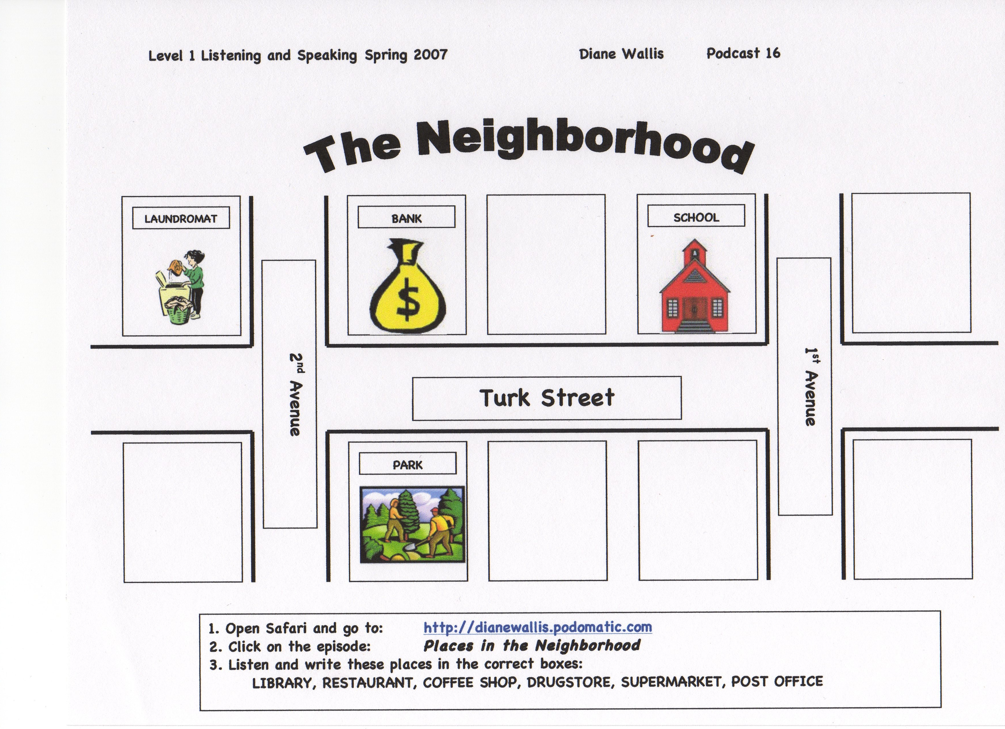
Exercise A

Exercise B

Look at the map from Exercise A.

Listen and circle “yes” or “no”.

1. yes no

2. yes no

3. yes no

4. yes no

Exercise C

Look at the map from Exercise A.
Listen to the questions.
Write your answer.

1.___________________________________________________

2.___________________________________________________

3.___________________________________________________

