Feng Hao Yang
Cooking Lesson
Slice a roast chicken. | 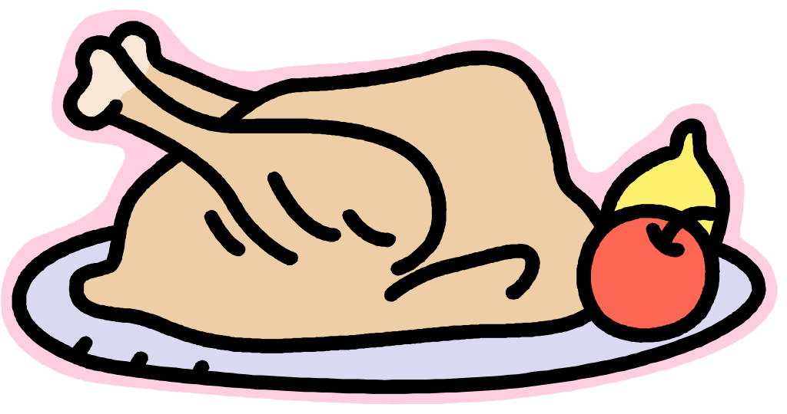
Grate some carrot s. | 
Cut some lettuce and purple cabbage. | 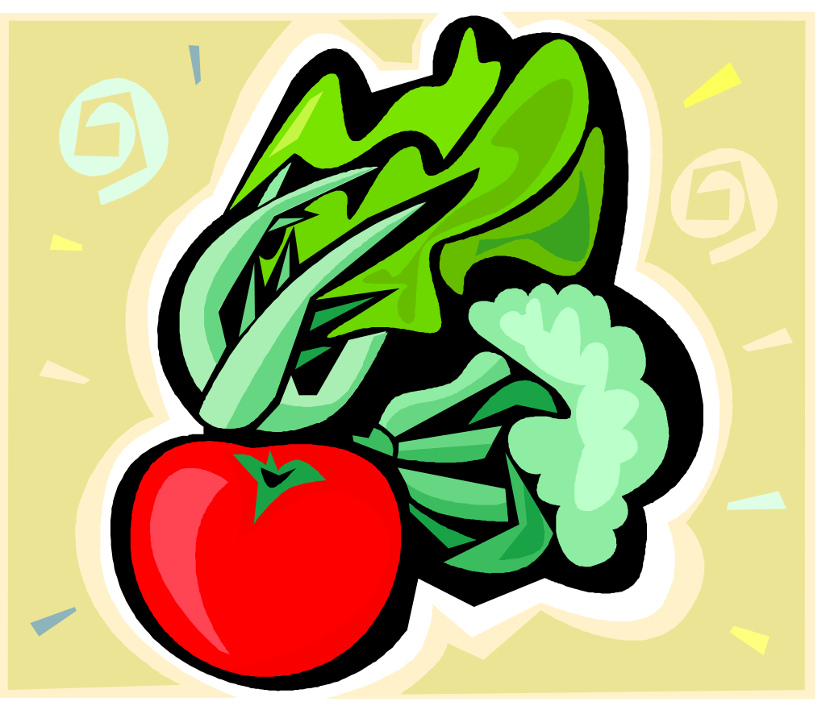
Add some green onion and fried peanut. Stir and serve it with mustard dressing. | 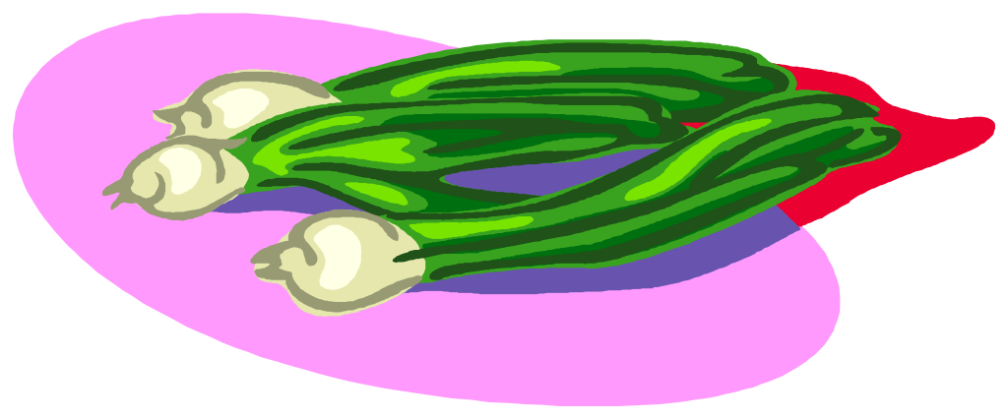
Enjoy your chicken salad. | 

