Activity: File Systems Flashcards
- Open Internet Explorer to my Web page: http://fog.ccsf.cc.ca.us/~sbowne/ and click Flash Cards
- Select Ch1h: File Systems and go through them all
NTFS Permissions (continued) Pages 115-121
Default NTFS Permissions
Newly formatted partition: Full Control for Everyone
New folders or files Inherit permissions from parent folder
New user or group given access to a file or folder Allow Read & Execute, List Folder Contents, and Read
14 NTFS Special Permissions see table 2.9 on pages 117-119
- Traverse Folder/Execute File, List Folder/Read Data, Read Attributes, Read Extended Attributes, Create Files/Write Data, Create Folders/Append Data, Write Attributes, Write Extended Attributes, Delete Subfolders and Files, Delete, Read Permission, Change Permissions, Take Ownership, Synchronize
The five NTFS File Permissions and the six NTFS Folder Permissions we discussed last time are actually combinations of the 14 Special Permissions as shown in the charts on pages 119-120.
Activity: Viewing Special Permissions Page 121
- Log in to your Windows 2000 Professional computer as Administrator.
- Double-click My Computer and double-click the C: drive.
- Right-click the NTFSData folder and select Properties.
- Click the Security tab. Click the Advanced button.
- An Access Control Settings for NTFSData window opens. Highlight the Administrators line and click the View/Edit button. The Permissions Entry For NTFSData window opens, as shown on page 121 in the book.
NTFS Permissions (continued) Pages 122-124
Taking Ownership
- The user who creates a file is that file’s owner
- The owner can grant Take Ownership (or Full Control which includes Take Ownership) permission to another user.
- Any user with Take Ownership permission can make himself or herself the owner of a file
- Administrators can make themselves owners of any file or folder, even if they do not have the Take Ownership permission.
- No one can make someone else the owner of a file – that would amount to hiding the identity of the actual person who took ownership
Copying Files and Folders
Copy within the same NTFS partition | The new object inherits permissions of destination folder
Copy within to a different NTFS partition | The new object inherits permissions of destination folder
Copy to a FAT Partition | All NTFS Permissions are lost

Moving Files and Folders
Move within the same NTFS partition | The new object retains its original permissions
Move to a different NTFS partition | The new object inherits permissions of destination folder
Copy to a FAT Partition | All NTFS Permissions are lost
Activity: NTFS Permissions Flashcards
- Open Internet Explorer to my Web page: http://fog.ccsf.cc.ca.us/~sbowne/ and click Flash Cards
- Select Ch2b: NTFS Permissions and go through them all
NTFS Permissions and Shared Folders Pages 123-124
Share permissions only affect access over the network. They do not protect files from users who log on to the local machine. So NTFS Permissions are also needed to control access to objects in shared folders.
In order to access a shared file, a user must have share access to the containing folder and also NTFS permission to access that file.
If a user has two or more sets of share permissions (for example, by being a member of two groups), and any one share permission allows access to a shared folder, that user can access the folder.
If a user has two or more sets of NTFS permissions (for example, by being a member of two groups), and any one NTFS permission allows access to a folder or file, that user can access the folder or file.
Activity: Combining Share and NTFS Permissions Page 121
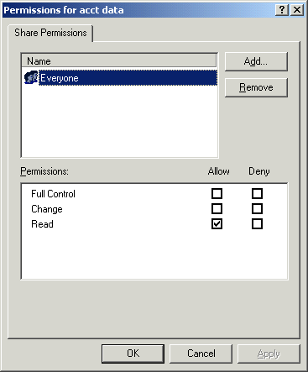
Team up with another student for this activity. One of you is Student A and the other is Student B.
Student A:
- Log in to your Windows 2000 Professional computer as Administrator.
- Double-click My Computer and double-click the C: drive.
- Right-click the Data folder and select Sharing. Make sure that the C:\Data folder is shared as Accounting Data.
- Click the Permissions button. Give Everyone Read permission, but not Full Control or Change as shown in the figure to the right on this page. Click the OK button to close the Permissions for Accounting Data folder. Click the OK button to close the DATA Properties folder.
- Open the DATA folder and create a new text file named ChangeMe. Right-click the ChangeMe file and select Properties. Click the Security tab and verify that Everyone has Full Control. Click OK to close the ChangeMe Properties box.
Student B:
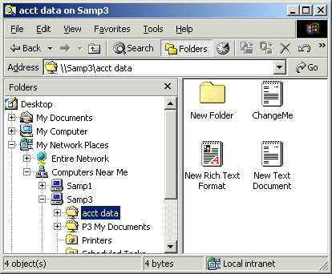
- Log in to your Windows 2000 Professional computer as Administrator.
- Right-click My Network Places and select Explore. Expand My Network Places, and expand Computers Near Me. Find Student A’s machine and expand it to see the shared Accounting Data folder. Open that folder. The ChangeMe file should be visible as shown in the figure to the right on this page.
- Double-click the ChangeMe file to open it in NotePad. Type some letters into the file and click File, Save.
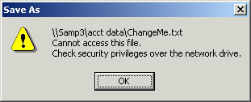
- A Save As dialog box opens, showing that the file will be saved in the shared folder. Click the Save button. A Save As box pops up like the one shown to the right on this page, saying that you lack security privileges to save this file. You have sufficient NTFS permissions, but you lack sufficient share permissions.

