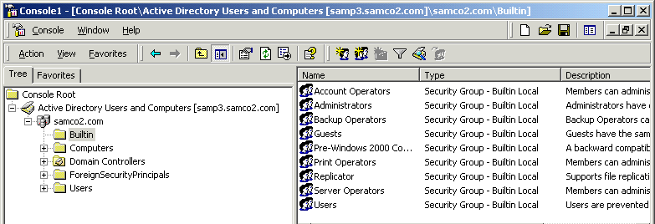
Built-in Domain Local Groups Pages 537-539

Built-in Domain Local Groups have their own folder in Active Directory Users and Computers
  - This window can only be opened on domain controllers
Major Features of Built-in Domain Local Groups (for details see link Pro Ch 7k on my Web Page)
- Account Operators
  - Can create, delete, and modify user accounts and groups
  - Cannot modify Administrators or Domain Controllers
- Administrators
  - Administrators have complete and unrestricted access to the computer/domain
- Backup Operators
  - Backup Operators can override security restrictions for the sole purpose of backing up or restoring files
- Guests
  - Guests have the same access as members of the Users group by default, except for the Guest account which is further restricted
- Pre-Windows 2000 Compatible Access
  - A backward compatibility group which allows read access on all users and groups in the domain
  - Add Everyone to this folder to support legacy Windows NT resources
- Print Operators: Members can administer domain printers
- Replicator Supports file replication in a domain
- Server Operators Members can administer domain servers
- Users
  - Users are prevented from making accidental or intentional system-wide changes. Thus, Users can run certified applications, but not most legacy applications
Built-in Global Groups (on Domain Controllers) Pages 539-540
- Domain Admins: Designated administrators of the domain.
- Domain Admins have administrative privileges at every level in the domain, because
  - The Domain Admins group is automatically added to the Administrators domain local group and to the local Administrators group on every machine in the domain.
- Domain Guests: All domain guests.
- Domain Users: All domain users.
- Enterprise Admins: Even more powerful than Domain Admins
  - The Enterprise Admins group is added to the Domain Admins global group for all the domains in the enterprise

Special Groups (the most common ones) Pages 540-541
- Special groups are managed by the system, and not by administrators
- They are also automatically installed on all Windows 2000 computers
- They do not appear as groups in Active Directory Users and Computers, or in the Computer Management Tool, however.
- They can be used when assigning permissions to resources
    - To see them, right-click an NTFS folder, click Properties, on the Security tab, click Add
  - Everyone
    - All current network users, including guests and users from other domains. Whenever a user logs on to the network, they are automatically added to the Everyone group.
  - Authenticated Users
    - All users with valid computer accounts on the computer or in Active Directory. A more restrictive group to use than the Everyone group, because users can connect from another domain without having an account on your domain.
    - For example, consider a parent domain named Bigco.com with two child domains sf.Bigco.com and ny.Bigco.com. A printer in the sf office could be named printer1.sf.Bigco.com. If that printer were available to Everyone, users in ny.Bigco.com could use it even if they did not have accounts in the sf.Bigco.com domain. If the printer were only available to Authenticated Users, only users with a valid account in the sf.Bigco.com domain could access the printer.
  - Network
    - Users currently accessing a given resource over the network (as opposed to users who access a resource by logging on locally at the computer where the resource is located). Whenever a user accesses a given resource over the network, they are automatically added to the Network group.
  - Interactive
    - All users currently logged on to a particular computer and accessing a given resource located on that computer (as opposed to users who access the resource over the network). Whenever a user accesses a given resource on the computer to which they are currently logged on, they are automatically added to the Interactive group.
  - Creator Owner
    - The user account that created or took ownership of the resource
      - Portions from link Pro Ch 7l on my Web page (by Douglas Ludens at about.com)
User Rights Pages 541-549
- User Rights specify what users can do, and the rights of the built-in local groups can be modified in Local Group Policy
Activity: Viewing User Rights on a Windows 2000 Professional Machine
- Click Start, Run, and enter gpedit.msc to open Group Policy
- Expand: Local Computer Policy, Computer Configuration, Windows Settings, Security Settings, Local Policies
- Click User Rights Assignment. Your screen should look like the figure on the next page
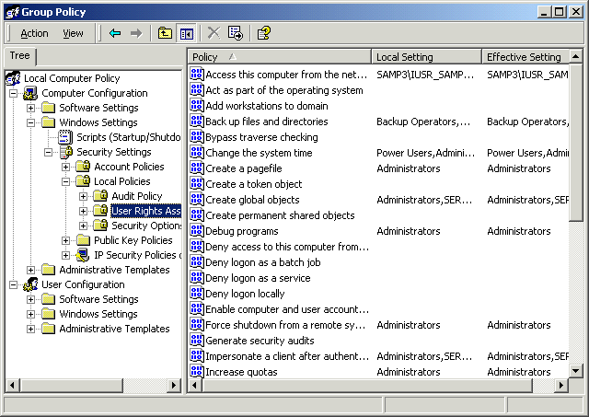
These are the User Rights
Note these important ones, which are detailed in your textbook on pages 544-547
- Access this Computer from the Network
- Backup files and directories
- Bypass traverse checking
- Change the system time
- Create a pagefile
- Deny Access to this computer from the network This right prevents its members from accessing the computer from the network
- Deny local logon This right prevents its members from logging on
- Force shutdown from a remote system
- Increase quotas Note: textbook is wrong on p. 546, this refers to processor quotas, not disk quotas
- Load and unload device drivers
- Log on locally
- Manage auditing and security log
- Restore files and directories
- Shut down the system
- Take ownership of files or other objects
The Administrators group has all the rights listed above by default, except Deny Access to this computer from the network and Deny local logon
All the User Rights are on link Pro Ch 7l on my Web page.

Local Group Policy Pages 549-550
Local Group Policy can also be used to control
- Administrative templates: Registry-based settings to control logon messages and many other things
- Software settings: Used to deploy software using Windows Installer
- Security Settings: Password policies and other security settings
- Scripts: Scripts may run at Logon, Logoff, Startup, or Shut Down
- Folder Redirection: Used to move the My Documents and other folders to the server. Only available in Domain Group Policy Objects.
Password Policies Pages 550-553
Password policies can be set in Group Policy
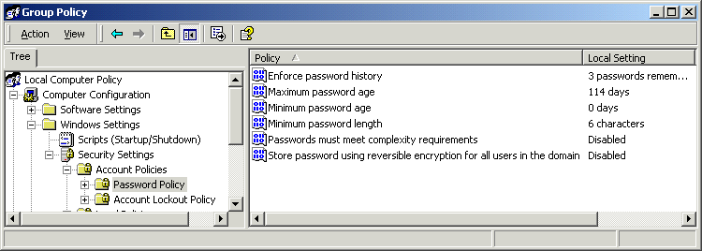
- Expand Local Computer Policy, Computer Configuration, Windows Settings, Security Settings, Account Policies, then click Password Policy

Account Lockout Policy
- Account Lockout Duration
- Account Lockout Threshold
- Reset Account Lockout Counter After
Monitoring Security Events Pages 553-556
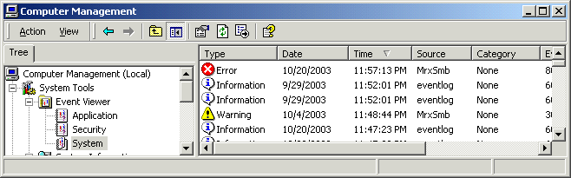
Events are recorded in Event Logs
- Event Viewer is located in Computer Management
- Right-click My Computer and select Manage
There are three types of logs:
- System log contains events logged by system components, such as drivers that failed
- Application log contains events logged by applications, and by services such as DHCP and DNS
- Security log contains security events such as logon and logoff attempts, but only if the Administrator has activated Auditing.
Event Types
- Error: a significant problem, such as a service that cannot load
- Warning: An event that may lead to trouble, such as low disk space
- Information: A normal event, such as loading a device driver
- Success Audit (security logs only): the user’s attempt succeeded, such as a successful logon
- Failure Audit (security logs only): the user’s attempt failed, such as a failed logon
Activity: Viewing System Log Events
Clearing the System Log
- Right-click My Computer and select Manage
- Under System Tools, expand Event Viewer.
- Right-click on System in the left pane, and select Clear All Events
- Click No in the pop-up box asking if you want to save the log.
Logging in Unsuccessfully
- Click Start, Shut Down, Log Off, OK
- Attempt to log in as Administrator with a password of xyz (or any other wrong password)
Logging in Successfully
- Log in as Administrator with the correct password
Viewing the System Log
- Right-click My Computer and select Manage
- Under System Tools, expand Event Viewer.
- Click on System in the left pane
- Open Internet Explorer and verify that you are connected to the Internet
- Unplug your network cable from the wall
- Refresh the Internet Explorer window and verify that you get a “The page cannot be displayed” error
- Make Computer Management the active window and press the F5 key to refresh it
- You should see an Information event. Double-click on the event to see its details. It should say that the network adapter was disconnected.
- Plug your network cable back in.
- Refresh the Internet Explorer window and verify that you are connected to the Internet again
- Make Computer Management the active window and press the F5 key to refresh it.
- Double-click any additional events that have appeared: there should be at least one new Information event showing that the network adapter was connected, as shown in the figure below.
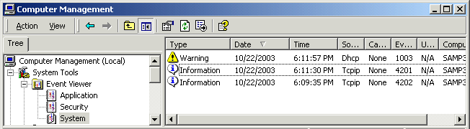

Audit Policies Pages 553-561
An audit policy defines what will be recorded in the security log
Security Event Categories (see details on pages 557-558)
- Account logon logs an event each time a user attempts to log on
- Logon events logs an event when logon events occur over the network, or are generated by services starting up
- Account Management
- Directory service events in Active Directory
- Policy change
- Process tracking
- Object access monitor access to a printer, shared folder, etc. (detailed chart on page 559)
- Privilege use used to monitor administrators
- System event Startup and shutdown events
Activity: Using Auditing
Opening Group Policy
- Click Start, Run, and enter gpedit.msc to open Group Policy
- Expand: Local Computer Policy, Computer Configuration, Windows Settings, Security Settings, Local Policies
- Click Audit Policy.
Enabling Auditing for Logon Events
- Double-click Audit account logon events. A Local Security Policy Setting box opens.
- Check both the Success and Failure check boxes and click OK.
Enabling Auditing for Object Access
- Double-click Audit object access. A Local Security Policy Setting box opens.
- Check both the Success and Failure check boxes and click OK.
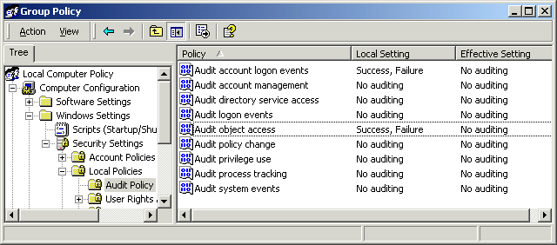
- Your screen should look like the figure below. Note that although the Local Setting column shows the auditing you specified, the Effective Setting shows No Auditing. That’s because the changes you made only take effect when you close Group Policy.
- Close Group Policy.

Viewing Logon Events
- Log off and attempt to log in as Administrator with an incorrect password, such as xyz.
- Log in as Administrator with the correct password.
- Right-click My Computer and select Manage
- Under System Tools, expand Event Viewer.
- Click on Security in the left pane. You should find a Failure Audit in the category Account Logon, and a Success Audit in the category Account Logon. Double-click those events and read the details.
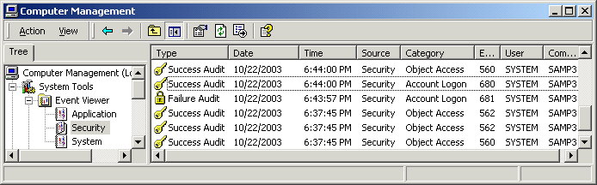
- There may be other events in the Security log, because a log on creates system access events, but those may vary from machine to machine.

Attempting to View Object Access Events
- Find the exact date and time of the latest entry in the Security log. You can sort the log by date by clicking on the gray Date column header. Write the date & time here: _________________________
- Locate a shared folder on your machine. If necessary, create a new folder and share it.
- Get another student to open My Network Places and navigate to the shared folder on your machine. To make sure the folder is being accessed, create a text document in it from another machine.
- Close Computer Management.
- Right-click My Computer and select Manage.
- Under System Tools, expand Event Viewer.
- Click on Security in the left pane. What new events are there? (Refer to the date & time you wrote in step 16.) There should be new Account Logon events because the other student generated network events by accessing a shared folder, but are there any new Object Access events?
- The reason there are no new Object Access events is that it only audits access to objects that have a System Access Control List (SACL) specified. Some system objects may have a SACL, but user-created objects do not have a SACL until it is specified on the Properties page.

Specifying a System Access Control List (SACL) for the Shared Folder
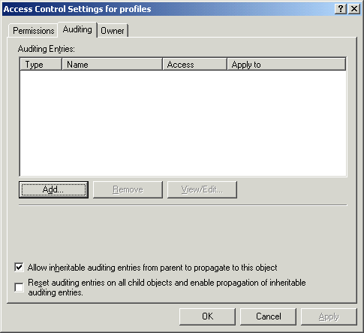
- Navigate to your shared folder (usually on the root of C:), right-click it and select Properties. Click the Security tab and click the Advanced button to open a Access Control Settings for Profiles window, as shown to the right on this page. Click the Auditing tab.
- The Auditing Entries list shows whose access events will be audited. Click the Add button to open a Select User or Group window.
- Select Everyone and click OK.

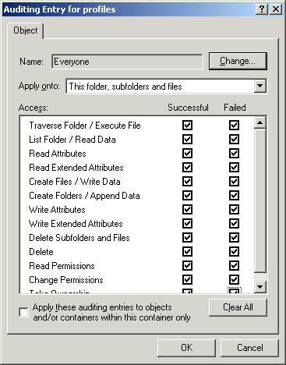
- An Auditing Entry for Profiles window opens as shown to the right. Here you can choose which actions will be audited. Select all the boxes and click the OK button.
- Click the OK button to close the Access Control Settings for Profiles window.
- Click the OK button to close the Profiles Properties window.

Viewing Object Access Events
- Open Computer Management if necessary, and navigate to Event Viewer.
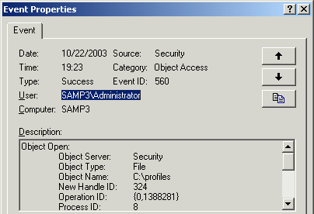
- Find the exact date and time of the latest entry in the Security log. You can sort the log by date by clicking on the gray Date column header. Write the date & time here: _________________________
- Get another student to open My Network Places and navigate to the shared folder on your machine. To make sure the folder is being accessed, create a text document in it from another machine.
- Close Computer Management.
- Re-open Computer Management, and navigate to Event Viewer.
- Click on Security in the left pane. Look for new Security events in the Category of Object Access and an Event code of 560. Double-click one of them and look at the Object Name. You should see the path to your network share, as shown in the example to the right on this page.

Security Configurations Pages 561-570
Skip it, we’ve already done enough of that

Notes:
- By default, Windows 2000 applies basicwk.inf, basicsv.inf, or basicdc,inf to newly installed Windows 2000 machines
- No security template is applied to a machine that is upgraded to Windows 2000
- Compatws.inf is the Security template that makes sure legacy applications will run on Windows 2000
- The High Security templates hisecdc.inf and hisecws.inf require Windows 2000 or greater on all machines. If you have older operating systems like Win NT or Win 9x in the network, use Compatws.inf.
Encrypting File System (EFS) Pages 570-574
Skip it, we’ve already done enough of that

Notes:
- EFS lets the user encrypt files using encryption keys that are managed by Windows 2000 Public Key Infrastructure (PKI) services.
- Encrypted files can only be opened by the user who created them, or by the recovery agent
- The default recovery agent is the Administrator
In-Class Assignment: Ch7a: Users and Groups with Instant Test 3 pts
- Open Internet Explorer to my Web page: http://fog.ccsf.cc.ca.us/~sbowne/ and click Flash Cards
- Select Ch7a: Users and Groups and go through them all. Then take the Instant Test.

