Local Users and Groups Page 87-98
Discretionary Access Control List (DACL)
- The list of users or groups given access to a network share
- Groups make security control easier to configure and maintain
Local Groups
- Created in Computer Management in Local Users and Groups
- Used to control access to resources on a specific machine
- Used in workgroups
- Still have effects in Domain environments
  - If a local administrator removes the Domain Admins group from the local Administrators group, they will no longer have administrative rights for local resources
Domain Groups
- Created in Active Directory Users and Groups on a domain controller
- Global Groups
- Domain Local Groups
- Universal Groups
- Used in Domains, and stored on domain controllers in Active Directory
Managing Groups
- Groups can be renamed or deleted
- Deleted groups vanish from all the DACL they are on, which can have unintended effects
Configuring and Controlling Shared Access Page 99-106
There are three main server roles
- File server
- Print server
- Application server
File Server
- To share folders (or drives), the server must have these things:
  - The Server service must be running
  - The data must be present in the folder
  - The folder (or drive) must be shared
- The Server service lets a computer share files, and it runs on both client and server versions of Windows
  - Windows 95 & 98 calls the server service File and Print Sharing
  - In Windows 2000 Professional and Windows 2000 Server, you can start and stop the Server service in
    - Control Panel, Administrative Tools, Services, or
    - Start, Programs, Administrative Tools, Services
  - If you right-click the Server service, you can Start, Stop, Pause, Resume, or Restart it
    - Pause lets the current clients continue using it, but does not let new clients connect to it
- To share a folder, a user must be in either the Administrators or Power Users group on the local machine
  - This applies to workgroups, and to clients and member servers in a domain environment
    - The Domain Admins domain group is automatically added to the Administrators group on every machine that joins the domain
  - Domain Controllers do not use Local Users and Groups at all – they use only Active Directory Users and Computers
- Share permissions are Full Control, Change, and Read
  - Full Control allows NTFS permissions to be changed over the network, but Change and Read share permissions do not
  - If a user has more than one set of share permissions in effect, due to group membership, the least restrictive one takes effect, unless there are Deny permissions
  - Deny permissions over-ride all other permissions
Activity: Shared Folders and Subfolders discussed on pages 105-106
Shared subfolders are like shortcuts: if a user opens them directly, they are unaffected by share permissions of the parent folder. This can cause strange security holes, like the one you will set up below.
  - This activity can be done on any network, either a domain using our hubs or the normal classroom network
  - You will need two machines, and two students working together: one File Server and one Client. The machines may be running Windows 2000 Professional or Windows 2000 server.
Creating the Parent Folder Pictures
- On the File Server machine, create a folder in the root of C: named Pictures.
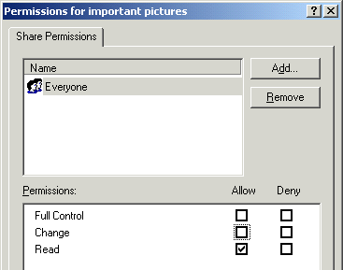
- Right-click the Pictures folder and select Sharing. Click the Share this folder radio button and click the Permissions button. Verify that Everyone has Full Control.. Click OK. Click OK.
Creating the important pictures Subfolder
- On the File Server machine, open the Pictures folder
- Create a new folder named important pictures in the Pictures folder.
- Right-click the important pictures folder and select Sharing. Click the Share this folder radio button and click the Permissions button. Change the permissions to Read only as shown in the figure to the right. Click OK. Click OK.

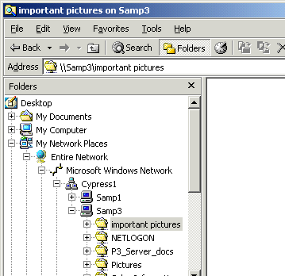
Using the important pictures Subfolder
- On the Client machine, right-click My Network Places and navigate to the shared folder important pictures, as shown in the figure to the right on this page.
- Right-click in the right pane, and select New, Text Document. Can you create a new document in this folder? You should receive an “Access Denied” message, because this folder is shared as read-only.
Using the Pictures folder
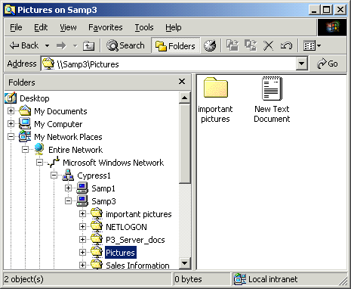
- On the Client machine, right-click My Network Places and navigate to the shared folder Pictures, as shown in the figure to the right on this page.
- Right-click in the right pane, and select New, Text Document. You can create a document in this folder, because the sharing permissions give Full Control to Everyone.

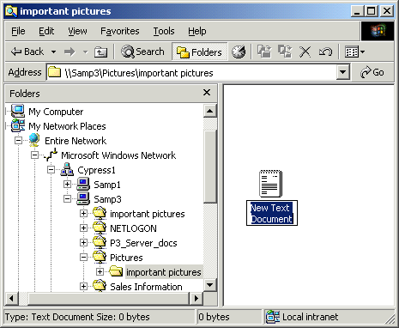
- Double-click the important pictures folder in the right pane to open the important pictures folder, as shown in the figure to the right on this page.
- Attempt to create a new text document inside it. You should be able to, because Everyone has Full Control of the Pictures folder and all subfolders opened from within it.
Compare the important pictures window to the right on this page with the important pictures on SamP3a window on the previous page. Make sure you understand this point: the same folder has different share permissions depending on how you open it.

Configuring and Controlling Local Access Page 107-114
This is a review of NTFS permissions and taking ownership. We have already covered it.

When Local File Security Interacts with Shared Folder Security Page 115-116
- To use a resource locally (INTERACTIVE), you need appropriate NTFS Permissions
- To access a resource over the network (NETWORK), you need both appropriate Share Permissions and NTFS Permissions
- If you want to simplify things and ensure that INTERACTIVE and NETWORK permissions are the same, do these three things:
  - Set all share permissions to Authenticated Users with Full Control
  - Ensure that the host partition is formatted with NTFS
  - Control access with NTFS permissions
The Distributed File System (Dfs) Page 116-126
Dfs provides the ability to logically group shared folders on different servers and to transparently link shared folders into a single, hierarchical namespace.
- If you have only one file sever, it’s easy to find shared folders
- If you have many servers, you can have trouble finding shares, and you may want to gather the shares all into one structure for organization: the Dfs structure
- Dfs Advantages:
  - Name transparency : Users can navigate the logical namespace without having to know the physical locations of the data.
  - Load sharing: Roots and replicas hosted on two or more computers provide load sharing. As users request files from the node in the Dfs namespace, they randomly select one of the computers for the accessed node.
  - Availability: Keeps important data accessible at all times, even when a server or disk drive fails or when a shared folder or file becomes corrupted.
    - For the full lost of advantages, see link Srv Ch 2c on my Web page.
- There are two types of Dfs: Standalone Dfs and Domain-Based Dfs
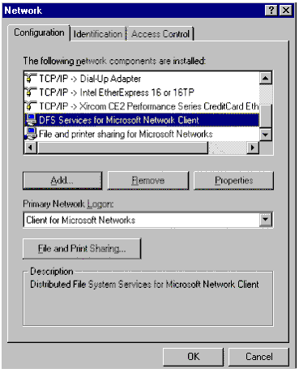
- Standalone Dfs
  - Controlled by a single server (the Dfs root server)
  - Not fault-tolerant: if the Dfs root server goes down, the whole Dfs structure is inaccessible
- Domain-Based Dfs
  - Controlled by Active Directory on one or more domain controllers
  - Active Directory is replicated to all the domain controllers, so failure of a domain controller will not make the Dfs structure inaccessible
  - The child nodes (shared folders) can also be replicated to redundant locations, providing fault-tolerance at that level as well
- Dfs support is included in Windows NT 4.0 (all versions) and Windows 2000 (all versions).
- To use Windows 95 or Windows 98 as a Dfs client, install the DFS Services for Microsoft Network Client found on the Windows 2000 Server installation CD-ROM in the path Clients\Win9x.

Activity: Making a Standalone Dfs Structure Pages 117-122
  - This activity can be done on any network, either a domain using our hubs or the normal classroom network
  - You will need two machines, and two students working together: one Dfs Root Server and one File Server. The Dfs Root Server must be running Windows 2000 server. The File Server may be running Windows 2000 Professional or Windows 2000 server.
Installing a Standalone Dfs Root
- On the File Server machine, create a folder in the root of C: named Fruits. Share that folder with the default share permissions.
- On the Dfs Root Server machine, create a folder in the root of C: named Vegetables. Share that folder with the default share permissions.
- On the Dfs Root Server machine, create a folder in the root of C: named Food. Share that folder with the default share permissions.
- On the Dfs Root Server machine, click Start, Programs, Administrative Tools, Distributed File System.
- In the Distributed File System window, select Action, New Dfs Root from the menu bar.
- The New Dfs Root Wizard opens. Click Next.
- In the Select the Dfs Root Type screen, click Create a standalone Dfs root and click Next.
- In the Specify the Host Server for the Dfs Root screen, click Browse, find your Dfs Root Server in the list, click it and click OK. Click Next.
- In the Specify the Dfs Root Share screen, verify that the Use an existing share radio button is selected, click the drop-down box arrow, and select Food. Click Next.
- In the Name the Dfs Root screen, accept the defaults and click Next.
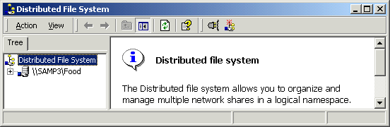
- In the Completing the New Dfs Root Wizard screen, click Finish. Your Dfs root should appear in the Distributed File System window as shown below.

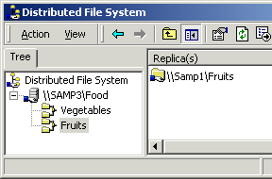
Adding Dfs Links to a Dfs Root
- On the Dfs Root Server, in the Distributed File System window, right-click the Food Dfs link and select New Dfs Link.
- In the Create a New Dfs Link window, enter a Link name: of Vegetables.
- Click the Browse button and navigate to your shared Vegetables folder. Select it and click OK. Click OK.
- Repeat Steps 12-14, adding Fruits from your file server. The final Dfs structure should look like the example to the right on this page.
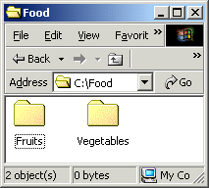
Viewing the Dfs Structure From My Computer on the Dfs Root Server
- On the Dfs Root Server, double-click My Computer and double-click C:. Find the Food folder and double-click it. You should see Fruits and Vegetables folders inside it, as shown in the figure to the right on this page.
- Double-click the Fruits folder. You cannot open it – an Access is denied window opens. Double-click the Vegetables folder. You cannot open it either. The reason is that those folders are not really subfolders of C:\Food:. The Vegetables folder is in the root of C:, and the Fruits folder is on a different machine altogether. Opening a Dfs structure through My Computer is the wrong way to access a Dfs structure.
Viewing the Dfs Structure From My Network Places
- On the Dfs Root Server right-click My Network Places and select Explore Expand Entire Network, Microsoft Windows Network, and navigate to Dfs Root Server. Open the Food folder. You should see Fruits and Vegetables folders inside it, as shown in the figure below.
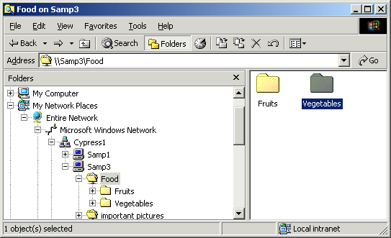
- Double-click the Fruits folder. It should open. Right-click inside it and create a text file named Pear.txt
- Double-click the Vegetables folder. It should open. Right-click inside it and create a text file named Corn.txt
- On the File Server, double-click My Computer and double-click C:. Find the Fruits folder and double-click it. You should see the Pear.txt file that was created from the Dfs Root Server.
- On the File Server right-click My Network Places and select Explore Expand Entire Network, Microsoft Windows Network, and navigate to Dfs Root Server. Open the Food folder. You should see Fruits and Vegetables folders inside it, as shown in the figure above. The Dfs structures is available from each machine in the network, with the same path.

Removing the Dfs Root
- On the Dfs Root Server machine, click Start, Programs, Administrative Tools, Distributed File System.
- In the Distributed File System window, right-click the Food Dfs link and select Delete Dfs Link. Click Yes in the pop-up box.
Activity: Making a Domain-Based Dfs Structure Pages 117-122
  - This activity must be done on your domains, with the domain controller unplugged from the wall and connected to at least one member machine with a hub
  - You will need two machines, and two students working together: one Domain Controller and one File Server. Both the Domain Controller and the File Server must be running Windows 2000 Server.
Installing a Domain-based Dfs Root
- Verify that you have a shared folder named Fruits on the File Server machine, shared with Full Control for Everyone.
- Verify that you have shared folders on the Domain Controller named Vegetables and Food, shared with Full Control for Everyone.
- On the Domain Controller, click Start, Programs, Administrative Tools, Distributed File System.
- In the Distributed File System window, select Action, New Dfs Root from the menu bar.
- The New Dfs Root Wizard opens. Click Next.
- In the Select the Dfs Root Type screen, click Create a domain Dfs root and click Next.
- In the Specify the Host Domain for the Dfs Root screen, verify that your domain name is filled in and click Next.
- In the Specify the Host Server for the Dfs Root screen, verify that your Domain Controller’s DNS name is filled in, and click Next.
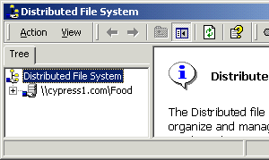
- In the Specify the Dfs Root Share screen, verify that the Use an existing share radio button is selected, click the drop-down box arrow, and select Food. Click Next.
- In the Name the Dfs Root screen, accept the defaults and click Next.
- In the Completing the New Dfs Root Wizard screen, click Finish. Your Dfs root should appear in the Distributed File System window as shown in the figure to the right on this page.

Adding Dfs Links to a Dfs Root
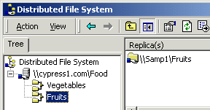
- On Domain Controller, in the Distributed File System window, right-click the Food Dfs link and select New Dfs Link.
- In the Create a New Dfs Link window, enter a Link name: of Vegetables.
- Click the Browse button and navigate to your shared Vegetables folder. Select it and click OK. Click OK.
- Repeat Steps 12-14, adding Fruits from your file server. The final Dfs structure should look like the example to the right on this page.

Creating and Enabling a Dfs Root Replica
- This process will create a replica of the Dfs root on your File Server. To make a place for it, create a new shared folder in the root of C: on your File Server named FoodReplica. Share it with the default permission (Full Control for Everyone).
- On the Dfs Root Server, in the Distributed File System window, right-click the Food Dfs link and select New Root Replica.
- In the New Dfs Root Wizard window, click the Browse button, and select your File Server. Click OK. Click Next.
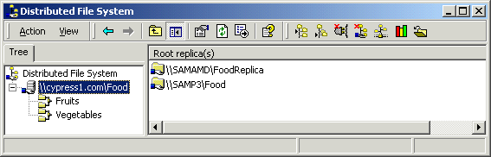
- In the Specify the Dfs Root Share window, click the Use an Existing Share button, and select FoodReplica. Click Finish. You should see the two Root replicas in the right pane of the Distributed File System as shown below.

- At this point, the folders are prepared for fault tolerance, but no replication policy has been configured, so the replica will not be synchronized with the original Dfs root. To make the fault-tolerance work, do the following steps.

Enabling Dfs Root Replication
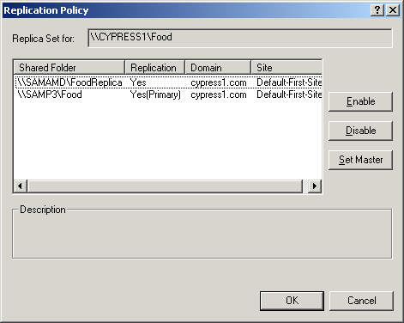
- On the Dfs Root Server, in the Distributed File System window, right-click the Food Dfs link and select Replication Policy.
- In the Replication Policy window, both Food and FoodReplica appear. Click on Food and click the Enable button. Click on FoodReplica and click the Enable button. Your screen should now look like the example to the right, with Food as the Primary – it is the initial master that will be replicated to FoodReplica. Click OK. Click Next.
- Now the Dfs root has been made fault-tolerant: if a server fails, it will still work. But the data in the folders is not fault-tolerant, so that’s the next activity.

Configuring Folder Replication in a Domain-Based Dfs
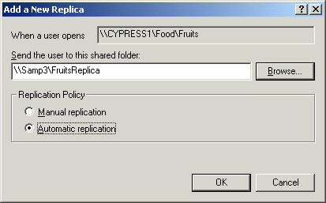
- The original Fruits folder is on the File Server. This process will create a replica of the Fruits folder on the Domain Controller. To make a place for it, create a new shared folder in the root of C: on your DomainController named FruitsReplica. Share it with the default permission (Full Control for Everyone).
- On the Dfs Root Server, in the Distributed File System window, right-click the Fruits folder in the left pane and select New Replica….
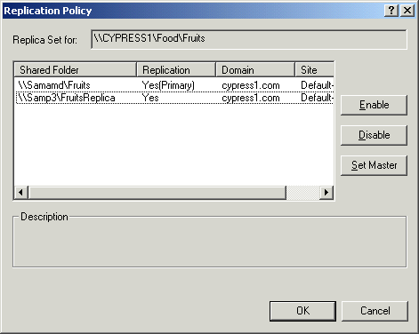
- In the Add a New Replica window, click the Browse button, and navigate to the FruitsReplica folder on your Domain Controller. Click OK. Click the Automatic replication radio button. Your screen should look like the example to the right on this page. Click OK.
- The Replication Policy window appears. Click on Fruits and click the Enable button. Click on FruitsReplica and click the Enable button. Your screen should now look like the example to the right, with Fruits as the Primary – it is the initial master that will be replicated to FruitsReplica. Click OK. Click Next.

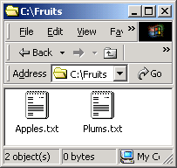
Observing Replication
- On the File Server, open the C:\Fruits folder. Leave it open so you can see its contents, as shown to the right on this page.

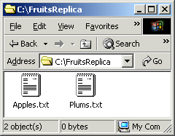

- On the Domain Controller, open the C:\FruitsReplica folder, as shown to the right on this page. Right-click in the empty space in the C:\FruitsReplica window and create a new text file named Plums.txt.
- Watch the C:\Fruits folder on the File Server. A new file should appear within a minute or two. You may have to press the F5 key to refresh the screen to see it with its correct name.

In-Class Assignment: Pro Ch2a: Dfs Flashcards with Instant Test 3 pts
- Open Internet Explorer to my Web page: http://fog.ccsf.cc.ca.us/~sbowne/ and click Flash Cards
- Select Pro Ch2a: Dfs and go through them all. Then take the Instant Test.

