Monitoring and Optimizing System Resource Use Pages 267-269
Establish a baseline by measuring performance when your server is working well, to detect and prevent problems, by monitoring:
- Memory
- Processor
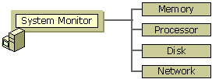
- Hard disk
- Network card(s)
Performance Monitor
- Four methods available for collecting data
  - System monitor
    - Used to see what’s happening right now on the server
  - Counter logs
    - Save performance data for later reference, or to average over hours or days
    - Saves data at specified time intervals, such as every 15 seconds
    - Caution: Logs can fill your hard disk, so you may want to put them on a separate partition
    - Logs can be viewed with Performance Monitor, Microsoft Excel, or other programs
  - Trace logs
    - Saves data when specified events occur, such as Process creations/deletions or Disk input/output
    - Saves the log in a proprietary .ETL file format
    - No utility is provided with Windows 2000 to view the results of the trace log,
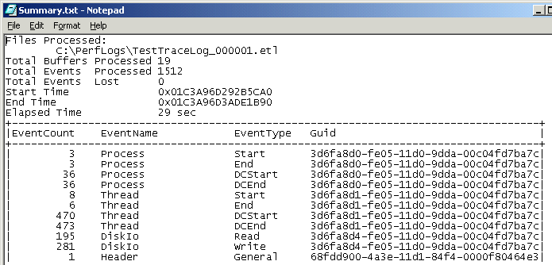
    - The necessary utilities are in the Windows 2000 Resource Kit, and can be downloaded from links Srv Ch 4b and 4c on my Web page
    - Even if you use those tools, the data is very confusing: all you get is a bunch of long Guid numbers as shown to the right
  - Alerts
    - Log an entry in the event log, or take some other action, when a counter reaches a certain level
- Three types of data
  - Object – the software or device being monitored, such as memory or processor
  - Counter – a specific statistic for an object, such as Available Bytes for the Memory object
  - Instance – a specific occurrence of an object you are watching, if you have two or more similar devices.
    - For example, in a two-processor system you have three instances: 0, 1, and _Total

Activity: Using System Monitor Pages 270-274
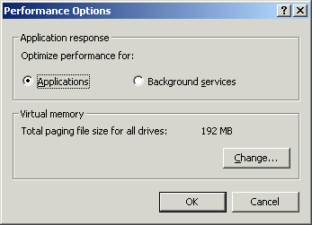
This activity can be done on any Windows 2000 Server machine, regardless of its network connections.
Enabling Priority Boost
- Right-click My Computer and click Properties. Click the Advanced tab. Click the Performance Options button. A Performance Options window opens as shown in the figure to the right on this page.
- Verify that the Applications radio button is selected. Click OK. Click OK. This enables the Priority Boost so that foreground processes get more priority.
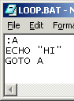
Writing the LOOP.BAT Test File
- You should already have the C:\LOOP.BAT test file on your hard drive. If you do not, type it into Notepad as shown in the figure to the right and save it as C:\LOOP.BAT.
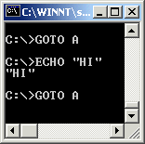
Starting Two CMD Processes
- Click Start, Run and enter CMD to open a Command Prompt window.
- In the Command Prompt window, enter C:\LOOP to start a rapidly scrolling display, as shown in the figure to the left on this page. This creates some processor activity to measure.
- Repeat steps 2 and 3 to open a second scrolling Command Prompt window. Resize both windows to make them small, and put on the left side of the screen.
Using Performance Monitor
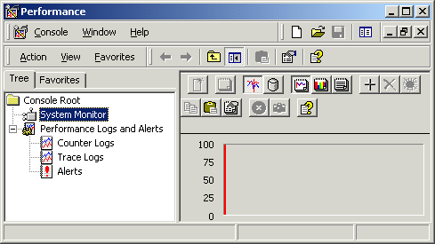
- Click Start, Programs, Administrative Tools¸ Performance to open a Performance window as shown to the right on this page.
- In the left pane, note the four methods for collecting data:
  - System monitor
  - Counter logs
  - Trace logs
  - Alerts
Make sure that System Monitor is selected.
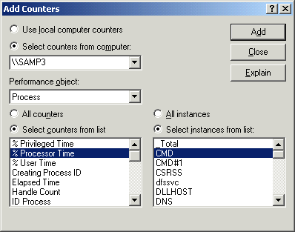
- Click the + tool on the toolbar to add a counter. The Add Counters box opens, as shown in the figure to the right on this page. Note that here you can choose which computer to monitor as well as indicate the three types of data:
- Object (labeled as Performance object)
- Counter (listed to the lower left)
- Instance (listed to the lower right)
- Click the Performance object drop-down box arrow and select Process.
- Make sure that the counter % Processor Time is selected in the list on the left.
- In the lower-right box, click CMD. Click the Add button. Click CMD#1. Click the Add button. Click the click CMD. Click the Add button. Click the Close button.
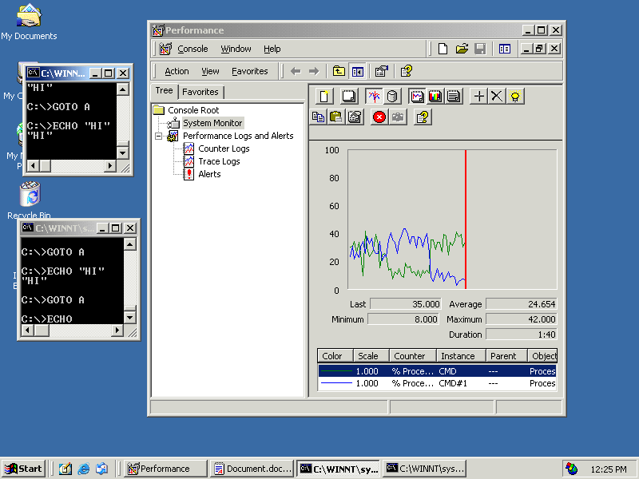
- Your screen should now look like the image to the right, with two colored lines showing on the graph. When the Performance window is active, the two lines show nearly the same processor activity. Click on one of the Command Prompt windows, and you should see its indicator rise. Click on the other one and it should rise to the top. These are the same values you saw in Task Manager, just presented in a graphical format.
Using System Monitor Properties
- Right-click on the graph in the Performance window and select Properties. Click through the tabs and examine the options. You can control the sampling interval, graph format, colors, and other properties here.
- On the General tab of System Monitor Properties, click Histogram in the View section. Click OK. Notice how the graph changes: now it just has two colored bars that indicate the activity level.
- Right-click on the graph in the Performance window and select Properties. On the General tab of System Monitor Properties, click Report in the View section. Click OK. Notice how the graph changes: now it shows changing numbers that indicate the activity level.
- Right-click on the graph in the Performance window and select Properties. On the General tab of System Monitor Properties, click Graph in the View section. Click OK. Now the normal graph should be visible.

Activity: Creating a Counter Log Pages 275-280
- A Performance window should already be open. If it is not, open one by clicking Start, Programs, Administrative Tools¸ Performance.
- In the left pane of the Performance window, make sure Performance Logs and Alerts is expanded. Right-click Counter logs and select New Log Settings.
- In the New Log Settings box, enter TestLog Click OK.
- In the TestLog window, on the General tab, the log file name is shown at the top. Leave it unchanged and click the Add button near the bottom of the window. An Add Counters window opens.
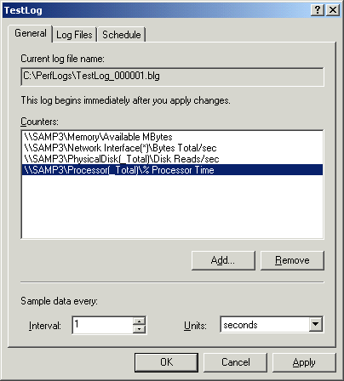
Adding Counters:
- Click the Performance object drop-down box arrow and select PhysicalDisk.
- Select the counter Disk Reads/sec in the list on the left.
- In the lower-right box, click _Total. Click the Add button.
- Repeat steps 23-25 to add these counters:
- Memory\Available MBytes
- Network Interface\Bytes Total/sec (All instances)
- Processor\% Processor Time _Total instance
After adding the four counters, click the Close button in the Select Counters window. Change the Interval at the bottom of the window to 1 second. You should see a TestLog window like the one shown to the right on this page. You now have counters for the four major performance areas: Memory, Processor, Disk, Network
- Click the Log Files tab. Look through the options: the location of the log file is shown and its file name. The End the file names with: option makes sure that each log file will a different name. Click the Log file type list box arrow and notice the options:
- Text File – CSV Makes a comma-separated value file appropriate for Excel or other programs
- Text File – TSV Makes a tab-separated value file appropriate for Excel or other programs
- Binary File Makes a file that must be opened with System Monitor
- Binary Circular File Makes a binary file that overwrites itself from the beginning when it hits its maximum size
Select Text File – TSV. In the Log file size section, click the Limit of radio button and accept the default file size limit of 1000 KB. Click the Schedule tab.

- Look through the options in the Schedule tab: Log files can be started and stopped automatically. The When a log file closes options let you set the system to either keep generating new log files as they fill, or to execute some other command when the log file is full. In the Start log section, click the Manually radio button. In the Stop log section, click the Manually radio button. Click OK.
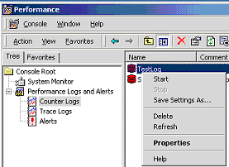
- In the left pane of the Performance window, click Counter logs. In the right pane, right-click TestLog and click Start.
Creating some Processor Activity
- Click Start, Run and enter CMD to open a Command Prompt window.
- In the Command Prompt window, enter C:\LOOP to start a rapidly scrolling display.
Creating some Disk Activity
- Click Start, Help.
Creating some Network Activity
- Right-click My Network Places. Explore to a network share and find a file on another machine. Drag it to your desktop.
Creating some Memory Activity
- Open several Internet Explorer windows.
Opening a Log File with System Monitor
- In the left pane of the Performance window, click Counter logs. In the right pane, right-click TestLog and click Stop.
- A Performance window should already be open. If it is not, open one by clicking Start, Programs, Administrative Tools¸ Performance.
- In the left pane of the Performance window, select System Monitor. Right-click on the graph and select Properties.
- In the System Monitor Properties window, click the Source tab. Click the Browse button and browse to the C:\PerfLogs\TestLog_000001.tsv file. Select that file and click Open.
- Click the Data tab. Click Add. An Add Counters window opens.
- Click the Performance object drop-down box arrow. Notice that only four objects are available, because you can only view counters you saved in the log.
- Select PhysicalDisk. Verify that Dusk Reads/sec and _Total are selected and click the Add button.
- Repeat step 40 to add these counters:
- Memory\Available MBytes
- Network Interface\Bytes Total/sec (All instances)
- Processor\% Processor Time _Total instance
- In the Add Counters window, click the Close button.
- In the System Monitor Properties window, click the OK button. You should see a graph with colored lines showing the activity history. If you want to adjust the scale, right-click one of the counters at the bottom of the graph and select Properties. On the Graph tab you can set the Vertical scale.

Activity: Creating an Alert Pages 282-284
- Right-click an empty area of the taskbar and select Task Manager. Click the Performance tab and see the CPU Usage. It should be very high, near 100%.
- Close the two Command Prompt windows to stop the LOOP process. That should lower the CPU usage down to 1% or some similar low value. Close the Windows Task Manager window.
- A Performance window should already be open. If it is not, open one by clicking Start, Programs, Administrative Tools¸ Performance.
- In the left pane of the Performance window, click Alerts. Right-click Alerts and select New Alert Settings.
- In the New Alert Settings box, enter TestAlert Click OK.
- In the TestAlert window, on the General tab, click the Add button near the bottom of the window.
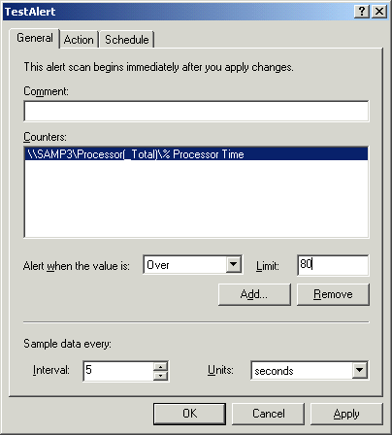
- In the Select Counters window, verify that the selected Performance object is Processor, the selected counter is % Processor Time, and the selected instance is _Total. Click the Add button. Click the Close button.
- In the TestAlert window, on the General tab, click the drop-down box arrow to the right of the Alert with the value is: section and select Over. In the Limit box, enter 80. Your screen should look like the example to the right on this page..
- .Click the Action tab. Review the choices: when the limit is reached, you can:
- Log an entry in the event log
- Send a network message
- Start performance data log
- Run a program
Leave Log an entry in the application event log checked, and the others unchecked.
Click the Schedule tab. In the Start Scan section, select Manually. In the Stop Scan section, select Manually. Click OK.
- .In the Performance window, right-click TestAlert and select Start.
- Click Start, Run and enter CMD to open a Command Prompt window.
- In the Command Prompt window, enter C:\LOOP to start a rapidly scrolling display.
- Right-click an empty area of the taskbar and select Task Manager. Click the Performance tab and see the CPU Usage. It should be very high, near 100%.

- Minimize all open windows. Right-click My Computer and select Manage. Expand Event Viewer in the left pane. Click Application.
- The recent events should include several alerts, as shown in the example below.
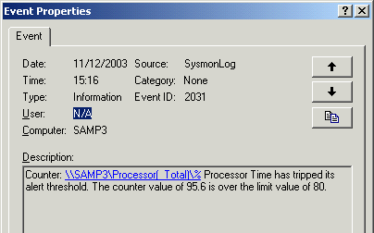
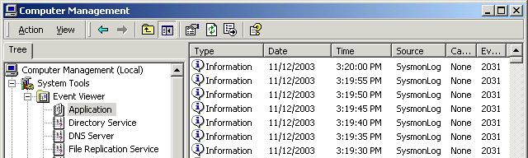
- Double-click a recent alert and you should see a message saying Processor time has tripped its alert threshold like the example to the right on this page.
- Note that there are a lot of these alerts: a new one is generated every 5 seconds. To stop them, restore the Performance window, right-click TestAlert, and select Stop.

System cleanup and tuning Pages 284-289
Remove unnecessary software components
- Drivers, protocols, services
Tune Paging File
- Watch your server under typical load to see how large the paging file is, and set that as the minimum size
- Move the paging file off the system disk
- Buy a special disk, striped volume, or RAID volume for the paging file
- To resize or relocate the Paging File:
  - Right-click My Computer and select Properties
  - Click the Advanced tab of System Properties
  - Click the Performance Options button
  - In the Virtual Memory section, click Change
Tune the Server service
- Server handles all incoming network requests for file, print, and named pipe sharing
  - Named pipes allow remote administration of a server
- To tune the Server service:
  - Right-click My Network Places and select Properties
  - Right-click local Area Connection and choose Properties
  - Double-click File and Printer Sharing for Microsoft Networks
- This is the Server service
- To optimize the server for a small number of clients, click Minimize memory used.
- To optimize the server for a mixed usage of file and printer sharing in addition to other services, such as serving as an interactive workstation, click Balance.
- To dedicate as many resources as possible to file and print server services, click Maximize data throughput for file sharing.
- To optimize server memory for distributed applications that perform their own memory caching, such as Microsoft SQL Server, click Maximize data throughput for network applications.
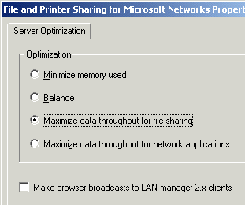
Note that this is different from what the textbook says on page 288. This is from link Srv Ch 4e on my Web page, a Microsoft Knowledge Base article

Using Performance Monitor to Discover Bottlenecks and Optimize Resource Utilization Pages 289-290
Four system components will affect performance:
- Memory
- Processor
- Hard disk
- Network card(s)

- Low RAM can cause high swapping activity, which will create disk activity and processor activity.
- Physical Disk counters are available by default, and they are all you usually need
- Logical Disk counter objects can be enabled with the diskperf –y command
- There are two kinds of network counters:
  - Network interface counters trace packets sent and received by the network card being monitored
    - Can be measured using Windows 2000 Network Monitor
  - Network segment counters monitor the performance of the entire network segment the card is attached to
    - They are beyond the scope of the course, because they cannot be measured with Windows 2000 components
    - They require the full Network Monitor that is available with the BackOffice product canned Systems Management Server (see link Srv Ch 1d on my Web page)
Counters to Monitor Pages 293-298
Category | Example
Disk usage | PhysicalDisk\Disk Reads/sec
Disk bottlenecks | Physical Disk\Avg. Disk Queue Length
Memory usage | Memory\Available Bytes
Memory bottlenecks | Memory\Pages/sec  Memory\Pages/Sec (hard page faults; over 20 indicates a bottleneck)
Network Usage | Network Segment\% Net Utilization (requires SMS Network Monitor)
Network throughput | Network Interface\Bytes total/sec
Processor Usage | Processor\% Processor Time
Processor Bottlenecks | System\Processor Queue Length

