Profiles Pages 359-366
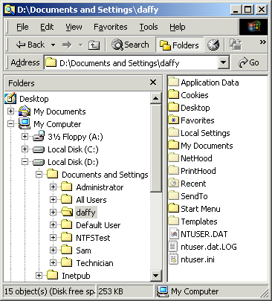
Three types of profiles:
Local Profiles
- Stored only on the local hard drive
- Only accessible from one workstation
- The first time a user logs in, the Default profile is copied to that user’s profile
- The All Users profile affects all users each time they log in
Roaming Profiles
- Stored on a network share
- Can be accessed from any computer on the network
Mandatory Profiles
- Mandatory profiles cannot be changed permanently: all changes are lost on log out
- To make a profile Mandatory, rename NTUSER.DAT to NTUSER.MAN
- Mandatory profiles can be either Local Profiles or Roaming Profiles
User Profile Components
- See figure to the right

Configuring Disks and Volumes Pages 366-366
Disk Structure
The figure below shows the MBR, partition table, and boot sectors on a disk with four partitions.
- Figure from http://www.microsoft.com/windows2000/techinfo/reskit/en-us/default.asp?url=/windows2000/techinfo/reskit/en-us/prork/prcb_dis_zbxs.asp
- Go to link Srv Ch 4j on my Web Page, click Master Boor Record
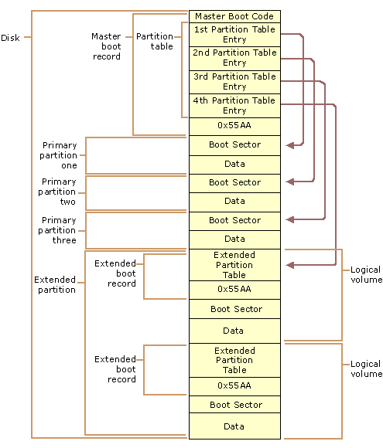
Summary of Startup Events
BIOS loads the Master Boot Record (MBR) from the first sector of the hard disk with the partition table.
The MBR points to the Active Partition on the hard disk, which is defined when the disk is formatted. Only one primary partition on a disk can be the Active Partition.
For Windows to load, the Active Partition must be a System Partition
The System Partition has a partition boot sector in sector 0, and it also has startup files NTLDR, BOOT.INI, and others
The partition that is chosen by the user from the BOOT.INI list is called the Boot Partition.
The files on the System partition are used only once at system startup
The files on the Boot partition are used all the time the computer is running

Detailed Startup Events
Power-On Self Test (POST)
- Determines the amount of memory in the computer
- Checks that required hardware devices, such as the keyboard, are present and functioning
- After the POST sequence, adapters that have their own basic input/output system (BIOS) run individual POST routines
Initial startup process
- After the computer finishes the POST, the system BIOS attempts to start an operating system.
- If drive A contains a bootable floppy disk, the BIOS loads its first sector (the partition boot sector) into memory.
    - If the floppy disk is not bootable, the message Non-system disk or disk error appears.
- If the BIOS does not find a floppy disk in the drive, it then searches for the active partition on the hard disk drive.
    - If there is no system partition on the first hard disk, the master boot record (MBR) displays one of the following errors:
Invalid partition table, Error loading operating system, or Missing operating system
- When the active partition of the hard drive is found, the system BIOS reads the MBR and loads it into memory.
- The MBR then scans the partition table for the system partition information.
- When the system partition information has been read, it loads sector 0 of the system partition into memory and starts it.
    - Sector 0 of the system partition can be a utility, a diagnostic program, or a partition boot sector that contains the startup code for the operating system.
- The system partition must be on the first physical disk and contain the Windows 2000 Startup Files listed below.
Windows 2000 Startup Files
File Name | Location | Function
Ntldr | Root of startup disk | Controls the operating system selection and the hardware detection process before passing control to the Windows 2000 kernel
Boot.ini | Root of startup disk | Displays the operating selections on the boot loader screen
Bootsect.dos | Root of startup disk (on multiple-boot systems) | Starts operating systems other than Windows 2000 (not present on totally Win 2k systems)
Ntdetect.com | Root of startup disk | Gathers information about the computer hardware
Hyberfil.sys | %systemdrive% | Hybernation information
Ntbootdd.sys | Root of startup disk | Used for for SCSI and some large IDE drives
Ntoskrnl.exe | %systemroot%\System32 | The kernel initiates the Windows 2000 Professional screen, and the Starting Up progress bar is displayed
Hal.dll | %systemroot%\System32 | hardware abstraction layer
System key | %systemroot%\System32\Config | registry key HKEY_LOCAL_MACHINE\SYSTEM
Device drivers | %systemroot%\System32\Drivers
Cdldr | Root of startup disk | Used to start Recovery Console

After NTOSKRNL is done, Winlogon.exe displays the Begin Logon box (Press Ctrl+Alt+Del).
From http://www.microsoft.com/windows2000/techinfo/reskit/en-us/default.asp?url=/windows2000/techinfo/reskit/en-us/prork/prbd_std_nfkh.asp
That is Link Srv Ch 4i on my Web page

In-Class Assignment: Pro Ch3b: Basic and Dynamic Disks with Instant Test 3 pts
- Open Internet Explorer to my Web page: http://fog.ccsf.cc.ca.us/~sbowne/ and click Flash Cards
- Select Pro Ch3b: Basic and Dynamic Disks and go through them all. Then take the Instant Test.
In-Class Assignment: Pro Ch3c: Volumes and Troubleshooting with Instant Test 3 pts

Activity: Configuring Disks and Volumes Pages 390-393
You will need to do this activity on a machine with at least 3 hard disks.
So far there is only one such machine in the room.
Examining the Starting Condition of the Disks
- Start the machine and log in as Administrator with a password of password.
- Right-click My Computer and select Manage
- Select Disk Management in the left pane of the Computer Management window. You should see a window like the one shown below on this page: three disks, with a C: partition on Disk 0, and unallocated space on all three disks.
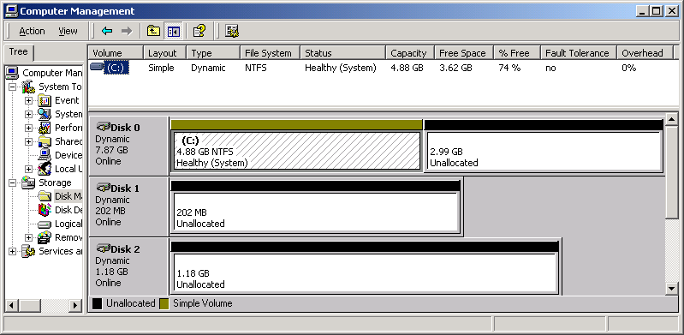

- Note that all three disks are Dynamic. Read the information about volume C: -- this is a Simple Volume on an NTFS partition, and it is not fault-tolerant. Resize the columns as shown above so you can read all the information about the volume.

Creating a Simple Volume
- In the Disk Manager window, right-click the free space on Disk 0. Select Create Volume.
- At the Welcome to the Create Volume Wizard screen, click Next.
- At the Select Volume Type screen, select Simple Volume and click Next.
- At the Select Disks screen, verify that Disk 0 appears in the right pane under the heading Selected dynamic disks. In the Size box, enter 50 and click Next.
- At the Assign a Drive Letter or Path screen, in the Assign a drive letter line, choose a drive letter selection of F: and click Next.
- At the Format Volume screen, accept the default file system of NTFS and the default allocation size. Enter a volume label of Simple and click Next.
- Review the selections you have made in the Completing the Create Volume Wizard screen and click Finish
- .Watch the Computer Management window as the new volume is created, assigned a drive letter, and formatted. When the format is complete, you should see a screen like the one below.

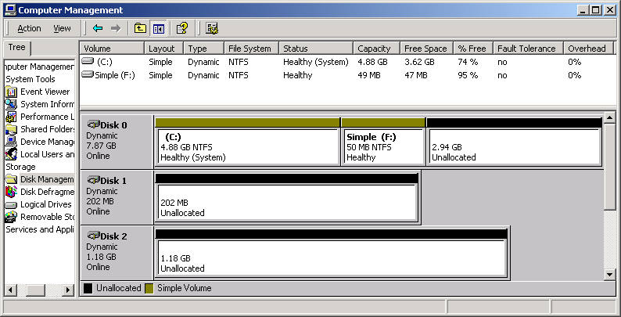

- . Read the information about volume F: -- this is a Simple Volume, and it is not fault-tolerant. .

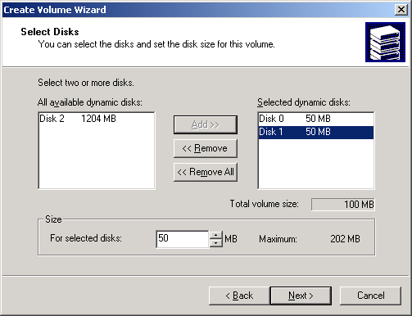
Creating a Spanned Volume
- In the Disk Manager window, right-click the free space on Disk 0. Select Create Volume.
- At the Welcome to the Create Volume Wizard screen, click Next.
- At the Select Volume Type screen, select Spanned Volume and click Next.
- At the Select Disks screen, verify that Disk 0 appears in the right pane under the heading Selected dynamic disks. In the Size box, enter 50. In the left pane, under the heading All available dynamic disks, select Disk 1. Click the Add button in the center of the screen to move Disk 1 to the right pane. Click Disk 1. In the Size box, enter 50. Verify that your screen looks like the figure above on this page, with a Total volume size of 100 MB and click Next.
- At the Assign a Drive Letter or Path screen, in the Assign a drive letter line, choose a drive letter selection of G: and click Next.
- At the Format Volume screen, accept the default file system of NTFS and the default allocation size. Enter a volume label of Spanned and click Next.
- Review the selections you have made in the Completing the Create Volume Wizard screen and click Finish
- .Watch the Computer Management window as the new volume is created, assigned a drive letter, and formatted. When the format is complete, you should see a screen like the one below.

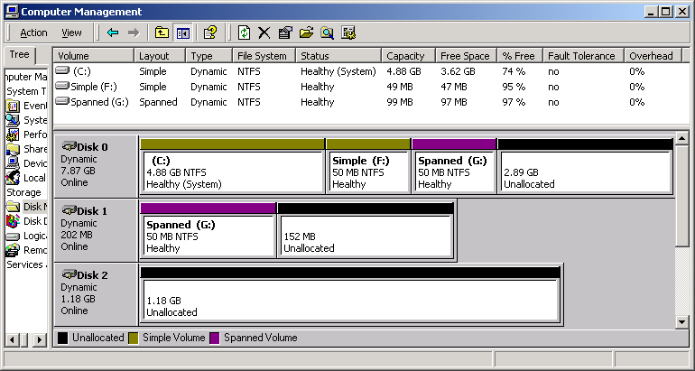

- . Read the information about volume G: -- this is a Spanned Volume, and it is not fault-tolerant. .

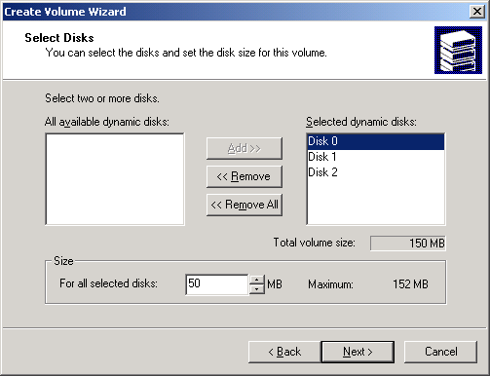
Creating a Striped Volume
- In the Disk Manager window, right-click the free space on Disk 0. Select Create Volume.
- At the Welcome to the Create Volume Wizard screen, click Next.
- At the Select Volume Type screen, select Striped Volume and click Next.
- At the Select Disks screen, use 50 MB from each of the three disks. Verify that your screen looks like the figure to the right on this page, with a Total volume size of 150 MB and click Next.
- At the Assign a Drive Letter or Path screen, in the Assign a drive letter line, choose a drive letter selection of H: and click Next.
- At the Format Volume screen, accept the default file system of NTFS and the default allocation size. Enter a volume label of Striped and click Next.
- Review the selections you have made in the Completing the Create Volume Wizard screen and click Finish
- .Watch the Computer Management window as the new volume is created, assigned a drive letter, and formatted. When the format is complete, you should see a screen like the one below.

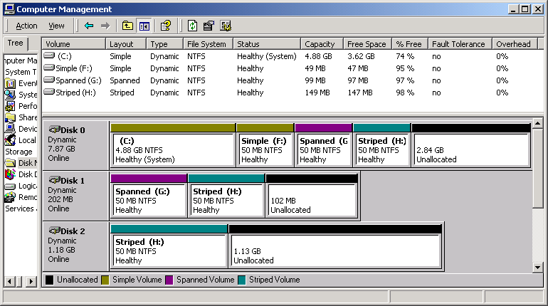

- . Read the information about volume H: -- this is a Striped Volume, and it is not fault-tolerant. .

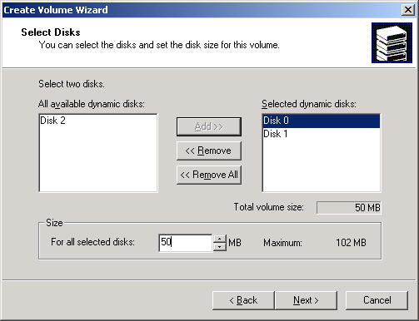
Creating Mirrored Volumes
- In the Disk Manager window, right-click the free space on Disk 0. Select Create Volume.
- At the Welcome to the Create Volume Wizard screen, click Next.
- At the Select Volume Type screen, select Mirrored Volume and click Next.
- At the Select Disks screen, use 50 MB from Disk 0 and 50 MB from Disk 1. Verify that your screen looks like the figure to the right on this page, with a Total volume size of 50 MB and click Next.
- At the Assign a Drive Letter or Path screen, in the Assign a drive letter line, choose a drive letter selection of I: and click Next.
- At the Format Volume screen, accept the default file system of NTFS and the default allocation size. Enter a volume label of Mirrored and click Next.
- Review the selections you have made in the Completing the Create Volume Wizard screen and click Finish
- .Watch the Computer Management window as the new volume is created, assigned a drive letter, and formatted. When the format is complete, you should see a screen like the one below.

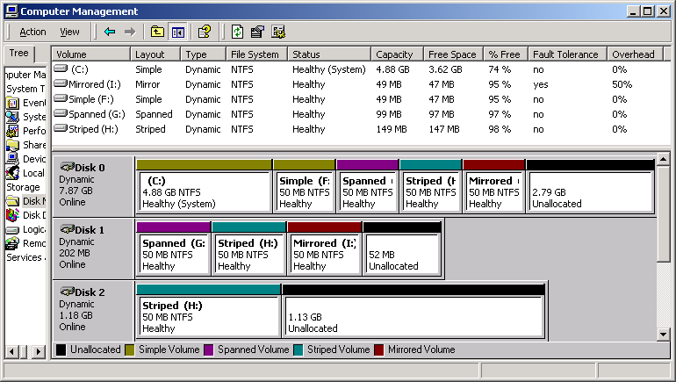

- . Read the information about volume I: -- this is a Mirrored Volume, and it is fault-tolerant. Note the Overhead of 50% -- it takes 100 MB of hard disk space to make a 50 MB mirrored volume.

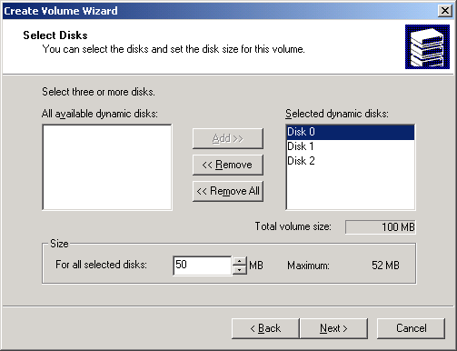
Creating a RAID-5 Volume
- In the Disk Manager window, right-click the free space on Disk 0. Select Create Volume.
- At the Welcome to the Create Volume Wizard screen, click Next.
- At the Select Volume Type screen, select RAID-5 Volume and click Next.
- At the Select Disks screen, use 50 MB from each of the three disks. Verify that your screen looks like the figure to the right on this page, with a Total volume size of 100 MB and click Next.
- At the Assign a Drive Letter or Path screen, in the Assign a drive letter line, choose a drive letter selection of J: and click Next.
- At the Format Volume screen, accept the default file system of NTFS and the default allocation size. Enter a volume label of RAID and click Next.
- Review the selections you have made in the Completing the Create Volume Wizard screen and click Finish
- .Watch the Computer Management window as the new volume is created, assigned a drive letter, and formatted. When the format is complete, you should see a screen like the one below.

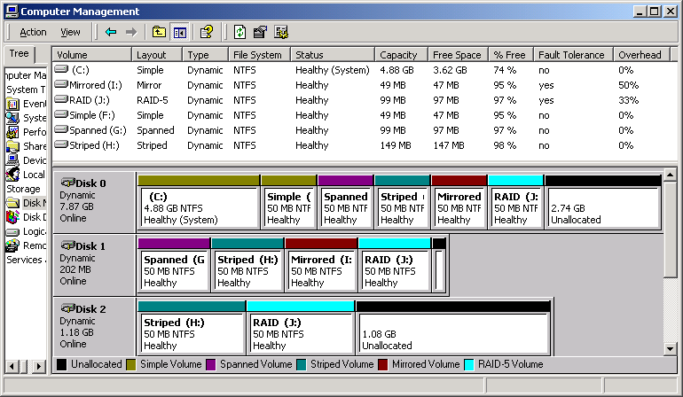

- . Read the information about volume I: -- this is a RAID-5 Volume, and it is fault-tolerant. Note the Overhead of 33% -- it takes 150 MB of hard disk space to make a 100 MB RAID-5 volume.

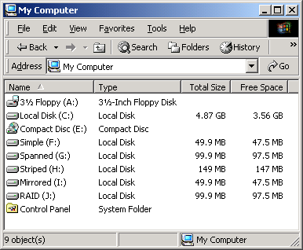
Storing a file on the volumes
- Open My Computer and click View, Details from the menu bar. You should see the Simple, Spanned, Striped, Mirrored, and RAID volumes as shown in the figure to the right on this page. Right now all the volumes are empty, with just a couple of MB used for the dynamic disk database.

- Open a second My Computer window and open C:. Find a file on the root of C: named Big.mov. Right-click Big.mov and select Copy. Close the C: window.
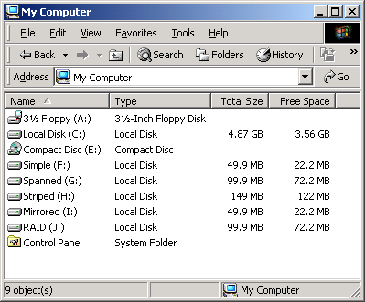
- Right-click the Simple volume and select Paste. The Big.mov file is copied to the new volume. Repeat the paste for the Spanned, Striped, Mirrored, and RAID volumes. After you are done the free space should decrease as shown in the figure to the right on this page.

Observing the Effect of a Total Disk Failure
- Shut down the server. Open the case and remove Disk 1. This creates a total disk failure – all data on that disk is gone.
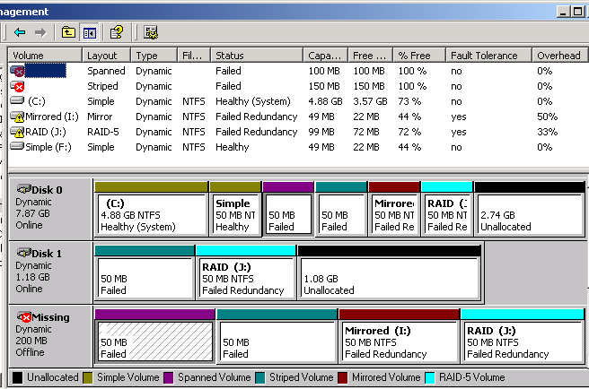
- Restart the server. Open Disk Management. You should see the display below: one disk is missing, so the Spanned and Striped volumes have a status of Failed. The Mirrored and RAID volumes have a status of Failed Redundancy.

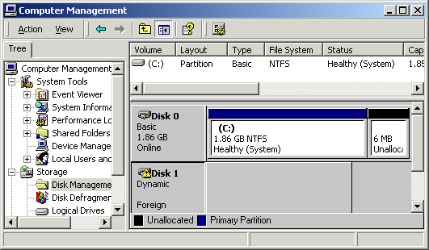
- Open My Computer. The Striped and Spanned volumes do not appear and cannot be opened. The Mirrored and RAID volumes can still be opened, and you can see the Big.mov file. Double-click Big.mov and verify that the movie can still be played from the Mirrored and RAID volumes.
- Install the hard disk you removed in another machine. Open Disk Management. The new disk has a status of Foreign, as shown in the figure to the right on this page.
Importing the Disk
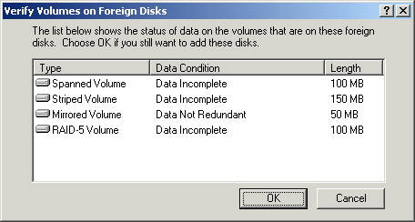
- Right-click Disk 1 in the lower pane of Disk Management and select Import Foreign Disks…
- In the Import Foreign Disks window, click OK.
- A Verify Volumes on Foreign Disks window opens as shown to the right on this page. Read the information and click OK.
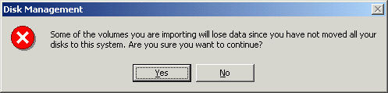
- A Disk Management window opens as shown to the right on this page, warning that data will be lost. Click Yes.
- After the import completes, your system shows two missing disks as shown below.

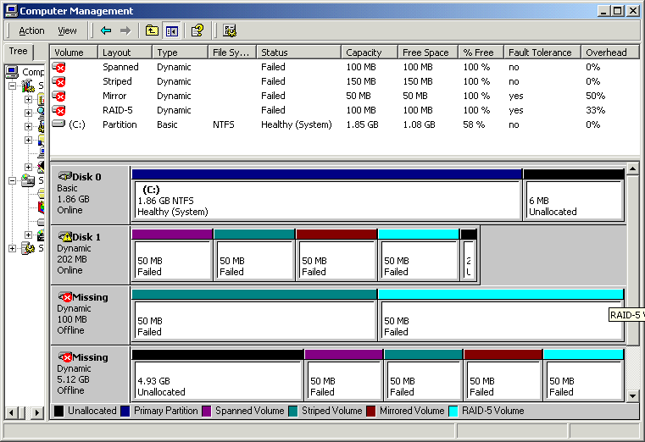
Erasing the Disk
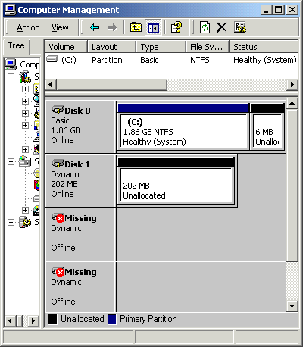
- Right-click on the first volume of Disk 1 and select Delete Volume. When a Delete Spanned Volume window pops up, click Yes. Delete the three remaining volumes on Disk 1 the same way.
- After you have deleted all the volumes, your Computer Management window should show only unallocated space on Disk 1, as shown in the figure to the right.
- right-click the free space on Disk 1. Select Create Volume. Create a Simple Volume using all the space and format it with the FAT file system. That ensures that all the data on the disk is erased.
- Turn off the computer and remove Disk 1.
Replacing the Failed Disk
- Reinstall Disk 1 in the original machine, start it up, and log in as Administrator with a password of password.
- Open Disk Manager. There are now 4 disks, one with a status of Foreign (the disk you just reinstalled) and one named Missing (the volumes that have been lost).
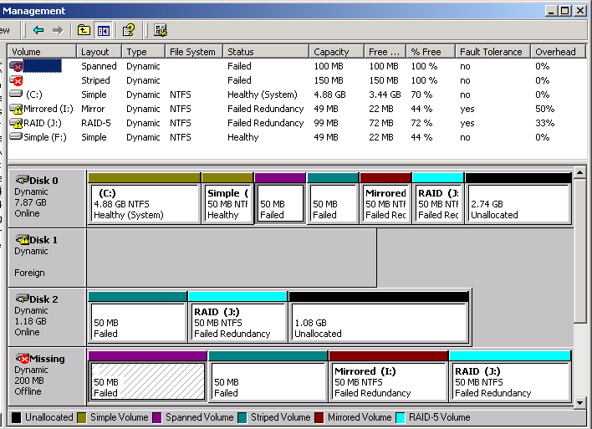

Deleting the Spanned and Striped Volumes
- Right-click the first partition on the Missing disk and select Delete Volume. When a Delete Spanned Volume window pops up, click Yes. Note that the volume disappears on both the Missing disk and on Disk 0.
- Right-click the second partition on the Missing disk and select Delete Volume. When a Delete Striped Volume window pops up, click Yes. Note that the volume disappears on both the Missing disk and on Disk 0.
Removing the Failed Mirror Volume
- Right-click the third partition on the Missing disk and select Remove Mirror.
- In the Remove Mirror dialog box, click Missing (if it is not already selected), and then click Remove Mirror.
- When you are prompted to verify that you want to remove the mirror, click Yes.
Importing the Disk
- Right-click Disk 1 and select Import Foreign Disks…
- In the Import Foreign Disks window, click OK.
- The Verify Volumes on Foreign Disks window shows one simple volume. Click OK.
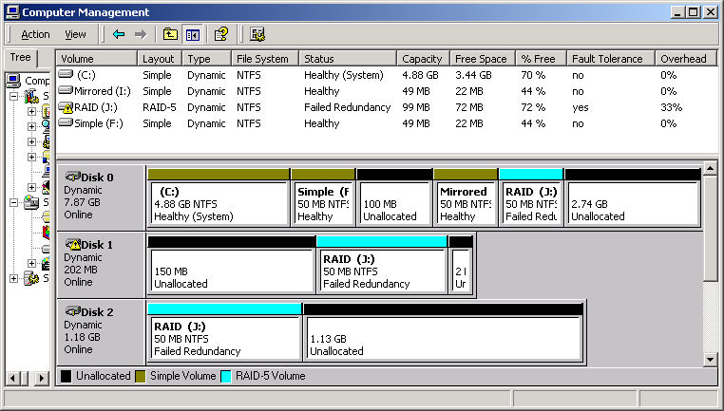
- After the import completes, the system recognizes the disk and automatically recreates the RAID partition, as shown below. But the data is not yet restored, so the RAID has a status of Failed Redundancy.

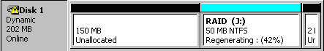
Restoring the RAID-5 Volume
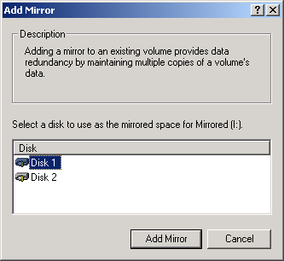
- Right-click Disk 1 and select Reactivate Disk. The RAID volume status changes to Regenerating as shown to the right. When the regeneration finishes, the volume status should change to Healthy.
Restoring the Mirrored Volume
- Right-click the Mirrored partition on Disk 0 and select Add Mirror. In the Add Mirror window, select Disk 1 and click Add Mirror, as shown in the figure to the right on this page.
- The Miirrored volume status changes to Regenerating. When the regeneration finishes, the volume status should change to Healthy.
- You should now have both the RAID and Mirrored volumes back as shown in the figure below. Notice that about 27 MB is used on each disk, because the Big.mov file has remained on the disk all along – the data has not been lost.
Deleting the Volumes
- To set the machine up for the next student, right-click the Simple volume on Disk 0 and select Delete Volume. When a Delete Simple Volume window pops up, click Yes. Repeat the same process to delete the Mirrored and RAID volumes.
- Verify that the Disk Management window matches the figure on page 4.


