DHCP Server Properties Pages 488-491
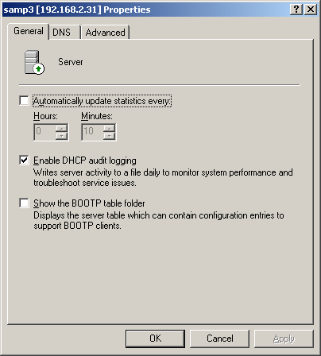
Open DHCP Server Properties by right-clicking the server in the DHCP console and selecting Properties
By default, DHCP Audit Logging is enabled.
- To see the log, go to the location specified on the Advanced tab of server Properties
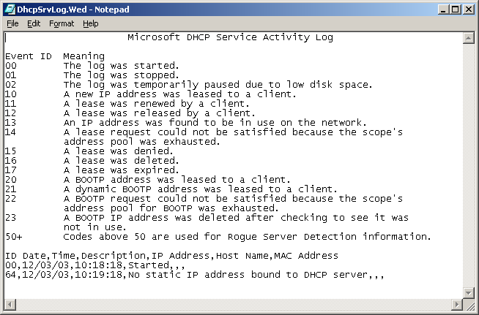
- By default, the log is in WINNT\System32\DHCP
- There are seven log files, one for each day of the week, named
  - DhcpSrvLog-Mon,
  - DhcpSrvLog-Tue
  - DhcpSrvLog-Wed, etc.
- The server logs are simple text files, as shown in the example below
- You can configure the size of the DHCP audit log files and other details by editing the Registry (see link Srv Ch 6g on my Web page).

DNS Dynamic Update
The DNS database connects computer names to IP addresses. Since IP addresses can change if you are using DHCP, the DHCP service is usually set to automatically update the DNS database whenever an IP address changes – a process called DNS Dynamic Update.
Clients running versions of Windows earlier than Windows 2000 do not support DNS dynamic update.
DNS Dynamic updates are sent for any of the following reasons or events:
- An IP address on any network connection is added, removed, or modified in the properties of the TCP/IP protocol.
- An IP address lease on any network connection changes or renews with the DHCP server. For example, when the computer is started or the ipconfig /renew command is used.
- The ipconfig /registerdns command is used to manually force a refresh of the client name registration in DNS.
- The computer is started (after it has been shut down).
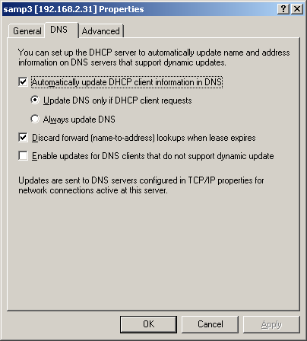
From link Srv Ch 6h on my Web page
On the DNS tab of server properties you configure how DHCP interacts with DNS.
- Check the Automatically update DNCH client information in DNS to enable dynamic updates
  - Update DNS only if DHCP client requests is the usual setting for Windows 2000 or XP clients – the DHCP client sends a request to the DNS server to update its records
  - Always update DNS makes DNS updates from the server, not from client requests.
- Discard forward (name-to-address) lookups when lease expires cleans old records out of the DNS database
- Enable updates for DNS clients that do not support dynamic update performs the DNS update from the server only for clients using older versions of Windows (before 2000). This amounts to a mixture of the two radio buttons discussed 3 paragraphs up, selecting Update DNS only if DHCP client requests for Windows 2000 or later clients, and Always update DNS for the pre-Windows 2000 clients.
The Advanced tab of DHCP Server Properties
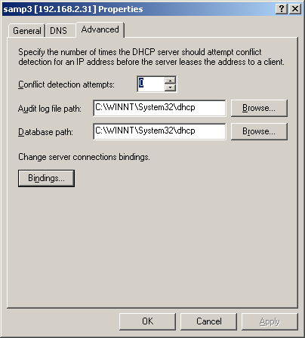
- Conflict detection attempts pings the LAN before assigning an address

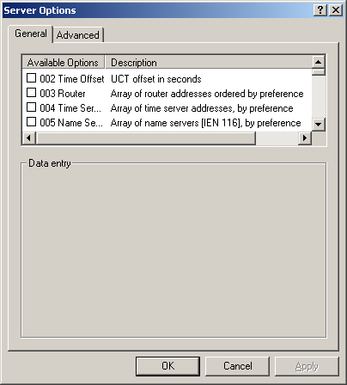
Right-click Server Options in the DHCP console and select Server Options to see a long list of Server Options in a tiny window. Most of these are DHCP Options used for non-Microsoft clients, but you can set the DNS Server here (see activity on page 5).

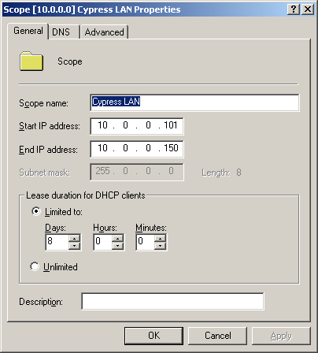
Scope Options
Right-click Scope and select Properties to change the address pool or lease duration (on the General tab)

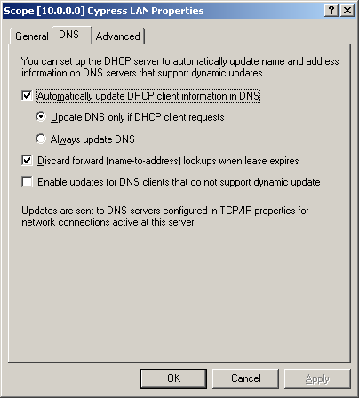
On the DNS tab you can set the DNS Dynamic update options for this scope, which override the server settings.

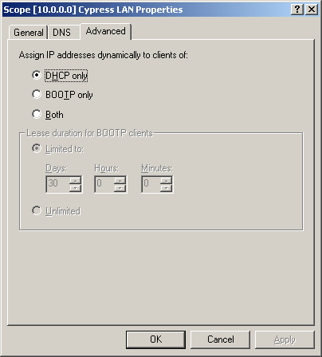

The Advanced tab is used to set up BOOTP if you are using that old technique on your network.
- BOOTP was originally designed to enable boot configuration for diskless workstations on older systems.
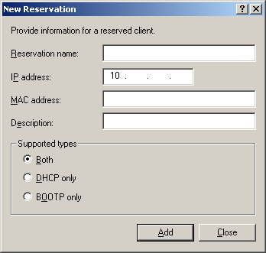
- For details, see link Pro Ch 6r on my Web page

Right-click Reservations in the Scope container in the DHCP console and select New Reservation

Here you can reserve IP addresses to match MAC addresses, which is more secure (but takes more administrative effort)

C:\Documents and Settings\Administrator>ping samamd

Pinging samamd [10.0.0.101] with 32 bytes of data:

Reply from 10.0.0.101: bytes=32 time<10ms TTL=128
Reply from 10.0.0.101: bytes=32 time<10ms TTL=128
Reply from 10.0.0.101: bytes=32 time<10ms TTL=128
Reply from 10.0.0.101: bytes=32 time<10ms TTL=128

Ping statistics for 10.0.0.101:
Packets: Sent = 4, Received = 4, Lost = 0 (0% loss),
Approximate round trip times in milli-seconds:
Minimum = 0ms, Maximum = 0ms, Average = 0ms

C:\Documents and Settings\Administrator>ARP -A

Interface: 10.0.0.1 on Interface 0x2
Internet Address Physical Address Type
10.0.0.101 00-60-97-ce-c9-14 dynamic
10.0.0.102 00-10-b5-0e-5c-8a dynamic

To get the IP addresses on your network, PING a machine and then use ARP –A to view the cache.

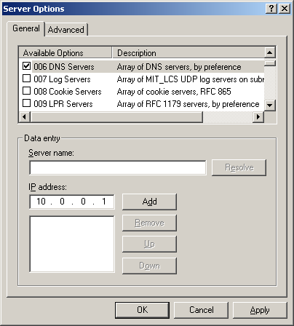
Activity: Setting the DNS Server Address in DHCP
- For this activity, use the same TCP/IP LAN, and the same server you have already set up as a DHCP Server.
- DHCP should already be running on the machine, if it is not, set it up as described in the Chapter 6, part 1 handout
- Click Start, Programs, Administrative Tools, DHCP. The DHCP console opens.
- Click Server Options.
- Click Action, Configure Options
- Scroll down to option 006 DNS Servers, check the check box, and fill in the IP Address 10.0.0.1 as shown to the right on this page. Click Add. Click OK.

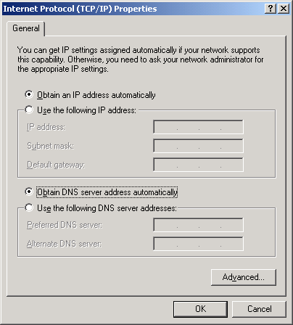
- Go to a DHCP client machine on your LAN and open Properties of My Network Places. Open Properties of TCPIP LAN. Open TCP/IP Properties and make sure it is configured to Obtain an IP address automatically and to Obtain DNS server address automatically as shown to the right on this page.
- At a Command Prompt, enter IPCONFIG /RELEASE and IPCONFIG /RENEW.
- Enter IPCONFIG /ALL and verify that your client has received the correct DNS server address.

Installing and Configuring DNS Pages 491-496
The main use of DNS is to make a domain, and usually it is done on the domain controller
A DNS server can also be configured on a server in a workgroup, but that is not commonly done, except as a step towards making a domain controller
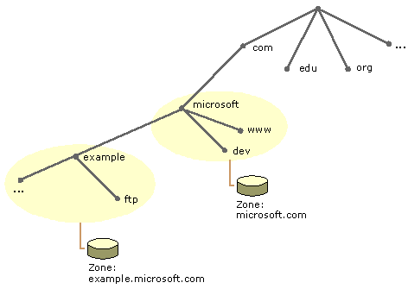
The most successful procedure we found to make a domain controller was to first get DHCP service running, then DNS, and then run DCPROMO at a command line to create a domain
DNS Zones determine what portion of the DNS tree a DNS server is responsible for
- When a domain is first created, it is a single zone
- If subdomains are created later, they can become separate DNS Zones like example.microsoft.com in the figure to the right
  - Figure from link Srv Ch 6j on my Web page
There are three types of DNS Servers:
- Primary Name Server is responsible for a DNS zone and stores the addresses in a local DNS file
- Secondary Name Server copies its addresses from a Primary Name Server through Zone Transfer
  - Secondary Zone Servers provide load balancing, redundancy, and fast DNS lookup in remote locations
- Caching-only DNS Servers do not have a local DNS file, but just cache recently used addresses to decrease WAN traffic
Activity: Making a DNS Server Pages 491-496
- For this activity, use the same TCP/IP LAN, and the same server you have already set up as a DHCP Server.
- DNS should already be installed on the machine, if it is not, install it through Add/Remove Software (see pages 492-493)
Starting DNS Service: Do this on your DHCP Server
- Click Start, Programs, Administrative Tools, DNS. The DNS console opens.
- In the DNS console, select your server name. Read the information in the right panel. Then open the Action menu and click Configure the Server.
- At the Welcome to the Configure the DNS Server Wizard screen, read the information and click Next.
- At the Root Server dialog box, choose This is the first DNS server on the network and click Next.
- At the Forward Lookup Zone dialog box, choose Yes, create a forward lookup zone and click Next.
- At the Zone Type dialog box, read the options. Choose Standard primary and click Next.
- At the Zone Name dialog box, name your domain anything you like, such as cypress.com and click Next.
- At the Zone File dialog box, accept the default zone file name and click Next.
- At the Reverse Lookup Zone dialog box, choose Yes, create a reverse lookup zone and click Next.
- At the Zone Type dialog box, choose Standard primary and click Next.
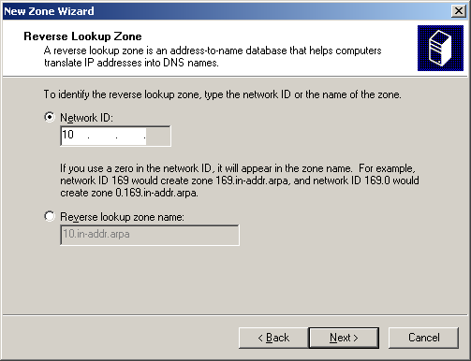
- At the Reverse Lookup Zone dialog box, you have to enter the network portion of the IP addresses you are using, as shown to the right on this page. For us, the network portion is 10 (only a single number because the subnet mask is 255.0.0.0. name your domain anything you like, such as cypress.com and click Next.
- At the Zone File dialog box, accept the default zone file name and click Next.
- At the Completing the Configure the DNS Server Wizard screen, read the information and click Finish.
Testing the DNS Service with NSLOOKUP
- The DNS Server is now up and running. To see what it does, open a Command Prompt window and use the NSLOOKUP to find the IP address of your DNS Server from its computer name, which should be Win9 or something like that. In my example to the right on this page, my DNS server is named Samp3. NSLOOKUP gets its information from the DNS service.
C:\Documents and Settings\Administrator>nslookup samp3
Server: localhost
Address: 127.0.0.1

Name: samp3
Address: 10.0.0.1
- In the DNS console, right-click your server name and select All Tasks, Stop. This stops the DNS service.
- Return to the Command Prompt window and use the NSLOOKUP again. You should get an error as shown to the right on this page.
C:\Documents and Settings\Administrator>nslookup samp3
*** Can't find server name for address 127.0.0.1: No response from server
*** Default servers are not available
Server: UnKnown
Address: 127.0.0.1

*** UnKnown can't find samp3: No response from server
- In the Command Prompt window, try using PING to reach the computers on your LAN. You should get a response, because PING can use other techniques to find machines, such as Broadcast, if DNS is not working.
- In the DNS console, right-click your server name and select All Tasks, Start.
Promoting your server to a Domain Controller
- Click Start, Run, and type in DCPROMO. Press the Enter key.
- At the Welcome to the Active Directory Installation Wizard screen, click Next.
- At the Domain Controller Type screen, accept the default choice of Domain controller for a new domain and click Next.
- At the Create Tree or Child Domain screen, accept the default choice of Create a new domain tree and click Next.
- At the Create or Join Forest screen, accept the default choice of Create a new forest of domain trees and click Next.
- At the New Domain Name screen, enter your domain name (the same name you used in step 7) and click Next.
- At the NetBIOS Domain Name screen, accept the default name and click Next.
- At the Database and Log Locations screen, accept the default locations and click Next.
- At the Shared System Volume screen, accept the default folder location and click Next.
- At the Configure DNS screen, select No, I will install and configure DNS myself and click Next. I do not understand why this screen appears when we already have DNS running.
- At the Permissions screen, select Permissions compatible only with Windows 2000 servers and click Next.
- At the Directory Services Administration Password screen, enter the password password in both boxes and click Next.
- At the Summary screen, read the information and click Next.
- At the Completing to the Active Directory Installation Wizard screen, click Finish.
- Restart your server when you are prompted to. Log in to your new domain as Administrator with a password of password.
Authorizing a DHCP Server
- We have seen the problems a rogue DHCP server can cause on a network. To prevent that, DHCP servers must be authorized before they well be able to run in a domain.
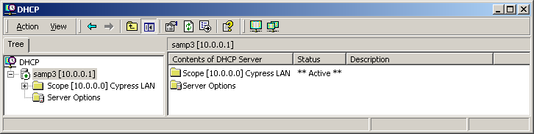
- Click Start, Programs, Administrative Tools, DHCP. The DHCP console opens. Your server should display with a red down-arrow, indicating that it is not operating.
- Click your server to highlight it and click Action, Authorize. Wait for the server to show a green up-arrow as shown to the right. It may take several minutes. You may have to click the refresh button (it has two curved green arrows on it).

Manually adding a new record to a DNS Server
- Click Start, Programs, Administrative Tools, DNS. The DNS console opens.
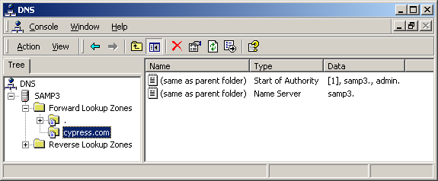
- Expand your server name, Forward and Lookup Zones. Select your domain name, as shown to the right on this page. Right-click your domain name and select New Host.

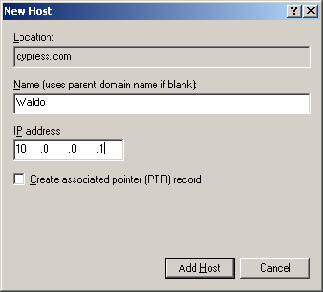

- In the New Host window, enter a Name of Waldo and an IP Address of 10.0.0.1. This will make Waldo a new alias for your server. Click the Add Host button. You should get a DNS message saying The host record Waldo.yourdomain was successfully created. Click OK to close the DNS message. Close the New Host window.

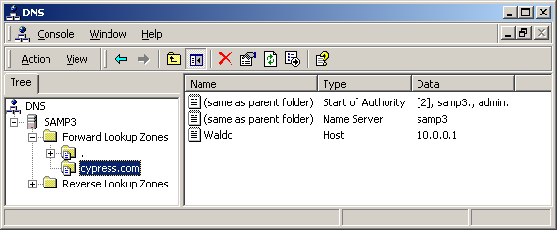
- You should see Waldo as a third record in the DNS console as shown to the right.

C:\Documents and Settings\Administrator>NSLOOKUP WALDO
Server: localhost
Address: 127.0.0.1

Name: WALDO.CYPRESS.COM
Address: 10.0.0.1
- Open a Command Prompt window and enter NSLOOKUP WALDO. You should see a response successfully finding the IP address 10.0.0.1 as shown to the right on this page.
Adding More Machines to the Domain
- Go to another machine on your LAN, not the DNS server. Right-click My Computer and select Properties. On the Network Identification tab, click the Properties button.
- In the Identification Changes window, click the domain radio button in the lower half of the window and type in your domain name without the .com extension (for example, cypress). Click the OK button.
- In the Domain Username and Password box, enter a username of Administrator and a password of password. Click the OK button. You should get a Network Identification box with the message Welcome to the domain_name domain.
- Click OK to close the Network Identification box and restart your machine when prompted to.
- Log in to your domain as Administrator with a password of password.
- On the domain controller, you should see the new record appear in the DNS console, under Waldo. But I could not get it to work.
WINS (Windows Internet Name Service) Pages 497-498
WINS is used to resolve NetBIOS names to IP addresses.
In a Windows 2000 environment, WINS is used when legacy clients and software such as Win 9x and Win NT require NetBIOS name resolution.
Windows 2000 WINS also supports dynamic registering of WINS names from DHCP.
For more details, see link Srv Ch 6m on my Web page.

