Writing Project: Partner Interview and Story
Read this story I wrote about my friend, Melinda. She was a nurse, but now she has a new job. She likes this new job much better than her old job.

Melinda
By Venette Cook
Many years ago, Melinda was a nurse, but now she doesn’t like working with sick people. She prefers teaching now. Now, she is a teacher’s aide in a private elementary school. She likes this job very much. She thinks she has the best job now. She enjoys teaching children to read and to think carefully. The other teachers are interesting to be with, too. She has a good salary and the school is beautiful. She is very happy at work almost all the time!


Dear Students,
Now it’s your turn to write a story. This page gives you information. Don’t type on this page. Open a new document in Word for your partner story. Find Word on the desktop.

- Ask a partner the questions on the next page. Try to add three more questions that you think are interesting.
- Take notes.
- Write a paragraph in MS Word. (Open a new document.) Use good sentences.
- Double space the paragraph.
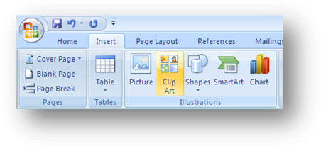
- Save. Save on your flash drive on in your folder.
- Choose an interesting Font.
- Use Size 14. Save.
- Check your spelling.
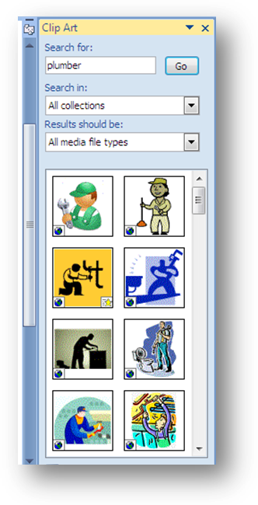
- Save again.
- Open Insert. (one click) This is the Tab next to Home. Choose Clip Art. (one click)
- Find the search box. Type in your partner’s job. (For example: plumber) Click go.
- Scroll and look at the pictures. Click on one clip art picture for your partner’s story.
H! Don’t type here!
- Type your name and date at the bottom.
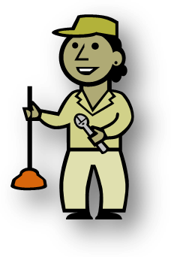
- Type your partner’s name at the top. Center your partner’s name.
- Save.
- Print.

Print this page (Control P)
My name:
Your name:

Questions: Ask these questions, and three more questions, too. Take notes with a pen or pencil.

- What was your last job?

- Where did you do that job?

- Where do you work now? How do you like your job?

- What job would be the best job for you? Why?

- What job skills do you enjoy using?

