English with Computers-Venette Cook
Learn about Power Point

People use power point to tell a story. You don’t write a lot in Power Point. You can tell your story with
- a few words,
- some clip art,
- some photos,
- some charts, or
- some sounds or music.
You don’t have pages in Power Point. You have slides. The slides go forward with
- a mouse click,
- a keyboard click (N for next slide), or
- automatically, like a movie.
You can make your story interesting with colors and transitions. Our first story will be about you!

Power Point Slides:
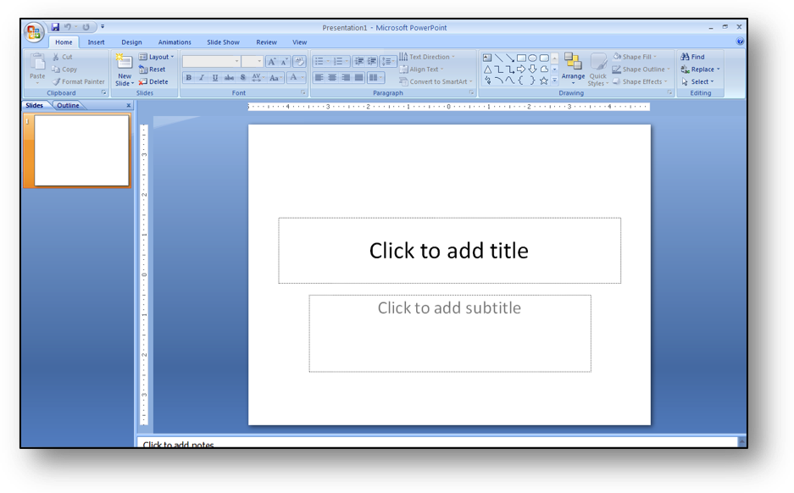

1

When you open Power Point your first slide looks like this.

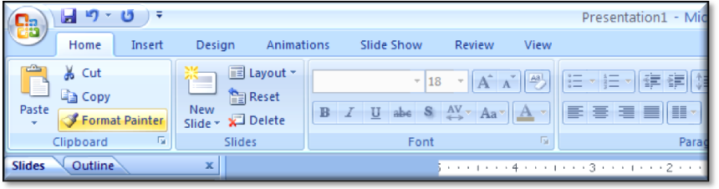
Here is the Home Tab. You can see copy and paste, and Font.
2

Click New Slide to see many kinds of slides. We can use the second kind to begin. We can try other ones later.
3
4
5
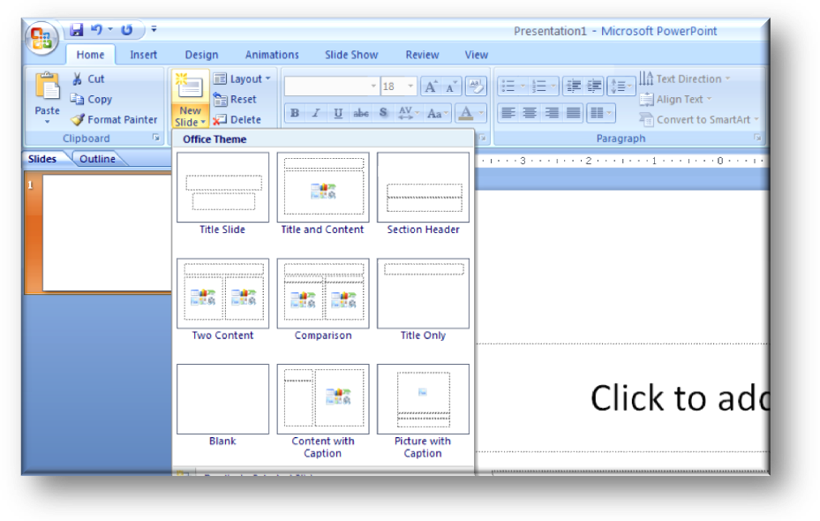
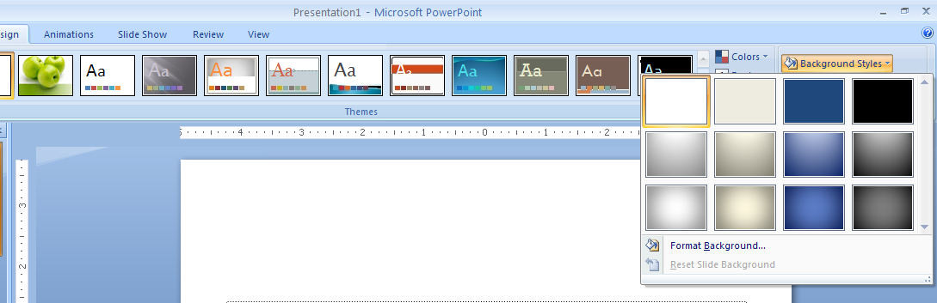
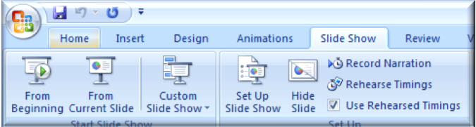
When you click Background Styles, you can see different colors. They will be on every slide.
When you have some slides ready, you click Slide Show. Then you see new choices. Click From Beginning to see your show.

