City College of San Francisco
Department of Engineering

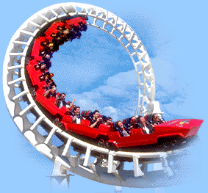

ENGN 37
Engineering Mechanics: Dynamics

Homework Problem Sets

Set #1
Rectilinear Motion

1. The motion of a particle is defined by the relation x = 3t⁴ + 4t³ - 7t² - 5t + 8, where x and t are expressed in millimeters and seconds, respectively. Determine the position, the velocity, and the acceleration of the particle when t = 3s.

2. The acceleration of a particle is directly proportional to the time t. At t = 0, the velocity of the particle is v = 16 inches/s. Knowing that v = 15 inches/s and that x = 20 inches when t = 1 s, determine the velocity, the position, and the total distance traveled when t = 7 s.

3. The acceleration of a particle is defined by the relation a = -k √v where k is a constant. Knowing that x = 0 and v = 81 m/s at t = 0 and that v = 36 m/s when x = 18 m, determine
a) the velocity of the particle when x = 20 m,
b) the time required for the particle to come to rest.

4. A particle is projected to the right from the position x = 0 with an initial velocity of 9 m/s. If the acceleration of the particle is defined by the relation a = -0.6v^{3/2}, where a and v are expressed in m/s² and m/s, respectively, determine
a) the distance the particle will have traveled when its velocity is 4 m/s,
b) the time when v = 1 m/s,
c) the time required for the particle to travel 6 m.

Set #2
Uniformly Accelerated Motion

1. A motorist enters a freeway at 36 km/h and accelerates uniformly to 90 km/h. From the odometer in the car, the motorist knows that she traveled 0.2 km while accelerating. Determine
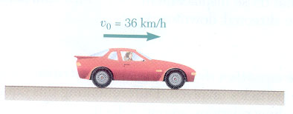
a) the acceleration of the car,
b) the time required to reach 90 km/h.

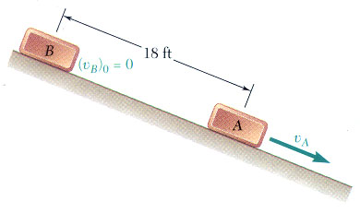
2. Boxes are placed on a chute at uniform intervals of time t_{R} and slide down the chute with uniform acceleration. Knowing that as any box B is released, the preceding box A has already slid 18 ft and that 1 s later they are 30 ft apart, determine
a) the value of t_{R},
b) the acceleration of the boxes.

3. Slider block B moves to the right with a constant velocity of 300 mm/s. Determine
a) the velocity of slider block A,
b) the velocity of portion C of the cable,
c) the velocity of portion D of the cable,
d) the relative velocity of portion C of the cable with respect to slider block A.
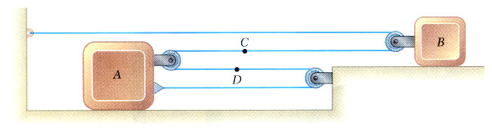

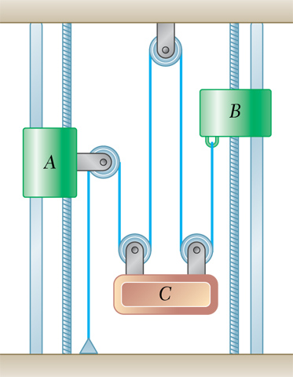
4. Collars A and B start from rest, and collar A moves upward with an acceleration of 3t² inches/s². Knowing that collar B moves downward with a constant acceleration and that its velocity is 8 inches/s after moving 32 inches, determine
a) the acceleration of block C,
b) the distance through which block C will have moved after 3 s

Set #3
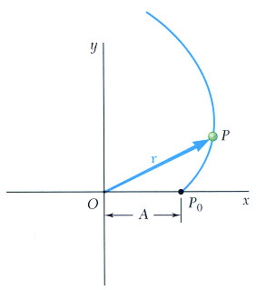
Curvilinear Motion

1. The motion of a particle is defined by the position vector r = A(cos t + t sin t)i + A(sin t – t cos t) j, where t is expressed in seconds. Determine the values of t for which the position vector and the acceleration are
a) perpendicular
b) parallel

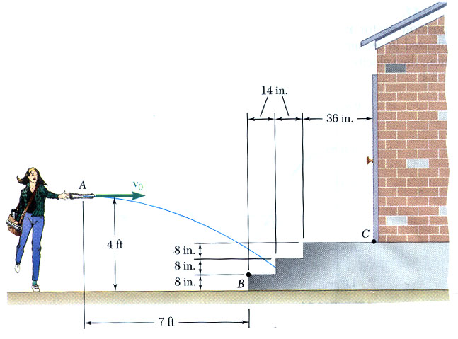
2. While delivering newspapers, a girl throws a newspaper with a horizontal velocity v_{o}.
Determine the range of values of v_{o} if the newspaper is to land between points B & C.

3. The initial velocity v_{o} of a hockey puck is 170 km/h. Determine
a) the largest value (less than 45º) of the angle α for which the puck will enter the net,
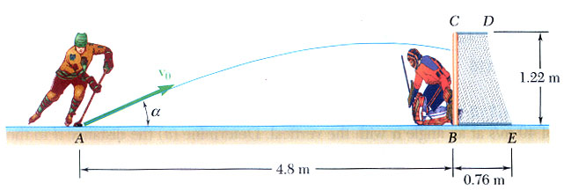
b) the corresponding time required for the puck to reach the net.

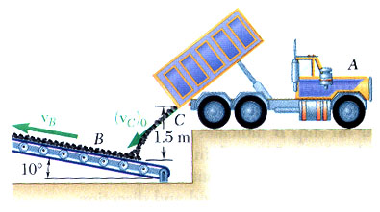
4. Coal discharged from a dump truck with an initial velocity (v_{C})_{o} = 1.8 m/s at 50º falls onto conveyor belt B. Determine the required velocity v_{B} of the belt if the relative velocity with which the coal hits the belt is to be
a) vertical,
b) as small as possible.

Set #4
Tangential/Normal & Radial/Transverse Components

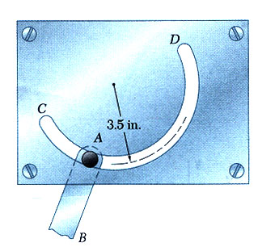
1. Pin A, which is attached to link AB, is constrained to move in the circular slot CD. Knowing that at t = 0 the pin starts from rest and moves so that its speed increases at a constant rate of 0.8 inches/s², determine the magnitude of its total acceleration when
a) t = 0
b) t = 2 s.

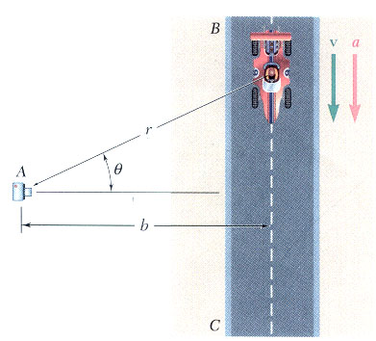
2. To study the performance of a race car, a high speed motion-picture camera is positioned at point A. The camera is mounted on a mechanism which permits it to record the motion of the car as the car travels on straightaway BC. Determine
a) the speed of the car in terms of b, , and ,
b) the magnitude of the acceleration of the car in terms of b, , , and ,

c) the average speed of the car during a 0.5-s interval if,
over this interval, the car travels from the position
= 60º to the position = 35º. (b = 25 m)

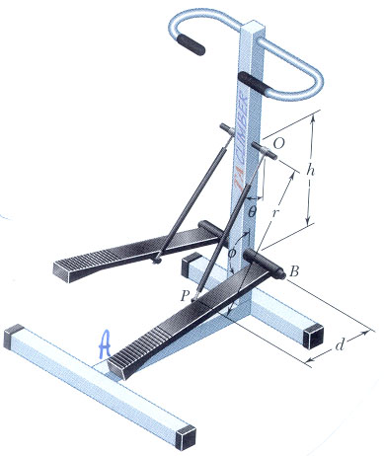
3. Show that 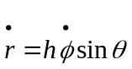 knowing that at the instant shown, step AB of the step exerciser is rotating counterclockwise at a constant rate .

Set #5
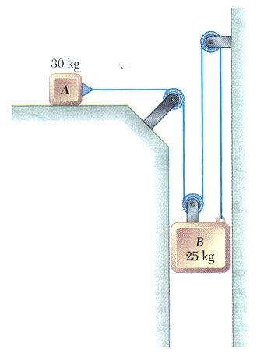
Equations of Motion

1. The two blocks shown are originally at rest. Neglecting the masses of the pulleys and the effect of friction in the pulleys and assuming that the coefficients of friction between block A and the horizontal surface are µ_{s} = 0.25 and µ_{k} = 0.20, determine:
a) The acceleration of each block.
b) The tension in the cable.
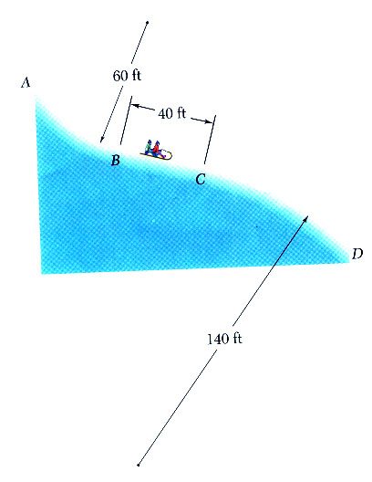

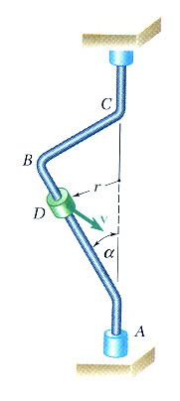
2. The portion of a toboggan run shown is contained in a vertical plane. Sections AB and CD have radii of curvature as indicated, and section BC is straight and forms an angle of 20º with the horizontal. Knowing that the coefficient of kinetic friction between a sled and the run is 0.10 and that the speed of the sled is 25 ft/s at B, determine the tangential component of the acceleration of the sled
a) just before it reaches B, and
b) just after is passes C.

3. A small, 300-g collar D can slide on portion AB of a rod which is bent as shown. Knowing that α = 40º and that the rod rotates about the vertical AC at a constant rate of 5 rad/s, determine the value of r for which the collar will not slide on the rod if the effect of friction between the rod and the collar is neglected.

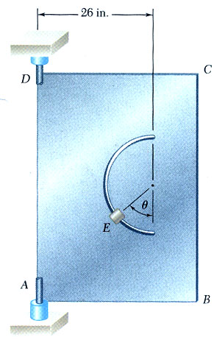

4. A semicircular slot of 10-inch radius is cut in a flat plate which rotates about the vertical AD at a constant rate of 14 rad/s. A small, 0.8-lb block E is designed to slide in the slot as the plate rotates. Knowing that the coefficients of friction are µ_{s} = 0.35 and µ_{k} = 0.25, determine whether the block will slide in the slot if it is released in the position corresponding to
a) θ = 80º
b) θ = 40º
Also determine the magnitude and the direction of the friction force exerted on the block immediately after it is released.
Set #6
Angular Momentum

1. The 100-g pin B slides along the slot in the rotating arm OC and along the slot DE which is cut in a fixed horizontal plate. Neglecting friction and knowing that rod OC rotates at the constant rate _{o} =12 rad/s, determine for any given value of θ
a) the radial and transverse components of the resultant force F exerted on pin B,
b) the forces P and Q exerted on pin B by rod OC and the wall of slot DE, respectively.
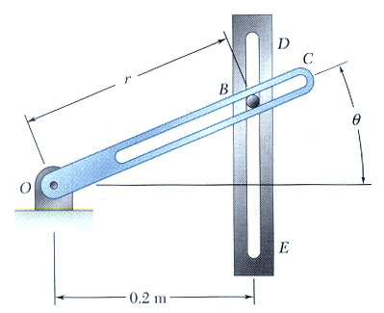

2. A particle of mass m is projected from point A with an initial velocity v_{o} perpendicular to the line OA and moves under a central force F along a semicircular path of diameter OA. Observing that
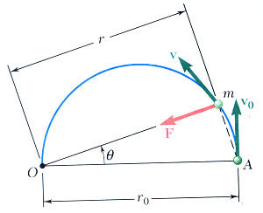
r = r_{o} cos θ, show that the speed of the particle is v = v_{o} /cos²θ.

3. A particle of mass m is projected from point A with an initial velocity v_{o} perpendicular to line OA and moves under a central force F directed away from the center of force O. Knowing that the particle follows a path defined by the equation 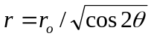, express the radial and transverse components of the velocity v of the particle as functions of θ.
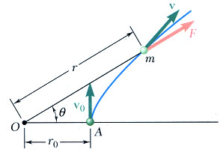
Set #7
Work, Energy, Power

1. A trailer truck enters a 2% downhill grade traveling at 65mph and must slow down to 40mph in 1000ft. The cab weighs 4000 lb and the trailer 12,000 lb. Determine
a) the average braking force that must be applied,
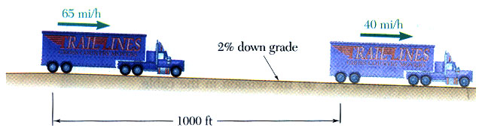
b) the average force exerted on the coupling between the cab and the trailer if 70% of the braking force is supplied by the trailer and 30% by the cab.

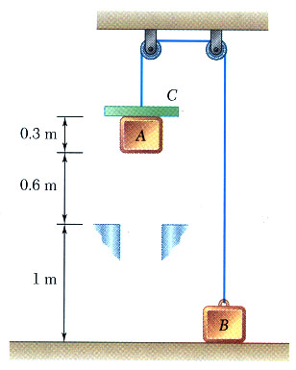

2. Two blocks A and B, of mass 4 kg and 5 kg respectively, are connected by a cord which passes over pulleys as shown. A 3-kg collar C is placed on block A and the system is released from rest. After the blocks have moved 0.9 m, collar C is removed and blocks A and B continue to move. Determine the speed of block A just before it strikes the ground.

3. A 10-lb block is attached to an unstretched spring of constant k = 12 lb/in. The coefficients of static and kinetic friction between the block and the plane are 0.60 and 0.40 respectively. If a force F is slowly applied to the block until the tension in the spring reaches 20 lb and then suddenly removed, determine
a) the velocity of the block as it returns to its initial position,
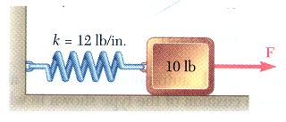
b) the maximum velocity achieved by the block.

Set #8
Conservation of Energy

1. A 3-kg collar can slide without friction on a vertical rod and is resting in equilibrium on a spring. It is pushed down, compressing the spring 150mm, and released. Knowing that the spring constant k = 2.6kN/m, determine
a) the maximum height h reached by the collar above its equilibrium position,
b) the maximum velocity of the collar.
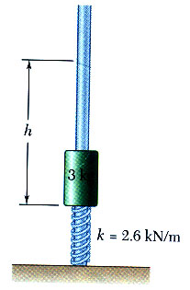

2. A 3-kg collar can slide without friction on a vertical rod and is held so that it just touches an undeformed spring. Determine the maximum deflection of the spring
a) if the collar is slowly released until it reaches an equilibrium position,
b) if the collar is suddenly released.

3. A 200-g package is projected upward with a velocity v_{o} by a spring at A; it moves around a frictionless loop and is deposited at C. For each of the two loops shown, determine
a) the smallest velocity v_{o} for which the package will reach C,
b) the corresponding force exerted by the package on the loop just before the package leaves the loop at C.
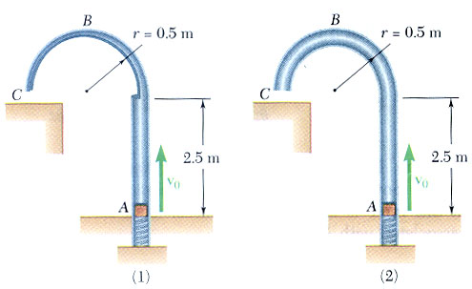
Set #9
Applications to Space Mechanics

1. Knowing that the velocity of an experimental space probe fired from the earth has a magnitude v_{A} = 20.2 x 10³ mph at point A, determine the velocity of the probe as it passes through point B.
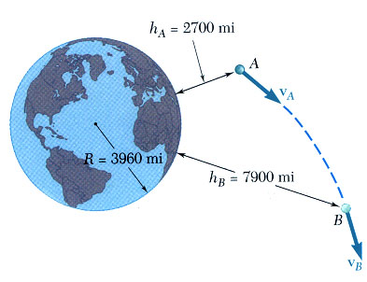

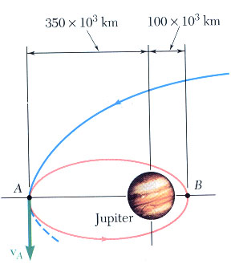
2. A spacecraft traveling along a parabolic path toward the planet Jupiter is expected to reach point A with a velocity v_{A} of magnitude 26.9 km/s. Its engines will then be fired to slow it down, placing it into an elliptic orbit which will bring it to within 100 x 10³ km of Jupiter. Determine the decrease in speed Δv at point A which will place the spacecraft into the required orbit. The mass of Jupiter is 319 times the mass of the earth.

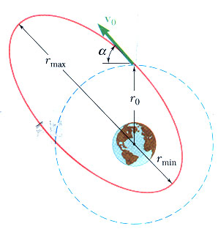
3. A satellite is projected into space with a velocity v_{o} at a distance r_{o} from the center of the earth by the last stage of its launching rocket. The velocity v_{o} was designed to send the satellite into a circular orbit of radius r_{o}. However, owing to a malfunction of control, the satellite is not projected horizontally but at an angle α with the horizontal and, as a result, is propelled into an elliptic orbit. Determine the maximum and minimum values of the distance from the center of the earth to the satellite.
Set #10
Impulse and Momentum

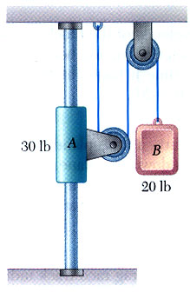
1. The system shown is released from rest. Determine the time it takes for the velocity of A to reach 2 ft/s. Neglect friction and the mass of the pulleys.

2. A mother and her child are skiing together, with the mother holding the end of a rope tied to the child’s waist. They are moving at a speed of 7.2 km/h on a flat portion of the ski trail when the mother observes that they are approaching a steep descent. She decides to pull on the rope to decrease the child’s speed. Knowing that this maneuver causes the child’s speed to be cut in half in 3 s and neglecting friction, determine
a) the mother’s speed at the end of the 3-s interval,
b) the average value of the tension in the rope during that time interval.
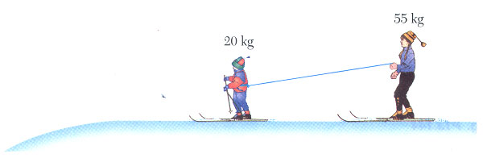

3. A baseball player catching a ball can soften the impact by pulling her hand back. Assuming that a 5-oz ball reaches her glove at 90 mph and that the player pulls her hand back during the impact at an average speed of 30 ft/s over a distance of 6 inches, bringing the ball to a stop, determine the average impulsive force exerted on the player’s hand.
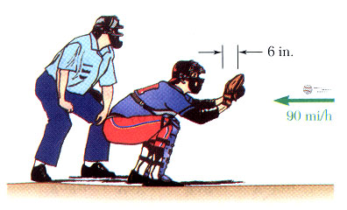
Set #11
Impact

1. A 600-g ball A is moving with a velocity of magnitude 6 m/s when it is hit as shown by a 1-kg ball B which has a velocity of magnitude 4 m/s. Knowing that the coefficient of restitution is 0.8 and assuming no friction, determine the velocity of each ball after impact.

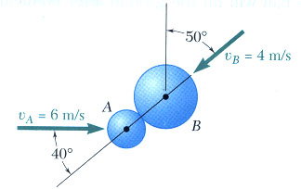

2. A 3-lb sphere A strikes the frictionless inclined surface of a 9-lb wedge B at a 90º angle with a velocity of magnitude 12ft/s. The wedge can roll freely on the ground and is initially at rest. Knowing that the coefficient of restitution between the wedge and the sphere is 0.50 and that the inclined surface of the wedge forms an angle θ = 40º with the horizontal, determine
a) the velocities of the sphere and of the wedge immediately after impact,
b) the energy lost due to the impact.
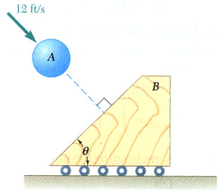
Set #12
Systems of Particles

1. Three identical cars are being unloaded from an automobile carrier. Cars B and C have just been unloaded and are at rest with their brakes off when car A leaves the unloading ramp with a velocity of 2.00 m/s and hits car B, which in turn hits car C. Car A then again hits car B. Knowing that the velocity of car A is 0.400 m/s after its first collision with car B and 0.336 m/s after its second collision with car B and that the velocity of car C is 1.280 m/s after it has been hit by car B, determine
a) the velocity of car B after each of the three collisions,
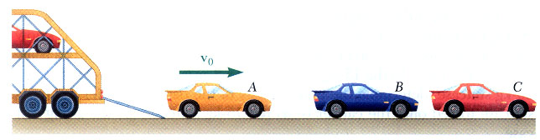
b) the coefficient of restitution between any two of the three cars.

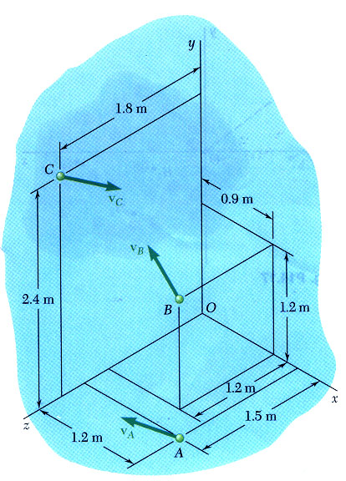

2. A system consists of three particles A, B, and C. We know that m_{A}= 3 kg, m_{B}= 4 kg, and m_{C}= 5 kg and that the velocities of the particles expressed in m/s are, respectively, v_{A} = -4i + 4j + 6k,
v_{B} = -6i + 8j + 4k, v_{C} = 2i + -6j + -4k.
a) Determine the angular momentum H_{o} of the system about O.
b) Determine the position vector of the mass center G of the system,
c) Determine the linear momentum mof the system,
d) Determine the angular momentum H_{G} of the system about G.
e) Verify this equation: H_{o} = x m + H_{G}

The vectors and define, respectively, the position and velocity of the mass center G of the system of particles relative to the Newtonian frame of reference Oxyz, and m represents the total mass of the system.

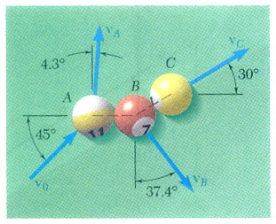
3. In a game of pool, ball A is moving with a velocity v_{o} when it strikes balls B and C which are at rest and aligned as shown. Knowing that after the collision the three balls move in the directions indicated and that v_{o} = 12 ft/s and v_{c} = 6.29 ft/s, determine the magnitude of the velocity of
a) ball A,
b) ball B.
Set #13
Systems of Particles

1. In a game of pool, ball A is moving with the velocity v_{o} = v_{o}i when it strikes balls B and C, which are at rest side by side. Assuming frictionless surfaces and perfectly elastic impact (i.e. conservation of energy), determine the final velocity of each ball, assuming that the path of A is
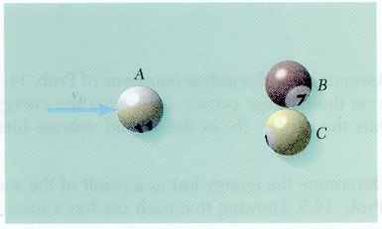
a) perfectly centered and that A strikes
B and C simultaneously,
b) not perfectly centered and that A v_{o}
strikes B slightly before it strikes C.

2. A 360-kg space vehicle traveling with a velocity v_{o} = (450 m/s)k passes through the origin O. Explosive charges then separate the vehicle into three parts A, B, and C, with masses of 60 kg, 120 kg, and 180 kg respectively. Knowing that shortly thereafter the positions of the three parts are, respectively, A(72, 72, 648), B(180, 396, 972), and C(-144, -288, 576), where the coordinates are expresses in meters, that the velocity of B is v_{B} = (150 m/s)i + (330 m/s) j + (600m/s) k, and that the x component of the velocity of C is -120 m/s, determine the velocity of part A.

3. Three identical spheres A, B, and C, which can slide freely on a frictionless horizontal surface, are connected by means of inextensible, inelastic cords to a small ring D located at the mass center of the three spheres (l’ = 2l cos θ). The spheres are rotating initially about ring D, which is at rest, at speeds proportional to their distances from D. We denote by v_{o} the original speed of A and B and assume that θ = 30º. Suddenly cord CD breaks, causing sphere C to slide away. Considering the motion of spheres A and B and of ring D after the other two cords have again become taut, determine
a) the speed of ring D,
b) the relative speed at which spheres A and B rotate about D,
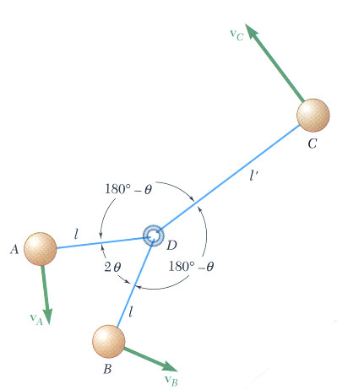
c) the percent of energy of the original system which is dissipated when cords AD and BD again become taut.
Set #14
Motion: Translation & Rotation

1. The angular acceleration of a shaft is defined by the relation α = -0.25 ω, where α is expressed in rad/s² and ω in rad/s. Knowing that at t = 0 the angular velocity of the shaft is 20 rad/s, determine
a) the number of revolutions the shaft will execute before coming to rest,
b) the time required for the shaft to come to rest,
c) the time required for the angular velocity of the shaft to be reduced to 1% of its initial value.
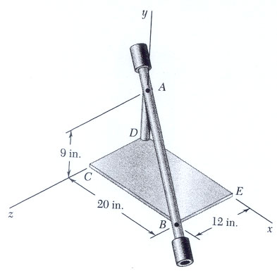

2. The assembly shown consists of two rods and a rectangular plate BCDE which are welded together. The assembly rotates about the axis AB with a constant angular velocity of 7.5 rad/s. Knowing that the rotation is counterclockwise as viewed from B, determine the velocity and acceleration of corner E.

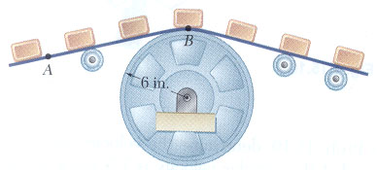
3. A series of small machine components being moved by a conveyor belt pass over a 6-inch-radius idler pulley. At the instant shown, the velocity of point A is 15 in./s to the left and its acceleration is 9 in./s² to the right. Determine
a) the angular velocity and the angular acceleration of the idler pulley,
b) the total acceleration of the machine component at B.

4. Two blocks and a pulley are connected by inextensible cords as shown. Block A has a constant acceleration of 75 mm/s² and an initial velocity of 120 mm/s, both directed downward. Determine
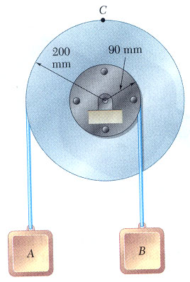
a) the number of revolutions executed by the pulley in 6s,
b) the velocity and position of block B after 6s,
c) the acceleration of point C on the rim of the pulley at t = 0.
Set #15
General Plane Motion
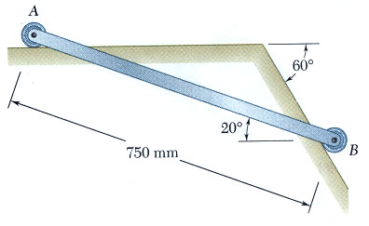

1. Small wheels have been attached to the ends of rod AB and roll freely along the surfaces shown. Knowing that wheel A moves to the left with a constant velocity of 1.5 m/s, determine
a) the angular velocity of the rod,
b) the velocity of end B of the rod.

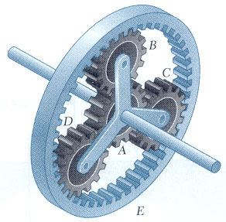
2. In the planetary gear system shown, the radius of gears A, B, C, and D is 3 inches and the radius of the outer gear E is 9 inches. Knowing that gear E has an angular velocity of 120 rpm clockwise and that the central gear has an angular velocity of 150 rpm clockwise, determine
a) the angular velocity of each planetary gear,
b) the angular velocity of the spider connecting the planetary gears.

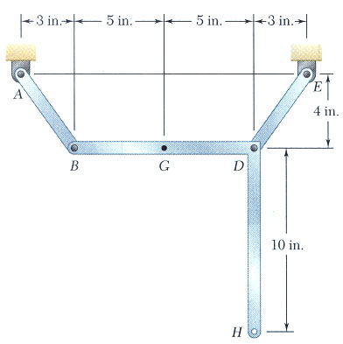

3. In the position shown, bar AB has a constant angular velocity of 20 rad/s counterclockwise. Determine
a) the angular velocity of member BDH,
b) the velocity of point G.

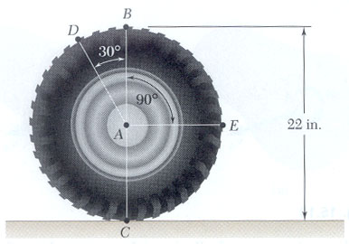
4. An automobile travels to the right at a constant speed of 48 mph. If the diameter of a wheel is 22 inches, determine the velocities of points B, C, D, and E on the rim of the wheel.
Set #16
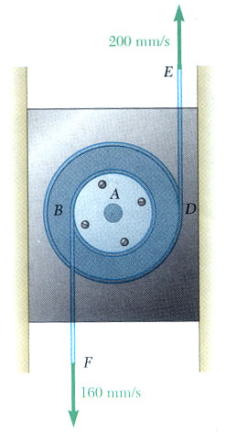
Instantaneous Center

1. A double pulley is attached to a slider block by a pin at A. The 30-mm-radius inner pulley is rigidly attached to the 60-mm-radius outer pulley. Knowing that each of the two cords is pulled at a constant speed as shown, determine
a) the instantaneous center of rotation of the double pulley,
b) the velocity of the slider block,
c) the number of millimeters of cord wrapped or unwrapped on each pulley per second.

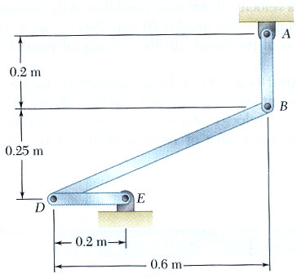

2. Knowing that at the instant shown the angular velocity of rod AB is 15 rad/s clockwise, determine
a) the angular velocity of rod BD,
b) the velocity of the midpoint of rod BD.

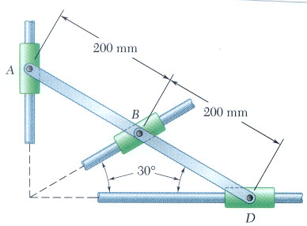
3. Two rods AB and BD are connected to three collars as shown. Knowing that collar A moves downward with a velocity of 120 mm/s determine at the instant shown
a) the angular velocity of each rod,
b) the velocity of collar D.

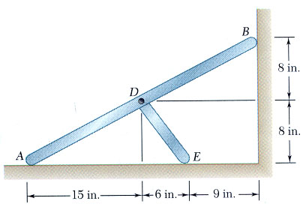
4. Two rods AB and DE are connected as shown. Knowing that point B moves downward with a velocity of 60 inches/s, determine
a) the angular velocity of each rod,
b) the velocity of point E.
Set #17
Acceleration in Plane Motion

1. A carriage C is supported by a caster A ad a cylinder B, each of 50-mm diameter. Knowing that at the instant shown the carriage has an acceleration of 2.4 m/s² and a velocity of 1.5 m/s, both directed to the left, determine
a) the angular accelerations of the caster and of the cylinder,
b) the accelerations of the centers of the caster and of the cylinder.

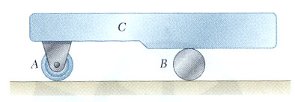

2. The motion of the 75-mm-radius cylinder is controlled by the cord shown. Knowing that end E of the cord has a velocity of 300 mm/s and an acceleration of 480 mm/s², both directed upward, determine the acceleration
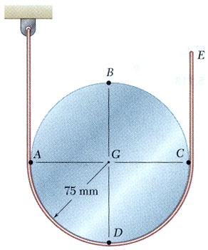
a) of point A,
b) of point B.

3. The disk shown has a constant angular velocity of 360 rpm clockwise. Determine the acceleration of collar C when θ = 90º.
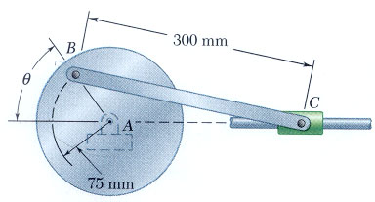
Set #18
Coriolis Acceleration

1. Two rotating rods are connected by a slider block P. The rod attached at B rotates with a constant clockwise angular velocity ω_{B}. For b = 10 inches and ω_{B}= 5 rad/s, determine for the position shown
a) the angular velocity of the rod attached at A,
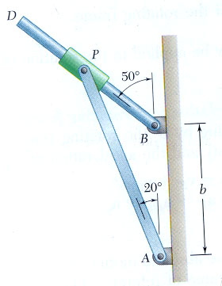
b) the relative velocity of the slider block P with respect to the rod on which it slides.

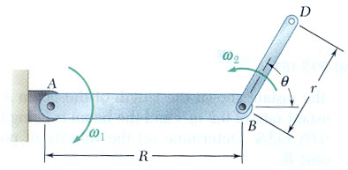
2. Rod AB of length R = 15 inches rotates about A with a constant clockwise angular velocity ω₁ of 5 rad/s. At the same time, rod BD of length r = 8 inches rotates about B with a constant counterclockwise angular velocity ω₂ of 3 rad/s with respect to rod AB. Knowing that θ = 60º, determine for the position shown the acceleration of point D.

3. The motion of pin D is guided by a slot cut in rod AB and a slot cut in the fixed plate. Knowing that at the instant shown rod AB rotates with an angular velocity of 3 rad/s and an angular acceleration of 5 rad/s², both counterclockwise, determine the acceleration of pin D.
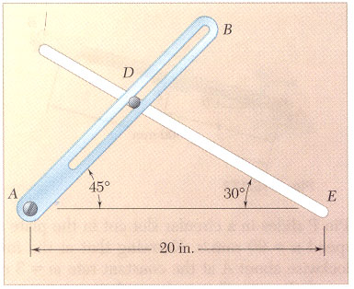

Set #19
Plane Motion of Rigid Bodies

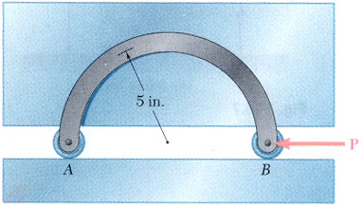
1. The motion of the 3-lb rod AB is guided by two small wheels that roll freely in a horizontal slot cut in a vertical plate. Determine
a) the force P for which the reaction at A is zero,
b) the corresponding acceleration of the rod.

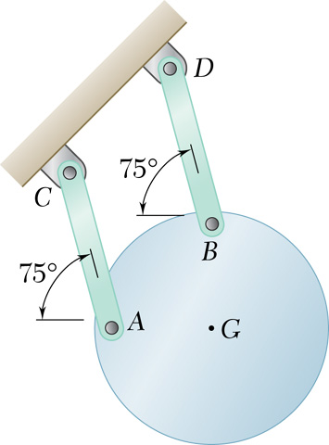
2. A uniform circular plate of mass 3 kg is attached to two links AC and BD of the same length. Knowing that the plate is released from rest in the position shown, determine
a) the acceleration of the plate,
b) the tension in each link.

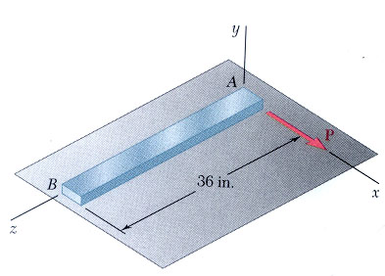
3. It takes 10 min for a 6000-lb flywheel to coast to rest from an angular velocity of 300 rpm. Knowing that the radius of gyration of the flywheel is 36 inches, determine the average magnitude of the couple due to kinetic friction in the bearings.

4. A uniform slender rod AB rests on a frictionless horizontal surface, and a force P of magnitude 0.25 lb is applied at A in a direction perpendicular to the rod. Knowing that the rod weighs 1.75 lb, determine the acceleration of
a) point A,
b) point B.
Set #20
Constrained Plane Motion

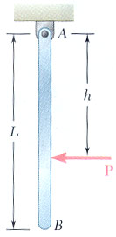
1. A uniform slender rod of length L = 36 inches
and weight W = 4 lb hangs freely from a hinge at A.
If a force P of magnitude 1.5 lb is applied at B horizontally to the left (h = L),
determine
a) the angular acceleration of the rod,
b) the components of the reaction at A.

2. Two uniform disks A and B, each of mass m and radius r,
are connected by an inextensible cable and
roll without sliding on the surfaces shown.
Knowing that system is released from rest
when β = 15º,
determine the acceleration of the center of
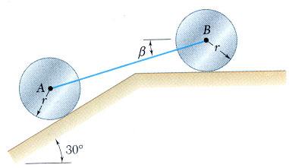
a) disk A,
b) disk B.

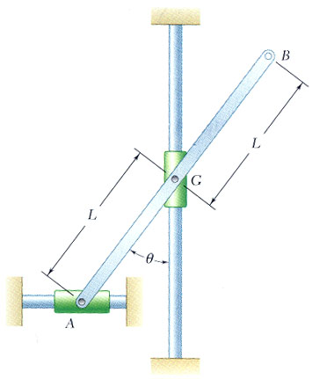

3. The uniform rod AB of weight W = 14 lb and total length 2L = 30 inches
is attached to collars of negligible weight
that slide without friction along fixed rods.
If rod AB is released from rest when θ = 30º,
determine immediately after release
a) the angular acceleration of the rod,
b) the reaction at A.
Set #21
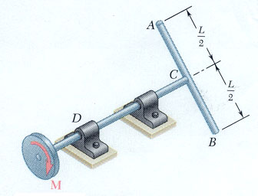
Work and Energy for Rigid Bodies

1. A 9-inch-diameter disk weighing 8 lb and rod AB of length L weighing 3 lb/ft are attached to the shaft CD as shown. A couple M of constant magnitude 4ft-lb is applied to the disk when the system is at rest. Knowing that the angular velocity of the system is to be 300 rpm after two complete revolutions, determine the required length L of the rod.

2. A 20-kg uniform cylindrical roller, initially at rest, is acted upon by a 90-N force as shown. Knowing that the body rolls without slipping, determine
a) the velocity of its center G after it has moved 1.5 m,
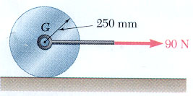
b) the friction force required to prevent slipping.

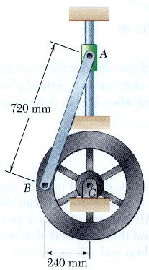

3. The 4-kg rod AB is attached to a collar of negligible mass at A
and to a flywheel at B. The flywheel has a mass of 16 kg
and a radius of gyration of 180 mm.
Knowing that in the position shown
the angular velocity of the flywheel is 60 rpm clockwise,
determine the velocity of the flywheel
when point B is directly below C.
Set #22
Impulse and Momentum for Rigid Bodies

1. A 3-kg sphere of radius r = 125 mm with an initial clockwise angular velocity ω_{o} = 90 rad/s is placed in the corner formed by the floor and a vertical wall. Knowing that the coefficient of kinetic friction is 0.10 at A and B, determine the time required for the sphere to come to rest.
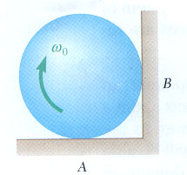

2. The double pulley shown has a mass of 3 kg and a radius of gyration of 100 mm. Knowing that when the pulley is at rest, a force P of magnitude 24 N is applied to cord B, determine
a) the velocity of the center of the pulley after 1.5 s,
b) the tension in cord C.

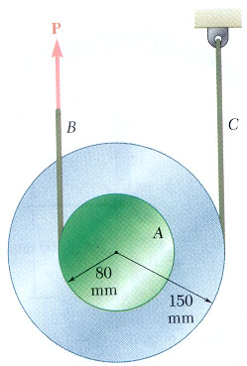
Set #23
Eccentric Impact for Rigid Bodies

1. A bullet weighing 0.08 lb is fired with a horizontal velocity of 1800 ft/s into the lower end of a slender 15-lb bar of length L = 30 inches. Knowing that h = 12 inches and that the bar is initially at rest, determine
a) the angular velocity of the bar immediately after the bullet becomes embedded,
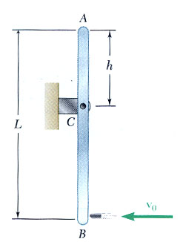
b) the impulsive reaction at C,
assuming that the bullet becomes embedded in 0.001 s.

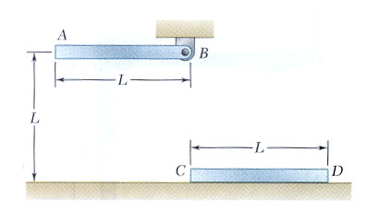
2. A slender rod AB is released from rest in the position shown. It swings down to a vertical position and strikes a second and identical rod CD which is resting on a frictionless surface. Assuming that the coefficient of restitution between the rods is 0.5, determine the velocity of rod CD immediately after the impact.

