Chapter 1: An Introduction
Materials Science for Engineers

Each word in the textbook title is significant.

Materials
Materials are the substances from which things are composed. Their impact on society cannot be underestimated. Civilizations have been designated by the level of their material advancement: The Stone Age, The Copper Age, The Bronze Age, The Iron Age, etc. How would you characterize the current era?

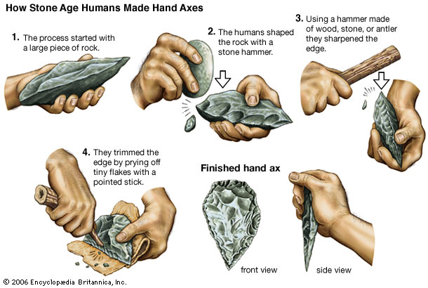

Primitive humans had access to only a limited number of materials that occurred naturally: stone, wood, clay, skins. Then, techniques were discovered to produce (engineer) materials that had superior properties. The earliest example is probably pottery which has been prevalent for thousands of years. Another example is heat-treated metals. Another is alloys. (Alloys are materials made from metals combined with impurities.) Today's engineers have created extremely sophisticated materials for very high-tech and demanding applications.

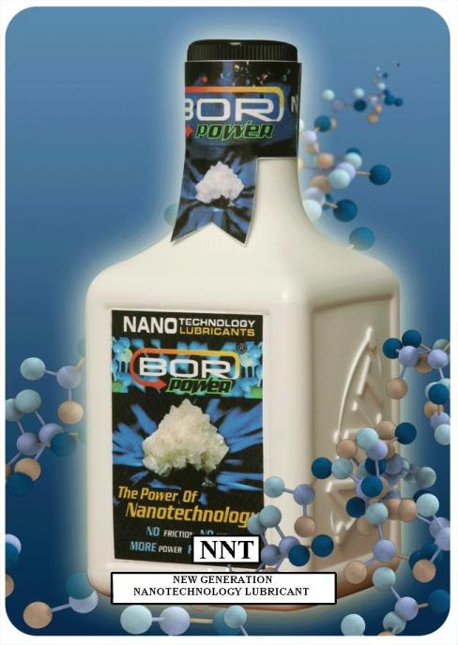

BOR POWER engine treatment additive is designed to extend the operating life and operating range of the engines. It forms a protective Intelligent Nano Layer that covers the engine exactly.

Science
The word science refers to the fundamental nature of the physical world. The science of materials refers to their structure and their properties.

Engineering
Ask ten engineers what the definition of the word engineering is and you will get several different answers. The most common will contain the idea that engineering is the field that applies basic science to solve society’s problems. One brilliant engineer said that engineering is the “art of compromise.”

In the field of materials, engineering refers to the processing techniques for materials and to the selection of an appropriate material for a specific application.
How does it all relate?

The fundamental science of materials looks at their structure and properties.
Materials engineering is the processing and selection of materials.
These concepts relate to each as follows.
Processing → Structure → Properties → Application

(The arrows can be read as the word “determines”.)

A material’s structure determines its properties which in turn determine the applications for which it can be used. However, with knowledge of the structure and some creativity, the engineer can formulate a process that will change the structure and enhance the properties, thereby enabling it to be used for a sophisticated application.

So from the knowledge of the fundamental science of materials, engineers develop processes (manufacturing techniques) that dramatically alter the natural (or equilibrium) structure of a material and hence its properties to meet specific requirements for an application.

In the last 100 years, knowledge of the basic science of materials has enabled scientists to engineer materials that meet ever more demanding specifications. The cutting edge nanotechnology promises to create new materials that will revolutionize many fields, including energy production, medicine and electronics.

Example:
The elimination of porosity in Alumina (Al₂O₃) is a good example of how microscopic structure affects properties.
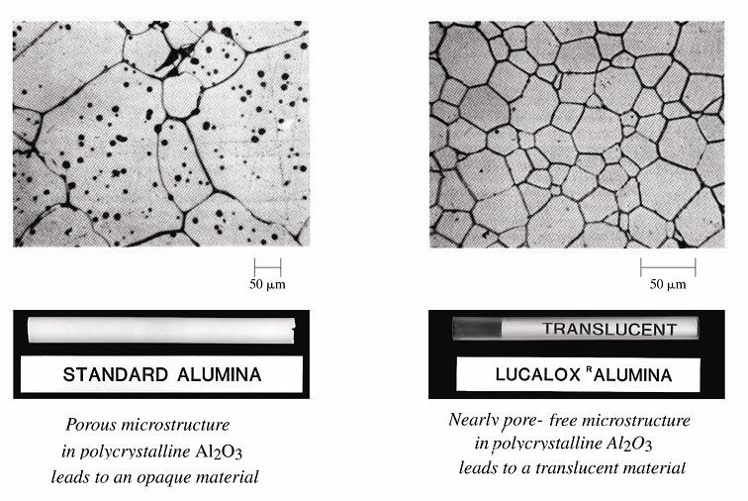
The Structure of Materials

The structure of materials can be discussed on different levels (scales) ranging from the human scale to the atomic scale:
- human scale – on the order of 1 meter
This is also called macroscopic scale because structure on this level is observable with the human eye.
- milliscale – on the order of 10⁻³ meter
- microscale – on the order of 10⁻⁶ meter
Milliscale and microscale are also called microscopic scale because structure on this level is observable with a microscope.
- nanoscale – on the order of 10⁻⁹ meter
Nowadays, this is also observable with a microscope.
- atomic scale – on the order of 10⁻¹⁰ meter

An example of atomic scale structure is whether materials have long-range order (crystalline) or short-range order (amorphous).

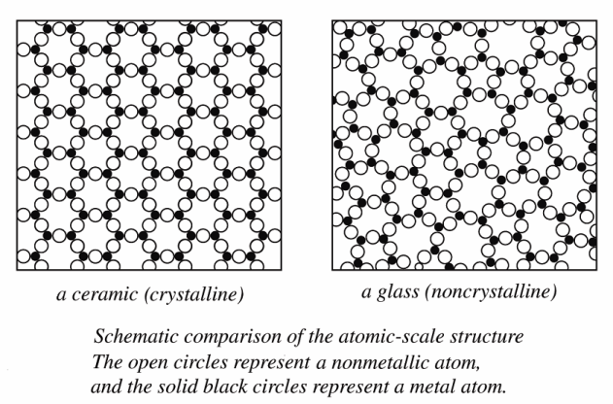
Material Properties
Material properties are the inherent characteristics of a material. These can be described qualitatively and quantitatively.

One can qualitatively say that metals are strong and shiny. Or that polymers are ductile. But how strong? How shiny? How much deformation will a polymer experience for a certain load? These kinds of questions relate to the quantification of material properties.

Engineers have quantified and standardized material properties with very careful and very specific definitions. These definitions are published by professional societies such as ASM, ASTM, ASME, ANSI.

For example a material property called Yield Strength is the level of stress (load divided by cross sectional area) at which point the material starts to yield (permanently deform). So this property measures a material's response to a mechanical stimulus. (Usually a material property measures the response to some stimulus.)

Material properties fit into six broad categories bases on the type of stimulus:
1. mechanical properties – measure the response to a load (force)
(e.g. tensile strength, elastic modulus)
2. electrical properties – measure the response to an electric field
(e.g. conductivity)
3. thermal properties – measure the response to heat
(e.g. melting temperature)
4. magnetic properties – measure the response to a magnetic field
(e.g. permeability)
5. optical properties – measure the response to electromagnetic or light radiation
(e.g. index of refraction)
6. deteriorative properties – measure the response to environmental factors including moisture, oxygen, uv radiation.

Classification of Materials

One way to classify materials is in these six categories:
- Metals/Alloys
- Ceramics
- Glasses
- Polymers
- Composites
- Semiconductors

An alternate classification of materials uses categories based on their properties:
- Structural materials
- Electronic materials
- Magnetic materials
- Semiconducting materials
- Optical materials

Criteria for selection of materials
Engineers must take into account various considerations when selecting materials for an application.

Some of the more obvious criteria:
- Material must meet design specifications. (strength, durability, etc.)
- Cost effective. (Both the material itself and its processing.)
- Environmental impact. (Must take into account “cradle to grave” impact.)
- Deterioration potential.

OVERVIEW OF ENGINEERING MATERIALS
 | STRUCTURE | PROPERTIES | EXAMPLES
Metals/ Alloys | - any metallic element /alloy  (see periodic table)  - simple crystalline structure  - metallic atomic bonding  - delocalized electrons | - high conductivity  - not transparent to visible light  (i.e. opaque)  - lustrous  - strong  - ductile | - iron (Fe)  - steel (Fe+C)  - aluminum (Al)  - copper (Cu)  - brass (Cu+Zn)  - magnesium (Mg)  - titanium (Ti)  - nickel (Ni)  - zinc (Zn)
Ceramics/  Glasses/  & Glass-Ceramics | - compounds of metals and non-metals (see periodic table)  - primarily ionic atomic bonding  (however, these bonds might have some covalent character)  - ceramics are crystalline  (crystalline structure can be relatively simple to relatively complex)  - glasses are amorphous  (primarily made of SiO₂)  - glass-ceramics are devitrified glasses | - insulative  - refractory  - wear resistant  - brittle  - strong  - hard  - chemically stable  - high melting temps  - glasses are transparent  - gl-cer can have low thermal expansion (good for thermal stresses) | - oxides  (Al₂O₃, MgO, SiO₂)  - nitrides (Si₃N₄)  - carbides  - silicates  - lithium-alumino-silicates  - clay  - cement
Polymers  (aka Plastics) | - organic compounds primarily based on C and H.  (see periodic table)  - large molecular structures in a chain or network configuration  - atomic bonding is covalent on the chains or network and additionally there is secondary bonds acting between the chains or network.  - 5-95% crystalline in relatively simple structures to very complex | - very ductile (elastic and plastic)  - low density  - low strength  - low melting temp  - high chemical reactivity  - insulative | - polyethylene  - PVC  - rubber  - acrylics - O  - nylons - N  - fluoroplastics - F  - silicones - Si
Composites | - Engineered materials of more than one type, usually a matrix material with fibers or particulates. | - Could be anything, depending on constituents, relative amounts and geometry | - fiberglass  - concrete  - asphalt  - wood
Semi-conductors | - elemental (Group IVA)  - compound  (Groups IIIA/VA or IIB/VIA)  - covalent/ionic bonding  - similar to ceramics | - intermediate conductivity which is extremely sensitive to minute concentrations of impurities  - precise control of chemical purity allows precise control of electrical properties  - techniques exist to produce variations in chemical purity over very small spatial regions  - hence, sophisticated and minute circuitry can be produced in exceptionally small areas (This is what makes micro-circuitry possible in ICs) | - Si, Ge, Sn  - CaS  - GaAs



